“No Peace for the Wicked”
Isaiah 56:9-57:21
Dan Leppo

I hope each of you had a blessed passion week. What an amazing God we have who would look upon each of us in our worst moments - yet still choose to die on a cross on our behalf. Three days later He would be resurrected providing victory over death and making a way to be forgiven by and reconciled with our Creator. After almost 30 years of faith, I never cease to be in awe of this life-altering truth.

If you recall, last lesson’s reading covered God’s invitation to both Jew and Gentile to return to Him. For the Jews, we read this reality will be taking place in the Millennium. Thankfully, we Gentiles didn’t have to wait until then. However, in this week’s reading, we find Isaiah being led by the Lord to clarify His issues with certain people in their current spiritual state. Specifically, Isaiah lays out God’s issues with:

- Leaders
- Idolators
- Proud & Greedy

The next section of the lecture will speak to God’s love for the contrite. Finally, we need to deal with the question of, “What about the wicked?”

There are many valid reasons that we can point to for the moral decay of this country. One of the primary reasons, in my mind, is a breakdown in the quality of leaders we have. What is the root word of leadership or leaders? – Lead. Leaders are supposed to lead those whom they’ve been charged with leading. One important question we should ask of our leaders is what basis are they leading? In other words, are they leading based on their own wisdom or seeking wisdom from God? Isaiah provides God’s assessment of the leaders of Israel at this time in history in verses 56:10-12. Below is a table that shares how God describes the leaders, the verse the description is coming from, and what the underlying character trait is of these deeply flawed leaders.

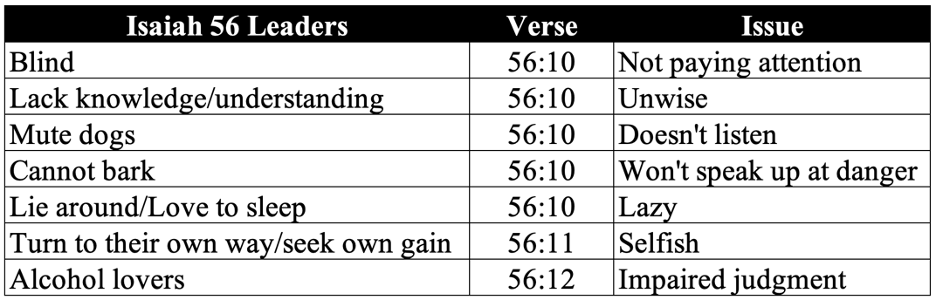

Our homework pointed out the duties of the watchman as outlined in Ezekiel 3:17-19. The watchman was supposed to be doing what? – Watching! What should he be watching for? Simplistically, efforts from the enemy to infiltrate not only the physical boundaries of the community, but also the spiritual boundaries. Ezekiel points out what these people should be doing when they encounter wickedness – they should be speaking out against it as an initial line of defense. One of the most effective weapons of warfare is the element of surprise – when your opponent is not aware of your coming attack. If the people you have in place to be watching for attacks will at least sound an alarm when recognizing trouble, then the surprise factor is reduced. This allows you to better prepare for a defense or counterattack.

From our above table, what were the watchman doing? They were not paying attention, they were not listening, and they were not speaking up. Ezekiel arrived at the same indictment of watchmen like these as Isaiah did in our reading – they will have selfishly served themselves as opposed to being courageous in pronouncing a moral standard.

In terms of church or spiritual leadership, we should be all the more attentive to the qualifications and character of those in leadership positions. Can you imagine the pastor of a church getting this kind of assessment from Jesus? As a pastor myself, I’m constantly concerned about what I’m offering to the people God has put before me. The Scriptures point out that teachers are going to be held to a higher level of accountability, and we should be. What questions should we be asking these people to help us determine whether or not they’re qualified to lead? For me, one of the first and most important questions is his commitment to the Word of God.

I just mentioned that when it comes to warfare, one of the more effective weapons is the element of surprise. Spiritually, though, I’ve found the tactics of our enemy, Satan, to be far more subtle – yet every bit, if not more, dangerous. His tactics were revealed in the Garden of Eden. What were these tactics? – He challenged the truthfulness and the voracity of God’s Word. Listen to his words to Eve in Genesis 3:1, “Has God indeed said, ‘You shall not eat of every tree of the garden’?” His first tactic is to question God’s Word. The next tactic is in verse 4 and 5, “You will not surely die. For God knows that in the day you eat of it your eyes will be opened, and you will be like God, knowing good and evil.” Here he goes from questioning God’s Word to not only denying it’s integrity but also providing an inaccurate assessment of God’s reasons for what He has commanded.

If a spiritual leader does not have a deep commitment to the study and teaching of God’s Word that provides foundational understanding of God and His character, he will be unarmed to be on the lookout for the subtleties of Satan’s tactics. Don’t kid yourselves loved ones, we are living in a time of fierce spiritual warfare – perhaps the most heightened time in history as we draw near to the end of the church age. The Apostle Paul in his letter to the Ephesians reminds us we need to be armed for this warfare, and our primary weapon is the sword of the Spirit – the Word of God.

Jesus is the head of the church, so He is the prototype of what a spiritual leader should look like. It’s His Word that directs us individually, so it only makes sense that it should be His Word that direct us corporately as a church body or Bible study like People of the Word. We just showed you the Lord’s assessment of the leaders in Isaiah’s day. Now let’s take a look at what happens when Jesus is leading.

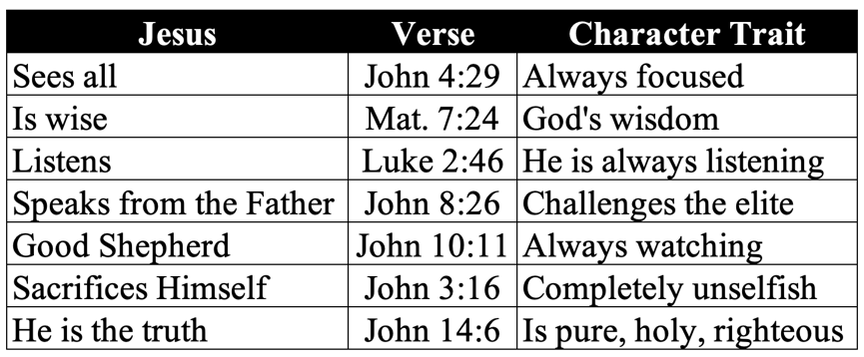

Let’s take one last look at these comparisons when putting them together:

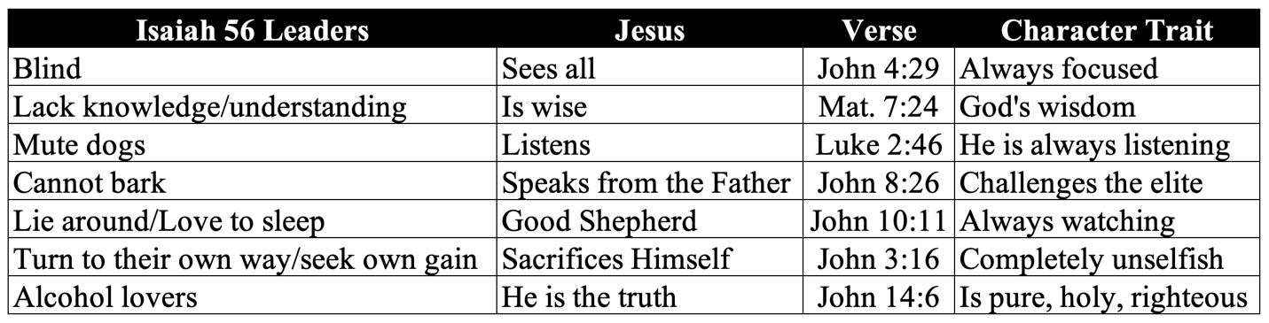

When looking at these two leadership types, which one is the one you want watching out for you? Even without the spiritual component, the answer should be straight-forward. Yet the spiritual component is the most important when choosing a leader. Jesus is the truth. Satan is a liar and a deceiver. What brings salvation – eternal safety? Faith. Faith is rooted in trusting. Who are we going to trust? The one that tells the truth, or the one that is a liar? The answer should be a simple one, but tragically, too many choose to believe the lies.

This leads us into the next issue God had in our reading which was with the idolators. From verse 3, Isaiah likens these people as “children of a sorceress, you offspring of adulterers and prostitutes!” He would go on in verse 8 and describe these people as violating their beds with worship of pagan symbols. Moses wrote under the leading of the Spirit in Exodus 34:14, “for you shall worship no other god, for the Lord, whose name is Jealous, is a jealous God.” God looks upon each of His creation – each of you – as objects of His passionate love. We were originally created by the Lord to have a deep, intimate, and personal relationship with the Lord.

Worship was designed by God to be an important expression of love and devotion for us to give to Him. The symbolism Isaiah is using in our reading is that of a spiritual adultery. Therefore, when we redirect our worship to man-made things like idols, God gets jealous. I’ve heard that Oprah Winfrey rejected believing in God for this very reason – she couldn’t handle the concept of God being jealous. I guess she’s never really been in love before. I’m not the Lord, but I do believe His jealousy is for not only His undying love for each of us, but also He’s coming from a place of recognizing both the folly of idol worship and the emptiness we are needlessly creating in our lives. Our Creator knows what is best for us, and the optimal and abundant life He designed us for includes worship to Him and Him alone.

Our reading points out an inevitable descending progression of idol worship. Beginning in verse 3, we learn of these idol worshipers mocking the righteous and the devout. Let’s think about the insanity of this mindset. Out of one side of their mouths, they’re sticking their tongues out in their sneering and mocking the worship of the true and living God. Out of the other side of their mouths, they’re worshipping worthless man-made objects that can neither hear nor receive their worship! Whenever I come upon such blatant stupidity, I’m so tempted to ask people, “Are you even listening to what you’re professing?”

From the mocking, the idolator steepens his/her descent into what should be the unthinkable - the sacrificing their children as a form of worship. Verse 9 mentions Molek – a Canaanite deity - primarily known for demanding child sacrifices by fire. Molek was around back in Moses’ days as he laid out commandments to the Nation of Israel to expressly not sacrifice children to Molek. Verse 9 provides the inevitable destination of idol worship, “you descended to the very realm of the dead.” This makes total sense as the wages of sin is death. An idol can never save anyone – it can only make someone feel better about their fleshly desires.

We’ve heard God’s thoughts on the leaders and the idolators, so the final target of Isaiah’s indictments is on the prideful and greedy. Verse 17 specifically pointed this out, “I was enraged by their sinful greed; I punished them, and hid my face in anger, yet they kept on in their willful ways.” Enraged is not a word you want to hear coming from the lips of God. As opposed to the movie character Gordon Gecko from Wall Street, God does not see greed as good. J. Paul Getty – one of the richest men in history was asked how much money would satisfy him, he replied, “Just a little more.” Greed is a fruit of the insatiable flesh. This is one of the great lies of living in the flesh and following its pursuits – there is no concept or possibility of achieving long-term satisfaction or contentment.

Greed and pride are typically linked as one’s greed for more puffs up one’s pride. C.S. Lewis aptly labeled pride the “Great Sin.” Pride began with Satan. He introduced the concept of pride to Eve with, once again, quoting Genesis 3:5, “For God knows that in the day you eat of it your eyes will be opened, and you will be like God, knowing good and evil.” This statement was designed to tempt her to make her aware of her ego – that she could be like God. That’s really what pride is at its barest bones – it is a misguided self-determination that you are in control – you can be your own god. Do any of you really feel like you’re in control with 100% of your lives?

God is no fan of pride – let’s look at just a few verses that make this abundantly clear. Notice how these verses not only point out God’s attitude towards pride, but also they also lay out its inevitable consequences.

- Psalm 10:2: “The wicked in his pride persecutes the poor; Let them be caught in the plots which they have devised.”
- Proverbs 16:18: “Pride goes before destruction, And a haughty spirit before a fall.”
- Proverbs 11:2a: “When pride comes, then comes shame.”
- Proverbs 13:10a: “By pride comes nothing but strife.”

In summary, we see that pride angers God; it causes us to persecute the poor; and it causes destruction, a fall, shame, and strife. Yet, for most of us – especially including me, we struggle with pride. I won’t speak for any of you, but offenses, mistreatment, and sins committed against me often inflame my pride. This comes from years of arrogance in my family’s history, so it’s a battle I will likely fighting for the rest of my life. I thank God daily for His patience and mercy with me as I wrestle with my stupid pride.

Ok – let’s move into a character-type to which God responds positively. Our memory verse reveals this person to be “the one who is contrite and lowly in spirit.” What does it mean to be contrite? “Feeling or showing sorrow and remorse for a sin or shortcoming.” For those of you who have had children or grandchildren, I’ve experienced that many of them go through a phase somewhere between 3-5 years old where they relentlessly ask the question “Why?” You’ll be telling them something factual, and they’ll respond “Why?” You attempt to provide an answer to that question, but they respond again with, “Why?” For me, this nerve-racking ping pong game eventually responds to the final question of “Why?” with “Because I said so!”

Yet there is much wisdom in the question, “Why?” I think we too often fall victim to taking things at face value. We aren’t curious as to why some things are the way they are. In this age of misinformation, questioning the relentless onslaught of information we’re bombarded with is good wisdom. God welcomes sincere questions, so I found myself asking what is it about the contrite and lowly in spirit that so appeals to God? Before I answer that, to arrive at the point of becoming contrite and lowly in spirit, I’ve come to believe there’s a process that everyone of us must go through. I don’t believe we are born with contrite and lowly spirits – I know I wasn’t. The first step in the process is recognizing there is such a thing as sin. Before I became a Christian, I had never heard of sin – I just figured that’s the way the world was. I knew people did bad things, but I had no plumb line to define what was good and what was evil.

The second step, which may seem too much like the first one, but it wasn’t for me. This step was recognizing I was wicked and sinful. As I noted earlier, I come from a very prideful and arrogant family – the notion that we were anything but totally awesome was poppycock. When I first heard about God and sin, I recognized that it made sense. However, it wasn’t until the weight and depth of my sin became personal, and I saw how it hurt those I loved, I finally recognized that I was wicked and sinful.

The third step in the process to arriving at a contrite spirit is to confess our wickedness and sin. John 1:9 promises that when we confess our sins, He is faithful and just and will forgive us our sins and purify us from all unrighteousness. That extension of forgiveness isn’t offered until we confess with our lips our sins.

The fourth step is to repent of our wickedness and sins. Confessing our sins is not enough, we must turn away from our sinful ways. That is evidence that we are serious about wanting to change our lives.

Now I’ll answer the question what is it about the contrite and lowly in spirit that so appeals to God? We just covered the big problem God has with us – our pride. When we arrive at the fourth step, our pride has taken a major and much needed blow. Our newfound self-awareness of our sinful state leaves us in a place of need for help. For me, the place to find that help is at the foot of the cross. I look up and see the kind of sacrificial leader I need. I see in the empty tomb that He is alive and able to help me – He is not some dumb idol. I see a God who had no pride - He humbled Himself to the point of death, which should have been mine. The place of a contrite and lowly in spirit is a place where, with our pride now crushed, belief and faith can take seed and grow. When we arrive at the place of a contrite spirit, we are rewarded great promises by God. In these verses, we learn God will not accuse us forever and will not always be angry with us. All of this leads to peace – His peace – the peace that passes all understanding. I don’t know about you, but I can use every bit of peace God has to offer. Amen?

The final component of our outline is what about the wicked? I hesitated on saying what I’m about to say because I don’t want you to think I believe there’s a conflict in God’s Word. There is not. I’m certain the conflict is with me. When we read the Psalms, the word “wicked” or a derivation of it is used 111 times in the NKJV. In many of these verses, we read of a deep desire for judgment and vengeance on the wicked. We read of phrases like:

- “God is angry with the wicked every day.” (Psalm 7:11)
- “The wicked shall be turned into hell.” (Psalm 9:17)
- “Let the wicked be ashamed; Let them be silent in the grave.” (Psalm 31:17)

Yet, what do we read about God’s heart towards the wicked in Ezekiel 33:11, “As I live,’ says the Lord God, ‘I have no pleasure in the death of the wicked, but that the wicked turn from his way and live. Turn, turn from your evil ways!” Are the Psalmist’s words and Ezekiel’s words in conflict? I don’t believe so because the Psalmist’s are true – they speak of the conduct of the wicked and inevitable fruit and eternal destination – absent of repentance. What does our reading reveal about the wicked in verses 57:20-21? “But the wicked are like the tossing sea, which cannot rest, whose waves cast up mire and mud. There is no peace,” says my God, “for the wicked.”

If someone is living a life absent of faith in Jesus Christ, then he/she is an enemy of God. Yet what do we hear from Jesus regarding our enemies? “You have heard that it was said, ‘You shall love your neighbor and hate your enemy.’ But I say to you, love your enemies, bless those who curse you, do good to those who hate you, and pray for those who spitefully use you and persecute you.” (Matthew 5:43-44) Isn’t this approach, in practicality, what Jesus did for all of His creation, including each of us, on the cross? Loved ones, I fully understand the negative emotions in response to all the wickedness that we’re surrounded with, but our Lord and Savior loves them as much as He does us. Our salvation wasn’t just for us – it was to become a testimony to those who don’t believe see that Jesus is real and loves them.

In summary, we’ve talked about God’s issues with:

- Leaders
- Idolators
- Proud & Greedy

We then covered what it means be contrite and lowly in spirit and why God gives favor to them. We concluded with the wicked, their lack of peace, and our role in revealing to them the truth of God’s love for them by how we love them.

For my conclusion, I felt led to think about what Jesus did during His 33 years of life – not just for me but for you and the rest of humanity – His greatest creative achievement. The first thing that came to my mind is Jesus made God more personal. Prior to His formal arrival on Earth 2026 years ago, God was no less God. The totality of His character, His power, His righteousness was complete. He does not change. However, when Jesus came on the scene as the Godman, He became more relatable. Our inability to comprehend a spirit God now was given the privilege to see it in human form. We saw His wisdom in His interactions with people. We saw Him stand up to the religious elite who had lost their way as His ambassadors. We saw Him display unparalleled caring, love, and miraculous power. All of these were Divinely inspired to make God more personal.

If He had stopped there, and this may sound weird, but that would have been cruel. If He had stopped there, making God more personal, He would be like dangling a carrot permanently just out of reach to a starving rabbit. The unattainableness of that carrot to the rabbit is a symbol, due to our unforgiven sin, of our inability to get to know this God whom we now have seen on a more personal level. Thankfully, Jesus didn’t stop at making God more personal. We just celebrated this last week that Jesus made the only way possible to have a personal relationship with this newfound personal God. Through His sacrifice on the cross, the temple – the place of God’s presence – the veil that was separating us from Him was torn from top to bottom by the Lord. Just as it started with Abraham, the door to God for everyone to enter into a relationship with Him going forward would be purely and solely by faith.

The third thing Jesus did for me and for each of you was amplify God’s powerful grace. As we have gone through the book of Isaiah this year, we have seen moments of God’s judgment on His chosen people – the Nation of Israel – the Jewish people. However, we have also seen displays of amazing grace to these stubborn and disobedient people. In the last lesson’s reading, we read about the glorious time in the Millennium when the Jews will be fully reconciled to God – completely due to God’s grace-driven desire to make this happen. The Apostle Paul reminds us we are receivers of the same heart’s desire of God – His grace - in his letter to the Ephesians. Verse 8 confirms this, “For by grace you have been saved through faith, and that not of yourselves; it is the gift of God.”

I don’t know about you, but I’m finding the reasons to praise God are increasing as I’m aging. Some of this is driven by the fact that there is more of my life in the rear-view mirror that I can now look back on and see God’s hands on my circumstances – especially in the painful ones. As I grow older, I’m confronted with the reality that my remaining days in this life are far fewer than the ones I’ve lived. This forces me to contemplate not only what am I to do with the time that I have left, but also to think about what happens when I breathe my last breath. With His resurrection, I have the hope that my last breath in this life will be immediately followed by my first breath in eternity coming face-to-face with my Savior. How can I not praise Him for what I have come to believe in is not just hope – but a certainty?

Loved ones, I encourage you to reflect on who Jesus is to you. He’s made God personal. He’s made a relationship with God possible. He’s shown us God’s grace is powerful enough to save us from our sins. If you’re a bad leader. If you’re an idolator. If you’re prideful and greedy. If you’re wicked. His heart for you is the same. He wants all of His creation to repent and turn to Him. We can play a role in this desire – we can reflect the love, grace, mercy, and forgiveness we have received and give it to those He brings into our lives. He gave us His Holy Spirit to empower us to do this. Your cross is sitting on the floor, loved ones. Will you pick it up and follow Him with it? Let’s stand and sing.

