“Babylon Will Fall”
Isaiah 13:1-14:23
Dan Leppo

The first verse of chapter 13 for today’s lesson tells us that we are reading a prophecy. A prophecy is a prediction of a future event. A fulfilled prophecy is one of the most powerful testimonies to not only God’s existence, but also to the truth of His Word and faithfulness to it. Because God is eternal, He sees the past, the present, and the future all at the same time. Therefore, if you believe in God, then believing in His prophetic words given to His chosen messengers should not be that difficult. President James Garfield once said about history, “It is the unrolled scroll of prophecy.”

Isaiah’s prophecy in today’s reading is regarding Babylon. This name is used in Scripture as a man-made world system that is built in defiance to God. As the
previous lecturers have noted, many prophecies have a two-fold fulfillment component. They can be either for something to take place in the near future or take place much further into the future – or both. Let’s start with the nearer-term fulfillment of what we learn in this lesson’s reading.

I said earlier that if you believe in God, then it shouldn’t be that difficult to believe His prophecies. Yet, regarding this particular one, the accuracy of its fulfillment is so stunning, some Bible critics can’t believe that all of it was written by Isaiah. This prophecy is believed to have been given sometime between 740 to 700 B.C. At this point in history, Assyria was the dominant world power - Babylon was under the control of Assyria. Babylon would not rise to become the dominant world power until 605 B.C. – this is over 100 years after this prophecy is written. Furthermore, the Medes, who during Isaiah’s time were virtually unknown, would be the eventual conquerors of Babylon (noted in chapter 13:17-19) – this would take place in 539 B.C. So, this prophecy is dealing with events as far in the future as maybe 200 years! As I said, because these events happened exactly as prophesied, critics cannot handle that Isaiah alone wrote this one – it must have been written by a later prophet. For my response to these unbelieving critics, I’ll channel Jack Nicholson in the movie A Few Good Men and say to them, “You can’t handle the truth!”

Now looking further into the future regarding this prophecy, there will be another Babylon rise in the time of the Great Tribulation. In Revelation chapter 17, God will judge the ecclesiastical, or religious, Babylon while in chapter 18, He will judge commercial Babylon. These judgments will be the final events before Jesus returns with us – His church - to complete the Great Tribulation judgment and usher in the Millenium. Ellen shared in last week’s lecture those 1,000 years will be a time of beautiful peace – even the wildest of animals will be at peace with each other and with us.

Regardless of which Babylon, God’s basis for judgment was the same - due to its Godlessness and sin. I will be honest with you, some of the graphic detail of the execution of God’s judgment via the Medes (noted in chapter 13:17 as the weapons of His wrath) is very difficult to read. This will be a total wipeout of this country. We read of the terror and anguish that will grip the people. They will writhe like a woman in labor. Verse 9 of chapter 13 describes this time as cruel. Some of the highlights, or lowlights, depending on your perspective will be:

- There will be much physical darkness. “The stars of heaven and their constellations will not show their light. The rising sun will be darkened, and the moon will not give its light.” (Isaiah 13:10) Joel would provide a similar prophecy in chapter 2, verse 10 of his book. Jesus quoted this verse in Matthew 24 when He was talking about the end times, so this is proof that this prophecy Isaiah is sharing is at least dealing with the Babylon that rises again in the Tribulation period.
- “Therefore, I will make the heavens tremble; and the earth will shake from its place at the wrath of the Lord Almighty, in the day of his burning anger.” (Isaiah 13:13)
- “Their bows will strike down the young men; they will have no mercy on infants, nor will they look with compassion on children.” (Isaiah 13:18)

I would imagine many of you were troubled by all these descriptions of God’s wrath and judgment – I know I was. The fate of the infants and children hit especially hard. A very fair question to come up with is, how can a loving and merciful God allow/initiate such brutality on little children? I’m going to share with you my personal belief when it comes to reading of God’s judgment on seemingly innocent children. I want to emphasize; this is just my belief. I’ve come to this conclusion based on my understanding of God’s character. Specifically, Psalm 7:11a tells us God is a righteous and just judge – that He is fair. Just look at the cross, what could be fairer to humanity than while we were still sinners, Christ died for us?

I believe prior to the age of accountability – that point where a child is cognizant enough of the concept of sin and its consequences - should that child die, he or she will go to heaven. I do not know what that age is – only God does. I cannot wrap my arms around the God that I believe in, who is just and fair, that He would send a child to hell if that child were not mature/old enough to realize his spiritual condition before a holy God. Now, what I’m about to say may leave some of you unsettled. Again, this is just my belief – it’s not coming from the Scriptures. Given the Godless environment these children were going to grow up in, they almost certainly would have rejected God at the age of accountability. At that point, they would be sentencing themselves to God’s judgment. Therefore, while their being killed as young children is an awful thing, from an eternal perspective, killing them before the age of accountability is an act of mercy. One more time, this is my personal belief.

The balance of Chapter 13 speaks to the judgment on Babylon, which our homework covered. The first half of chapter 14 offers hope for His chosen ones – the Nation of Israel. Verses 1 and 3 tell us, “The Lord will have compassion on Jacob; once again he will choose Israel and will settle them in their own land. Foreigners will join them and unite with the descendants of Jacob. The Lord gives you relief from your suffering and turmoil and from the harsh labor forced on you.” This is a picture of a fully reconciled Israel to God coming out of the Great Tribulation. God made His everlasting covenant with Abraham and the Nation of Israel, and He will keep it. This is why we must be steadfast in our support for Israel.

What we do here at the People of the Word is find the truth about God through the study of His Word. Jesus said in John 4:24 that God is spirit. Because He is spirit, we cannot see Him. However, the Apostle Paul states that we can see Him through what He creates in Romans 1:20, “For since the creation of the world His invisible attributes are clearly seen, being understood by the things that are made.” In other words, the invisible spirit God makes Himself visible through His tangible creation.

For example, the chairs each of you are sitting in were created pieces of furniture. One or more persons had to come up with the design, produce the components of the chair, and then assemble it. The chair is the proof of the evidence of the designer/ manufacturer. I don’t think anyone – even non-believers - could conjure up the hutzpah that the chair they were sitting in, over thousands or millions of years via a countless series of random fortuitous events came together in that exact condition on its own. If you can’t get there with something as simple as a chair, how in the world can you think this is how a far more complicated human being came to be? Yet, this is the essence of the theory of evolution. Personally, I think it takes far more faith to believe in evolution than it does to believe in a Creator God.

If God is spirit, then not only is He living in our physical or tangible world, but we are also forced to consider the reality that there is another world that we cannot see that lies beyond us – the spirit world. While we cannot see this world, the evidence of its existence is unmistakable. Have you ever been just minding your own business when some random – and maybe evil - thought just pops into your mind – it just came out of nowhere? Then, do you find yourself thinking, “Where did that come from?” I believe this is the influence of the spirit world. There are a few important truths we need to know about the spirit world.

- It is an active battlefield of good versus evil.
- We human beings are the bounty, or loot, for possession for both sides.
- God is in complete control of the spirit world.

Amidst this ongoing spiritual battle of good versus evil, while we may be the bounty of this warfare, God gives us the choice to pick a side. There is no third option in the spirit world. You’re either going to side with the good, or you’re going to side with the evil. The Lord created us with the power of choice. I believe the primary reason for giving us the power to choose is because He knows when it comes to a love-based relationship, which is what He designed each and every one of us to have with Him, the depth of such a relationship goes far deeper when each party chooses to love each other. The focus of spiritual war is our ultimate decision on which side to choose. Should we choose the good side via faith in Jesus Christ, we become bigger targets of our enemy. Now here’s the sinister part of the evil side…even if you choose to reject Jesus, you are still a target of destruction of the enemy. We will prove that through today’s reading and supplemental reading Carol mentions in the homework.

For those of us who confess Jesus as their Lord and Savior, we have made the decision for goodness. We not only have made the choice for goodness, but we have also made the choice to join the good team. Being a Christian is not, as the prosperity doctrine promotes, a life of rubbing the proverbial magic lamp and having God grant you endless wishes of success because of your faith choice. The true Christian life is one of joining a team of fellow believers to take action, via loving God and loving others, in sharing the good news to a world that has either not heard the news or has not personally experienced it. In other words, we become engaged on the battlefield for the good team in the spirit realm.

In a book written over 2,500 years ago, the ancient Chinese military strategist Sun Tzu in his classic work, The Art of War, said, “Know your enemy and know yourself, and you will not be imperiled in a hundred battles.” This strategy remains relevant to this very day – both in the physical and the spirit worlds. I believe Isaiah provides in our reading, along with supplemental verses noted in the homework, an important presentation of our true enemy, Satan. This is a critical point for the believer. Many, if not most of us, have throughout our lives come across people who have done evil things to us. The decision to conclude that these people are our enemy because of their bad treatment of us is completely understandable. However, the truth is they are not our enemy. The origin of their evil actions was, or is, Satan tempting them to do these things. Yes, they have made the choice to come into agreement with Satan’s tempting, but there is a strong likelihood their temptations came through deception.

Further emphasizing this point of who are true enemy is, Jesus said in John 3:16, “For God so loved the world…” There are no exceptions following that glorious proclamation. He didn’t say after this opening, “except your enemies or people who have done evil things to you.” Finally, if people were our enemy, why would Jesus, in His great commission in Matthew 28 challenge us to, “Go, therefore, and make disciples of all the nations.” Again, no exceptions. Loved ones, people are not our enemy, Satan and his demonic forces are our true enemy.

From today’s lesson, we read of the Lord’s anger with the king of Babylon, and from chapter 28 of Ezekiel, His anger is directed towards the prince of Tyre. Most of the Bible scholars I follow have concluded these two unnamed individuals are manifestations of Satan, or the Devil. As I just noted, our reading and the supplemental verses provided in the homework give us important insights to Satan. Therefore, my objective for this component of this lecture is to help each of us to “know our enemy.” Why we should do this in defending ourselves against attack is it helps us understand who he is and his tactics. Learning these things is part of what the Apostle Paul implored us to do in Ephesians 6:11, “Put on the whole armor of God, that you may be able to stand against the wiles of the devil.” In our presentation on Satan, we’re going to focus on:

- What was he like in his original design?
- What caused his fall?
- What are his tactics and intentions?
- What is his fate?

We’ll find that the second and third bullet points combined are really a true assessment of his character. Let’ start with Satan’s origin. We learned in Genesis 3:1 that the serpent – by most Bible scholar accounts – is Satan slithering around in the Garden of Eden, and he was created by God. This is a huge point as the creator is always greater than the creation. However, what we learn in our reading as well as in Ezekiel may come as a surprise compared the visual images Hollywood has cooked up. Some of Satan’s descriptives in his original design before his fall are:

- “You were the seal of perfection, full of wisdom and perfect in beauty.” (Ezekiel 28:12)
- “The workmanship of your timbrels and pipes was prepared for you on the day you were created.” Again, note the point that he was created. (Ezekiel 28:13)
- “You were the anointed cherub who covers; I established you; you were on the holy mountain of God.” (Ezekiel 28:14) Many Bible scholars believe Satan, or Lucifer in his original design, was an archangel – the highest order of angels – similar to the rank of Michael and Gabriel.
- “He had great wisdom and understanding.” (Ezekiel 28:4)

Doesn’t sound like the horned red dude with a pitchfork, does it? From Isaiah 14:16-17, the sight of Satan will shock many, “Is this the man who shook the earth and made kingdoms tremble, the man who made the world a wilderness, who overthrew its cities and would not let his captives go home?” It’s quite possible Satan may be one of the most beautiful beings God ever created.

Yet amidst all this wonderous original design, he had the same choice that every other angel and human creation must make - choose to obey God or disobey Him. Our reading provides us what led to his decision to disobey Him. Satan basically fell in love with how he was created as opposed to falling in love with Who created him.

From verses 13 & 14 of chapter 14, we hear Satan saying in his heart (notice the focus on himself via the “I” statements), “I will ascend to the heavens; I will raise my throne above the stars of God; I will sit enthroned on the mount of assembly, on the utmost heights of Mount Zaphon. I will ascend above the tops of the clouds; I will make myself like the Most High.” Did you notice within these five “I” statements him acknowledging his position before God? Three of the five use the word “ascend” and “raise.” He is implying the truth that God is above him with these words. The ultimate statement of pride is he will make himself like the Most High.

Ezekiel also points out Satan’s pride issues in that his “heart was lifted up” – meaning full of pride because of his God-given wisdom, understanding, beauty, and wealth. C.S. Lewis wisely calls pride the “great sin.” As noted in the homework, Proverbs 16:18 makes it clear what the perils are for the prideful person, “Pride goes before destruction, and a haughty spirit before a fall.” In addition to the verses in the homework, the Bible is extremely clear regarding how God views pride and haughtiness:

- 2 Samuel 22:28: “You will save the humble people; But Your eyes are on the haughty, that You may bring them down.”
- Psalm 101:5b: “The one who has a haughty look and a proud heart, Him I will not endure.”
- Jeremiah 50:31: “Behold, I am against you, O most haughty one!” says the Lord God of hosts; “For your day has come, the time that I will punish you.”

Now we’ll take a look at some of Satan’s tactics and intentions as a result of his prideful rejection of God. Starting with Jesus is always a good thing, so the Lord said about Satan in John 8:44, “He was a murderer from the beginning, and does not stand in the truth, because there is no truth in him. When he speaks a lie, he speaks from his own resources, for he is a liar and the father of it.” The Apostle Peter said in his first epistle, “Your adversary the devil walks about like a roaring lion, seeking whom he may devour.” (1 Peter 5:8) Satan is a liar, a murderer, and seeks to devour. Our reading describes the king of Babylon as someone who has destroyed and killed his people in chapter 14, verse 20. Revelation 12:9 confirms that Satan leads the whole world astray.

We’ve learned of Satan’s surprising creation, what led to his fall, and his tactics and intents. God is holy and just, so He must judge unholiness and injustice. When he fell in heaven, he was cast down from heaven to Earth according to Isaiah 14:12. I’ve often wondered how different things might be if God had cast Satan down on some other place like Pluto or Neptune. Chapter 20 of Revelation reveals Satan’s fate. An angel will come down out of heaven (I believe this will be Jesus Himself), seize him, bind him, and throw him into the Abyss. He will be locked away for 1,000 years unable to deceive the nations for this period – this is known as the Millenium, which will immediately follow the conclusion of the Great Tribulation. For reasons only God knows, at the end of the Millenium, Satan will be set free for a “short time.” He will then, finally, be thrown into the lake of burning sulfur, where the beast and the false prophet had been thrown. They will be tormented day and night for ever and ever.” Hallelujah.

Earlier, we said that, from a spiritual world perspective, that there are only two sides to choose – good and evil. We’ve presented the character of the leader of the evil side – Satan. Now I want to present the character of the leader of the good side – Jesus, or God. It’s been said that the Bible is a love letter from God to humanity. Even though He is an infinite Being, out of His mercy, grace, and love for His creation – meaning each of us, He reveals His character to us in His Word. He asks us to trust Him, but trust can only truly be found when you come to know someone. In my opinion, the greatest single demonstration to the totality of God’s character is found at the cross.

When I was in school, there was something called “Crib notes.” These were summarized and scaled-down notes to, allegedly, help quickly learn about a book or a topic. These morphed into books with titles of the topic followed by “…for Dummies.” Today, we have AI, which is turning our youth into dummies. I hesitate to equate the cross to a type of Crib’s notes, but I do believe the picture at the top of the next page is a powerful image that condenses and sums up the character of God.

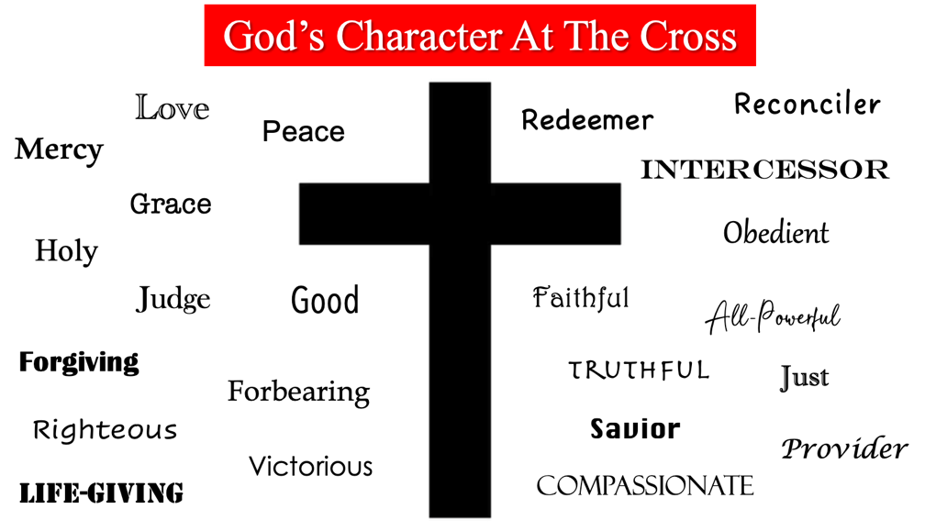

I see His love, mercy, grace, holiness, goodness, judgment, forbearance, forgiveness, righteousness, redemption, reconcilement, intercession, compassion, obedience, faithfulness, truthfulness, salvation, justness, provision, power, peacemaking, victoriousness, and life-giving – all at the cross. This may seem like a lot, but I can assure you this list is not exhaustive. My challenge to each of you is to see what else you learn and know about God at the cross and add it to this list.

Now that we have seen the character presentations of the leaders of good vs. evil in the spirit world, each person God creates has a side they must choose. To not choose is to choose evil. The choice for the good side – the choice for Jesus, demands a step of faith. You do not inherit faith from your parents, siblings, or spouses. Faith in Jesus is deeply personal – it is a commitment of both the heart and the mind. I know most, if not all of you, have made this choice – God bless you. Perhaps you can use this presentation to help you speak to those you know who have not yet made the commitment to Christ. Let’s look at a little more to help expose the truth of the two sides:

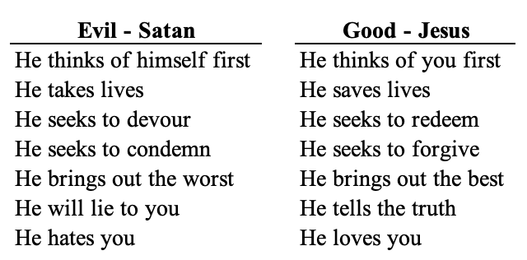

Verse 27 of chapter 14 is one of the more powerful verses you will find in the Scriptures, “For the Lord Almighty has purposed, and who can thwart him? His hand is stretched out, and who can turn it back?” No one, not even Satan, can stop God from what He has sovereignly purposed – His will and plan. Hebrews 10:31 offers this warning, “It is a dreadful thing to fall into the hands of the living God.” Isaiah tells us in our reading that this will be the fate of the Babylonians. For today’s world, this is also the fate of all the people we know who have yet to make the choice for the good side – the choice for Jesus. The key point is they still have a choice. They can continue to deny God and then dreadfully fall into the hands of the living God; or they can receive the truths from His Word that we’ve laid out here and choose to fall into the nail-pierced hands of the resurrected God – Jesus Christ.

We earlier mentioned the following truths about the spirit world:

- It is an active battlefield of good versus evil.
- We human beings are the bounty, or loot, for possession for both sides.
- God is in complete control of the spirit world.

There’s one more truth I want to add. There will be an end to this battle in the spirit world, and, spoiler alert, God wins! The good side will be victorious. The choice to choose good vs. evil is a choice of the heart. The heart is the symbol of love. God made His choice clear regarding His love for you on the cross. Our job now is to not only tell this truth to those in our lives who haven’t yet made the choice for Jesus but also show them what His love looks like in how we love them. There’s work to do loved ones. The question for each of us is will we do it? Let’s stand and sing the Doxology.

