Lesson 12 – Woes & Blessings
Isaiah 28:1-29:24
By Dan Leppo

I hope you all had a Happy Thanksgiving, and your tryptophan hangovers are things of the past. I also hope you have enjoyed today’s Christmas party as a lot of effort has gone into making this last meeting of the year special. None of today – and everything else about People of the Word, would be possible without your generous and sacrificial giving. This spirit of giving is one of the foundational pillars of this Bible study. We’re not here to take anything from you. We’re to give whatever God gives to us back to you in hopes you will receive the deep truth of His love for each of you and then take it out to share with others.

Beginning with today’s lesson in Chapter 28, we enter six woes – concluding with the sixth being a prophecy of the Battle of Armageddon in chapter 34. The first of these sixth woes starts with verse 1 of chapter 28, and it is on Ephraim, or the Northern Kingdom of Israel. As a reminder, when the previously united Nation of Israel split in two after King Solomon’s passing, of the ten tribes that joined together to form the Northern Kingdom, the tribe of Ephraim was the greatest in both numbers and in power. This is why the two names of the Northern Kingdom and Ephriam are used interchangeably. History tells us Shalmaneser, king Assyria was about to invade and take Ephraim into captivity around 721B.C. Not only was this prophecy for Ephraim, but it also was a “heads up” to Judah – the Southern Kingdom. Judah was on the same path of disobedience to God – just not quite as far down it as Ephraim. God is showing mercy to Judah by giving them a sneak preview of their fate if they continue down the path of disobedience.

Ephriam’s capital was Samaria, and today it is a beautiful, lush area southeast of the Sea of Galilee. The below map provides you some perspective on where Samaria lies within the combined Kingdoms of Israel.

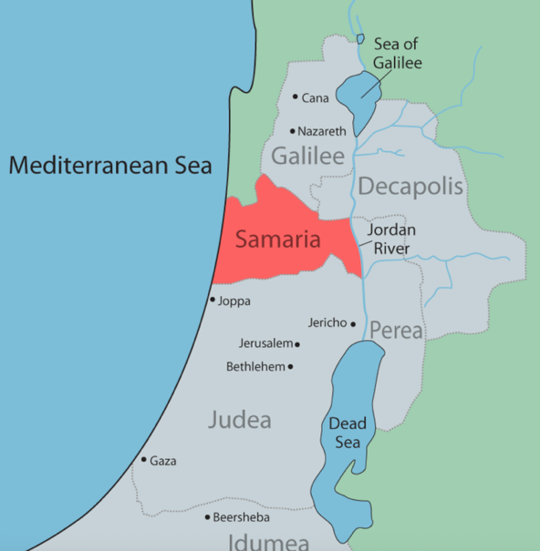

Ephraim was completely pagan – no interest in God whatsoever. Notably, in the very first verse of today’s reading, we learn one of Ephraim’s chief vises that got them to the depths of where they were was drunkenness. The topic of alcohol within the Christian faith is often heavily debated. There is not one verse that says it is a sin to drink wine, beer, or any other type of alcohol. Jesus’ first recorded miracle was turning water into wine! The pro-alcohol side of the church constantly reminds us of these Biblical truths. However, the Bible cannot be clearer regarding the issue of drunkenness. Here are a just a few straightforward verses from the Lord regarding His thoughts on drunkenness:

- Ephesians 5:18a: “Do not get drunk with wine, for that is debauchery.”
- Romans 13:13: “Let us walk properly, as in the day, not in revelry and drunkenness, or in lewdness and lust, not in strife and envy.”
- Proverbs 20:1: “Wine is a mocker and beer a brawler; whoever is led astray by them is not wise.”

Verse 7 tells us what the primary issue is with drunkenness, “they stagger when seeing visions, they stumble when rendering decisions.” Being drunk impairs our judgment. When I look back on my days of drinking, what memories I still have are ones of bad hangovers and stupid decisions. I realize that my words on the issue of alcohol might be stepping on some toes. Again, the Bible is clear that drinking alcohol is not a sin – if it is done in moderation. The problem that arises is knowing where that line is between moderation and drunkenness? Given alcohol impairs our judgement, determining that line, by definition, becomes more difficult. Look, I get it, the occasional glass of wine or beer can take the edge off. The Apostle Paul, though, offers a far better alternative in Ephesians 5:18b, “…but be filled with the Spirit.” That’s Spirit – not spirits.

As all of us lecturers have shared with you, Isaiah’s prophecies often contain both near-term and long-term warnings. Verses 1-4 deal with the nearer term with the as previously mentioned soon-to-be invasion of Assyria on Ephraim. In verses 5-6, we step into the future, “In that day the Lord Almighty will be a glorious crown, a beautiful wreath for the remnant of his people. He will be a spirit of justice to the one who sits in judgment, a source of strength to those who turn back the battle at the gate.” Wherever you read the phrase “in that day,” the Scriptures are referring to the Day of the Lord. This is speaking to the time beginning with the Great Tribulation and going through the 1,000-year period following Christ’s return known as the Millennium. We read in verse 5 of that day when Jesus will, finally, be rightfully looked upon by all people as the King of Kings and Lord of Lords. I know a lot of Christians get excited about the crown, or crowns, they’re going to be rewarded for their service. For me, the only crown I care about is the one Jesus is going to wear. If He’s wearing His crown, life will be as it should – completely under His rule and reign.

Another cause of Ephraim’s downfall was their pride. Their pride is revealed in their mocking of Isaiah and rejecting God’s word in verses 9-13. I like how Warren Wiersbe links the sin of drunkenness and pride, “People are so intoxicated by intellectual pride that they laugh at the simple message of the gospel presented by humble witnesses.” In the case of Ephraim, we read in verse 10 the mocking of God’s word as described in the NIV, “Do this, do that, a rule for this, a rule for that; a little here, a little there.” I prefer the NKJV, “For precept must be upon precept, precept upon precept, line upon line, line upon line, here a little, there a little.” We’re going to get to the concept of foundation building in a little bit, but the teaching and learning of God’s Word is a slow and methodical process.
Much of today’s society – especially the younger generations - has the attention span of gnat, and this is a real concern of mine when it comes to teaching the Bible. People want short-cuts to virtually everything today – that’s the essence of technology – doing everything faster. The challenge is God is infinite, and we are finite. By that truth alone, trying to comprehend the complexities of communicating the character of an infinite Being into the mind of a finite being is a doable but daunting effort. This is why it takes time – teaching foundational precepts, or truths, of God to which a person can build a healthy and honest knowledge of and relationship with his/her Creator.

This is a good segue verse 16, “So this is what the Sovereign Lord says: “See, I lay a stone in Zion, a tested stone, a precious cornerstone for a sure foundation; the one who relies on it will never be stricken with panic.” This verse is quoted many times in the New Testament including Matthew, Mark, Luke, Acts, Romans, 1 Corinthians, and Ephesians. This prophecy is an extension of the prophecy in Psalm 118:22, which says, “The stone which the builders rejected has become the chief cornerstone.” The cornerstone that all these Scriptures are speaking to is, of course, the Messiah, Jesus Christ. King David said, regarding the Messiah, in his Psalm 62, “He only is my rock and my salvation; He is my defense; I shall not be moved. In God is my salvation and my glory; the rock of my strength, and my refuge, is in God.” (vs. 6-7)

My question to each of you is what do you see as the foundation of your life? Is it truly Jesus? Or is it your financial strength, your intellect, your legacy, your appearance, or something/someone else? As I wrote each of these alternatives, they all have one thing in common – they can change. You can lose your money in the wrong investments; you can lose your intellect to dementia; your legacy can be re-written by revisionist historians, and your appearance?? When I look in the mirror these days, I have no idea who that old man is looking back at me! Is that really what you want in a foundation – something that can change? What do the Scriptures say about God in terms of change?

- Hebrews 13:8: “Jesus Christ is the same yesterday, today, and forever.”
- Malachi 3:6a: “For I am the Lord, I do not change;”

By God not being one to change, we can rely on His immutable faithfulness. Deuteronomy 7:9 beautifully proclaims, “Therefore know that the Lord your God, He is God, the faithful God who keeps covenant and mercy for a thousand generations with those who love Him and keep His commandments;” Loved ones, each and every one of us is going to face tough times – symbolically, these times take on images of the occasional storms that will come your way. Unless you choose, and it is a choice, to make Jesus Christ the cornerstone of your life’s foundation, your ability to survive and get through these storms will be seriously hindered.

Before we leave verse 16, I want to talk about the portion of the verse that says, “the one who relies on it will never be stricken with panic.” I looked up the definition of panic on Mirram-Webster.com, and its definition is telling, “of, relating to, or resembling a mental or emotional state (such as fear) that is extreme, sudden, and often groundless.” The last word of this definition, groundless, is fascinating. That means there is no basis for the panic. Getting back to verse 16, the promise to the one who relies on the cornerstone – the one who relies on Jesus, is he/she will never be stricken with panic.
If we’re honest with ourselves, most of us are operating with at least a little fear. Maybe some of us don’t want to call it fear. So, I’ll assume all of us are at times concerned about someone or something. While you might not be at the point of panic, the underlying mindset or heart-set of being fearful or concerned about something or someone is the lack of fully trusting in Jesus as our life’s foundation. With verse 16, God provides us the promised fruit of reaching the point of a fearless faith.

For each of our places of residences – whether they be an apartment, condo, or home, we can easily take for granted the foundation to which they are built upon. These places of residences have roofs, floors, walls, windows, furnishings, and fixtures. These are the parts of our residences that we see and, hopefully, enjoy each day. Yet, if some great storm like a hurricane, tornado, or earthquake should happen, all these components of the house could be destroyed. A foundation, though, is underneath – it’s what we cannot see. If the foundation is built right, it will withstand any storm and can be built upon again.

Try to picture our day-to-day activities – our lives as our physical residences. When the storms of life hit, and they always do - things like the death of a spouse, child, or parent; the loss of a job; or a terminal illness diagnosis, our visible/physical world – our proverbial residences can be badly damaged. However, depending on what, or who, we have built our residences of life on, this will determine our ability to survive the pain and suffering of these storms. If your day-to-day lives can be visualized as a residence, then the foundation to which our residence lies upon is likened to what we believe to be true – or our faith. As I said earlier, we can’t see the foundation to our residences, but we know it’s there. Notably, Hebrews 11:1 tells us about our foundations – our faith that it is the evidence not seen.

I had some fun looking through the Bible to build my personal foundation of faith, and I wanted to share that with you. Regarding the below, the left column mentions God’s character trait, and the column to the right provides the Scripture, or Scriptures, that support the trait. I came up with a 5-layered foundation.

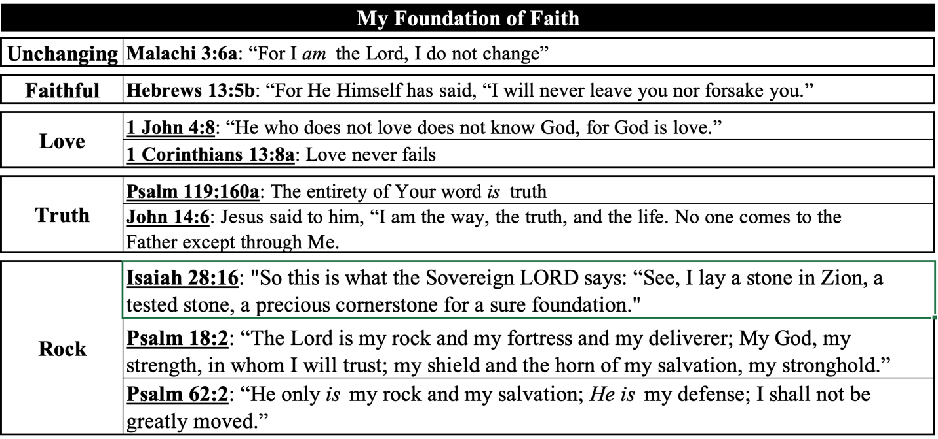
This is my stab at describing the foundation of my faith. I want to encourage each of you to do the same. It was a helpful exercise for me. I trust He will richly reward you if you do the same.

For the second time in verse 18, Isaiah mentions “a covenant of death.” The covenant he is referring to is during King Ahaz’s reign; the people made a treaty with Assyria. In the days of King Hezekiah, they would turn to Egypt for their defense. Both moves failed because neither of them involved God. Have you ever been in a bind when you were so gripped by fear or pain and suffering you sought out options for relief or help beyond God? I’ll be honest and raise my hand. This phrase “covenant of death” is profound. If you’re not in covenant with God, then you are knowingly or unknowingly in covenant with Satan. Satan is the instigator of all sin, and the wages of sin is death. We, who have chosen to place our faith in Jesus Christ, have made a covenant of new life with the God of the living. What a better covenant! The covenant we have offers a living and true hope.

Isaiah’s words throughout verses 21-29 of chapter 28 appear to be a response to the misguided mindset of the people of Ephriam (and most of the people from Judah, as well) that they were relying on God’s past deliverances in the face of a coming Assyrian invasion. This confidence they have in God being their Deliverer was right – but they got only one-half of the equation correct. The God of the Bible indeed delights in being everything to those who believe in Him. However, what brings Him the greatest joy is when those who believe in Him seek an interactive relationship with Him. Our original design was to be in an unfettered constant and intimate communing connection with Him. The primary objective of sending His Son to be the sacrifice for yours and my sins was to, from top to bottom, tear the thick veil that separated us from Him due to our sin. This glorious act of devotional and atoning love made a way for us to be restored to our original design – to be in fellowship with our Creator.

The misguidance of the Ephraimites – and, sadly, even many Christians today is they don’t understand, or worse, don’t care about their role in a relationship with God. If, as we just said, enter the new covenant God offers each one of His creations, the implied agreement is that it is a two-way deal. Isn’t that what a relationship is supposed to be? Satan is no doubt behind this deception that faith in God is like having our own personal genie. We come to think we’re so loveable because of our faith that how can God not grant us everything we desire? I won’t speak for any of you, but when I attempt to present myself before a holy God on my own merits, the only desire I have is for Him to give me grace and mercy. Loved ones, faith in God is not a religion – it’s a relationship. He designed us to have this with Him, so it should become the highest goal of each believer to pursue this gift He offers to all.

Another way to describe the Ephraimites mindset regarding their misguided confidence of God delivering them despite their absence of any personal accountability to Him is to call out the scourge for entitlement. In other words, regardless of their behavior, God owed His delivering ways to them. This spirit of entitlement has infiltrated the American society so deeply I’m not sure we can recover from it. Worse, it has seeped into the church and disguised it as the prosperity doctrine. What lies below this tidal wave of entitlement-mindedness is the lie that because we’re Americans or because we’re Christians, we’re above God’s judgment. We’ve gone from a country and a faith that understands what we have is out of the grace of God, to a people who think what we have is because God owes us the blessings He’s given us. There is nothing in Scripture that supports such a mindset. More importantly, Job 41:11 specifically rejects the notion that God owes anyone anything, “Who has preceded Me, that I should pay him? Everything under heaven is Mine.”

Moving into chapter 29, we read about the second Woe – this one is to Ariel. Question 13 of the homework notes that Ariel is another name for Jerusalem. Ariel means “lion-like.” The word can also mean “the lion of God.” Notably, the lion is the insignia of the tribe of Judah. Jesus is called the Lion of the tribe of Judah in Revelation 5:5. This woe, or prophecy, is another one of those dual-type pronouncements. The short-term prophecy would be fulfilled upon the arrival of Nebuchadnezzar and the Babylonians when they take Judah into captivity. The longer-term prophecy will be fulfilled at the end of the Great Tribulation. Jesus will return, with us, and wipe out all the enemies of Jerusalem – saving His people from extermination. As opposed to His humble arrival in a manger that we’ll be celebrating later this month, there will be nothing humble about Christ’s second coming. He will be clothed in majesty, and everyone – believer and non-believer – will have no doubt it’s Jesus.

As I kept reading through chapter 29, I found multiple descriptions of:

- The experience of God for the ones who oppose the Lord.
- The experience of God for the ones who trust in the Lord.

As for those who choose to oppose the Lord, they will experience:

- When a hungry person dreams of eating but awakens hungry still. (verse 8)
- When a thirsty person dreams of drinking but awakens faint and thirsty still. (verse 8)
- The wisdom of the wise will perish; the intelligence of the intelligent will vanish. (verse 14)
- Woe to those who go to great depths to hide their plans from the Lord, who do their work in darkness and think, “Who sees us? Who will know? (verse 15)
- Shall what is formed say to the one who formed it, “You did not make me”? Can the pot say to the potter, “You know nothing”? (verse 16)

As I look upon these descriptions of those who oppose the Lord, I see lives that are unfulfilling, shrouded in shaming secrecy, and wrapped in pride.

Now let’s look at what we learn about those that trust in the Lord.

- In that day the deaf will hear the words of the scroll, and out of gloom and darkness the eyes of the blind will see. (verse 18)
- Once more the humble will rejoice in the Lord; the needy will rejoice in the Holy One of Israel. (verse 19)

In reading these verses, I see those who choose to trust in the Lord will be given the hope of deliverance from, at least, spiritual deafness and blindness. We also see hope promised for the humble and the needy. They will be able to rejoice in the Lord. We as believers today can do this as the Apostle Paul exhorts us in Romans 5:11, “And not only that, but we also rejoice in God through our Lord Jesus Christ, through whom we have now received the reconciliation.” When was the last time you rejoiced in the Lord? Regardless of your circumstances, you just lifted your hands and voice and praised God for His love, goodness, and provision. I encourage you to do this. He’s certainly worthy of our rejoicing. Rejoicing in the Lord is soul soothing.

The last three verses of Chapter 29 speak to the descendants of Jacob at the time of Jesus’ second return. We see beautiful descriptions of what life will be for all who believe heading into Christ’s millennial reign:

- No longer will Jacob be ashamed; no longer will their faces grow pale. (verse 22)
- When they see among them their children, the work of my hands, they will keep my name holy; they will acknowledge the holiness of the Holy One of Jacob and will stand in awe of the God of Israel. (verse 23)
- Those who are wayward in spirit will gain understanding; those who complain will accept instruction.” (verse 24)

I want to conclude by going back to chapter 28, verse 29 that presents us with a glorious promise, “All this also comes from the Lord Almighty, whose plan is wonderful, whose wisdom is magnificent.” The “this” Isaiah refers to is God’s attention to detail for the farmer to properly plant, harvest, and prepare for food. Seeds in the Bible are symbols of God’s Word. With this truth, if we re-word verse 29, we get, “All of God’s Word comes from the Lord Almighty, whose plan is wonderful, whose wisdom is magnificent.” I want to both affirm and encourage each of you to remember that the efforts you are making in this Bible study will produce a growing trust in God’s wonderful plan for you, and you will receive His magnificent wisdom.

We are a little more than 1/3 through this year’s session, and I can completely understand how one could grow weary of all the pronouncements of woes and judgments. Thankfully, God, in His grace, continuously sprinkles in amidst these pronouncements’ reminders of His desire for His children to repent as well as the rewards to those who do. We need to hold onto nuggets like verse 29 when it feels like pronouncements of woes are upon us. Amid our pain and suffering, it can feel like God isn’t there. God had been silent for 400 years after the book of Malachi. Yet when He finally spoke again, His first new message was what we’re celebrating at this time of year – the birth of the promised hope in the form of a baby in the manger – God’s only begotten Son, Jesus.

Whether it’s due to the retail industry or Hollywood and all their Christmas movies, the romance of this season isn’t in things. The true meaning of this season is Jesus. I’m not saying that being with family and sharing gifts isn’t a good thing. However, the world that I see is one that is either desperately striving to find something hopeful to hold onto or has arrived at the point that hope is as much a fantasy as the sugary-sweet Christmas movies. No better gift we can give to any person we know – relative, friend, neighbor or even stranger – is the message that the baby in the manger is God’s offer to receive and experience the love each person was designed to have. We can do this through witnessing to them with Bible verses, but without spiritual discernment through the Holy Spirit, many people will not feel the weight of their truthful impact. What people will understand and feel, is if we sincerely offer to them the sacrificial love God gave and continues to give to us. This is His amazing grace. How about we become that sweet sound to those He brings into our lives this Christmas season? Amen? Let’s stand and sing.

