“You Must Be Born Again”
John 2:1-3:21
Dan Leppo

What a blessing it is to see you all here! I hope you have enjoyed your Summer, and I look forward to joining and sharing with you the Apostle John’s amazing Gospel and three epistles. Last week, Maggie opened this year’s session with a wonderful lecture covering chapter one where we are introduced to:

- Jesus as both God and the Lamb of God – the latter defining His earthly redemptive mission.
- John the Baptist as the fulfilment of the prophesied prophet of the voice crying in the wilderness and ushering in the Messiah.
- Several of the disciples of Christ including Nathanael who probably lost the possibility of getting a job with the Nazareth Chamber of Commerce.

As we step into Chapter 2 and part of Chapter 3, we’re treated to:

- Jesus’ first documented miracle.
- His act of “cleaning house.”
- A conversation He has with one of the Jewish religious leaders that unveils a few of the foundational New Testament doctrinal truths.

Our reading kicks off at a wedding in Cana. Per the below map, Cana is a quick Uber, if Jesus had the app, from His hometown - Nazareth. You can also see to the east the Sea of Galilee where Jesus will spend much of His ministry.

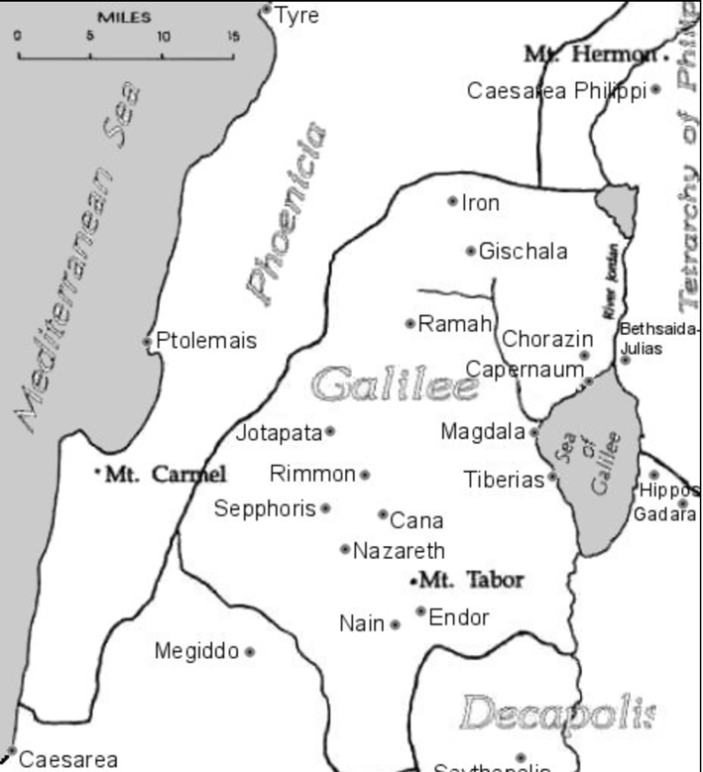

In Jesus’ day, Jewish weddings lasted for one week, so verse one tells us this was the 3rd of seven days. His mother, Mary was there, and He and His disciples were invited guests – likely because of Mary’s connection. It’s interesting there’s no mention of Joseph here, which is one of the reasons Bible scholars assume Joseph had died by the time of Jesus’ ministry.

Mary was informed there was no more wine, and it was of concern to her. Some commentaries indicate that her concern may have indicated Mary was a hostess at the wedding. Hostesses were typically aunts of the groom, so this wedding could possibly be for John the Baptist, who was Mary’s nephew. This is fun speculation, but that’s all it is. Mary told Jesus they were out of wine, and Jesus’ response seems a little rough to His mother, “Woman, why do you involve me?” Jesus replied. “My hour has not yet come.” The Hebrew word for “woman” is “gune.” It is a term of respect but not affection. Mary had likely lived a life of shame and behind-the-back judgmental comments given the circumstances of her giving birth to Jesus. As I noted earlier, she was also quite possibly a widow at this point. A fair reaction to this chilly response from a son to His mother is, ‘Where’s the love?’

The second half of Jesus’ response was probably the reason, “My hour has not yet come.” This phrase is used seven times in John’s gospel. What hour is Jesus speaking of? In His prayer in John 17:1, He said, “Father, the hour has come. Glorify your Son, that your Son may glorify you.” Jon Courson describes this “hour” as “the time of irrefutable declaration of who He was, of the undeniable proof of His deity. It is when His earthly ministry would be finished. His appointed mission completed; His Father fully glorified.” Ultimately, this “hour” would Him being crucified as the Lamb of God as the sacrifice for our sins.

Try to look at Mary’s approaching Jesus as a supplication, or a request, in prayer. She knew who He was, and she was experiencing a difficult situation at the wedding. She wisely sought His help, yet His chilly response appeared to be a “no.” Her reaction to His rebuke demonstrated her humility and understanding of the nature of a relationship with Jesus. She turned to her servants and said, “Do whatever He tells you.” Isn’t this a sort of ‘not my will, but Thy will be done’ statement?’ She was no doubt unhappy, or at the very least disappointed in His response, but she submitted to Him trusting that He would do what is best and glorifies God. Oh, how we all need to learn this. God is not an order taker. Out of His grace and permissive will, though, He provides for us. However, if the answer to our request is a “no” or “not now,” then we need to be at peace with the Lord’s decision and trust the words in Jeremiah 29:11: “For I know the plans I have for you,” declares the Lord, “plans to prosper you and not to harm you, plans to give you hope and a future.”

So, now we get to the first miracle. What’s the first thing Jesus did? He got His servants involved. Did He need the help? No, but He chose to get people – willing servants - involved in His work. So it goes, as His servants, for us to this very day. Their obedience to get six 20-30-gallon stone pots and fill them with water allowed them to be participants in the miracle. He told one of the servants to draw some of what is in one of the pots and take it to the master. The master noted that the wine Jesus provided was better than the first wine, which was usually the best of the wines served.

This miracle has been corrupted by pro-drinking Christians that if Jesus is going to make wine, then He must be ok with us drinking it. Before I get into my comment of this position, I want to make it clear that there is nothing in Scripture that says it is a sin to drink alcohol. However, the Bible is extremely clear about drunkenness. Ephesians 5:18, “Do not get drunk on wine, which leads to debauchery. Instead, be filled with the Spirit.” By the way, “Spirit” is not a plural word, folks. Spirit – not spirits. I know I’m probably stepping on some toes right now as it is likely many of you drink alcohol. Again, if you’re not getting drunk, there is nothing unbiblical about the occasional beer, wine, or cocktail. However, Vickie and I have had extensive first-hand witnessing of the carnage of alcoholism in both of our families, so my comments are not without practical foundation.

For those who take this miraculous work of the Lord to rationalize their desire to drink alcohol, then I invoke them to not stop there in following Christ. If they’re going to use this work of the Lord as the impetus on how they want to lead a component of their lives, then they should do all the other things He tells us to do; pick up our cross daily and follow Him; love God and others; live a life of sacrifice to self. You can’t pick and choose the directives when following Jesus. If you do that, you are like the lukewarm water Jesus spoke of to the Laodiceans in third chapter of Revelation. What did he do with lukewarm water? – He vomited it out. Interesting that drunkenness can often lead to vomiting. I’ll let that comparative visual settle in your minds and move on.

Jesus and His posse headed to Jerusalem for it was Passover. He arrived at the temple and found those who sold oxen and sheep and doves as well as the money changers doing business in the court of the Gentiles. This court was the outermost court of the temple grounds where oxen, sheep, and doves were sold. These animals were “pre-approved” as acceptable sacrifices for the purpose of forgiveness. The animals the people would bring would be rejected as acceptable for the most trivial reasons to force people to pay for the “acceptable” animals. Not surprisingly, the prices for the pre-approved animals were very high. Who were the beneficiaries of these high prices? The greedy Jewish religious leaders.

The moneychangers were no less guilty – foreigners would bring their own currency to pay the temple tax. The moneychangers would reject the foreign currency as acceptable, so they would exchange the foreign currency at a deep discount for shekels. Later, of course, the moneychangers would make money at selling the foreign currency they purchased at a discount for market prices.

In seeing this, Jesus showed for the first time in Scripture demonstrative anger, “When He had made a whip of cords, He drove them all out of the temple, with the sheep and the oxen, and poured out the changers’ money and overturned the tables. And He said to those who sold doves, “Take these things away! Do not make My Father’s house a house of merchandise!” (John 2:15-16) What can we take from this controlled outburst from our Lord?

- It took time to fashion the cords into a whip, so this was no impetuous action.
- The Lord takes very serious and will not allow what is evil in His holy place. If God did not show His righteous indignation to sin, then He would be invalidating the perfection of His holiness.
- As our Good Shepherd, He has no patience for false religious practices that place people’s souls in jeopardy.

I want to focus on Jesus’ line, “Take these things away!” What was Jesus doing in this scene? He was cleaning house. This is an image of our sanctification process as believers. Jesus, via the Holy Spirit, wants to take away all those things that are stealing from the truth of God’s love and care for us. What He’s physically doing in the court of the Gentiles is what He’s doing, spiritually, in the lives of us believers. We are commanded to “be holy, for I am holy.” We cannot be formed into the image of Jesus unless we are committed to allowing the Lord to take away what is evil and not good for us.

In verses 18-21, the religious leaders, clearly not in their happy place with Jesus’ actions, confronted Him with what I think was an odd question, “What sign do You show to us, since You do these things?” I can understand questions like, ‘What’s Your problem, dude?’ Or, ‘Where do you get off messing with our stuff?’ My belief is the religious leaders were taken not only by the physical actions of Jesus, but also by the line “My Father’s house.” Perhaps by hearing “My Father” they understood this could be a sign that Jesus was claiming to be the Messiah. Jesus’ response to their sign question was, “Destroy this temple, and in three days I will raise it up.”

This statement was the first in the book of John where the Lord distinguishes between the physical realm and the spiritual realm. Notably, the alleged religious leaders did not get the true message of Jesus’ words – they were only thinking the physical world. While Jesus had to physically come to the world to be the sacrifice for our sins, His primary mission was to introduce the Kingdom of God, which is a spiritual Kingdom. It’s taken me longer than I would like to admit developing an understanding of the truth of the spirit world. The time I’ve spent studying the cross and what happened there has helped me tremendously in this pursuit. It introduced the ability for me to consider the “bigger purpose” concept amid something that doesn’t make any sense. Why does a perfect and holy man willingly subject Himself to betrayal, torture, and murder? Unless He’s insane, which His wisdom and love clearly demonstrate He’s not, then the only other conclusion I can come up with is there must have been a bigger plan, or purpose, at the cross.

That has helped me in the painful challenges my family and I have faced. My earthly, or fleshly side sees nothing but hurting or random afflictions. However, if I venture into the Kingdom of God where God is good, is love, and is in control, then I start to look at things from an eternal perspective. This is how I’ve come to the point that I believe this life that we lead following Jesus is really a spiritual “boot camp” in preparation for our eternal life. I won’t lie to you, the painful circumstances are no less painful, but now I try to look at them and ask the Lord, “What are you trying to teach me in this affliction?”

The final three verses of chapter two describe the omniscience of God – the omniscience of Jesus. We’re told that many believe in His name when they saw the signs He did. If we are given the privilege to see a sign from God – a clear demonstration of Divine power, they are no doubt cool and awesome. Signs can evoke great emotion and awe, but this runs the risk of becoming a fleshly appeal. What’s the one thing the flesh wants? – More. If the flesh doesn’t get what it wants, it dismisses the value of the sign. This is why we read in verses 24 and 25, “But Jesus did not commit Himself to them, because He knew all men, and had no need that anyone should testify of man, for He knew what was in man.” A deeper dive into this verse is 1 Samuel 16:7, “But the Lord said to Samuel, “Do not look at his appearance or at his physical stature, because I have refused him. For the Lord does not see as man sees; for man looks at the outward appearance, but the Lord looks at the heart.” We may be able to fool ourselves, but God is never fooled. He sees right through our facades and examines ground zero of our sin nature – our hearts.

Moving into chapter three, we’re introduced to a man named Nicodemus. He was a ruler of the Jews, which meant he was a member of the Sanhedrin – the top council of religious leaders. Jesus had his biggest issues with these men. Therefore, it is notable that Jesus would grant an audience with this man. We need to remember this when we’re not feeling very worthy of approaching God. Whether our feelings are based on lies we’re believing, or we’ve sinned, we live in the grace of God who gladly accepts us as we are for the purpose of forgiving, restoring, and redirecting. Nicodemus came in the night which stirs up all kinds of speculation that is just that – speculation – as to the reason(s) for the time of day for the visit. The point we need to stay focused on is Jesus agreed to meet with him.

Nicodemus opened the conversation with a statement of praise, “Rabbi, we know that You are a teacher come from God; for no one can do these signs that You do unless God is with him.” My guess is by this statement, Jesus senses Nicodemus’ desire to meet with Him is sincere in its purpose – to learn, not to trip Him up or entrap Him. Jesus’ response to this praise is fascinating to me. Nicodemus did not ask a question, but Jesus’ statement in verse three feels like the answer to a question, “Most assuredly, I say to you, unless one is born again, he cannot see the kingdom of God.” I love this about Jesus – He doesn’t mince words – He cuts to the chase. He introduced the truth of the Kingdom of God.

We, as believers with the indwelling of the Holy Spirit, know that the Kingdom of God is a spiritual Kingdom. Nicodemus’ response, only able to comprehend the fleshly world, was understandable, “How can a man be born when he is old? Can he enter a second time into his mother’s womb and be born?” Jesus replied, “Most assuredly, I say to you, unless one is born of water and the Spirit, he cannot enter the kingdom of God. That which is born of the flesh is flesh, and that which is born of the Spirit is spirit.” (vs. 5-6). This statement is the first of many foundational Net Testament truths revealed by Jesus in John’s gospel. With the Bible, whenever there is a first mention of something, scholars attach greater significance to what is being said. I’ve spent a lot of time thinking and praying over this concept of needing to be born again. One thing that has become clear to me is that if we need to be born again, then we must be dead. If we were not dead, why would we need to be born again?

Just as Nicodemus needed to learn, so do we need to understand Jesus is speaking of the spiritual realm regarding being born again. Romans 6:23 tells us that the wages of sin is death. The death being spoken of is a spiritual death. To get a grip on this, we need to go back to God’s original design for the human being. I like pictures, so I’ve prepared my visual interpretation of what Jesus was trying to communicate to Nicodemus. The first visual is that of our original design – the triune Godhead connecting to the three-component (Body, Soul, Spirit) human at the spirit level:

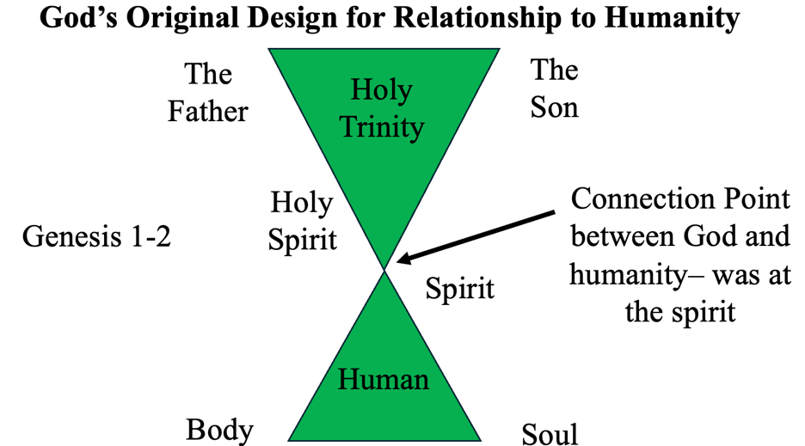
When Adam sinned, as God promised, he did surely die – his spirit died. This death of the spirit terminated our ability to have a peaceful and unobstructed relationship with God – please see the below diagram.

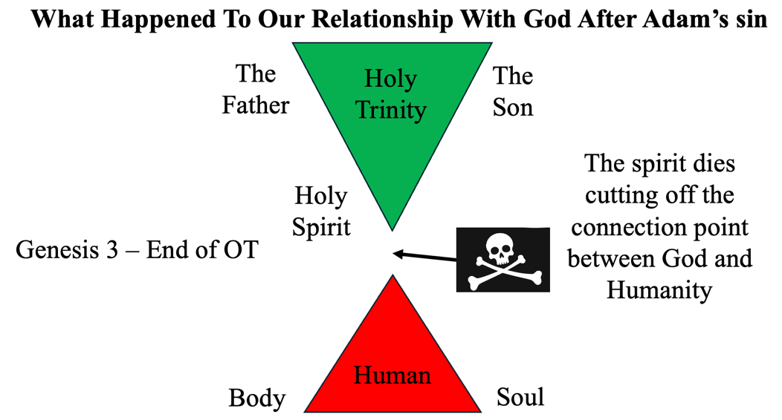

The above diagram provides the current spiritual state of every nonbeliever. Now you can see that the only way to reconnect to God in the spirit is for the spirit to be born again. This happens through faith in Jesus’ finished work at the cross and resurrection. Please see the below diagram:
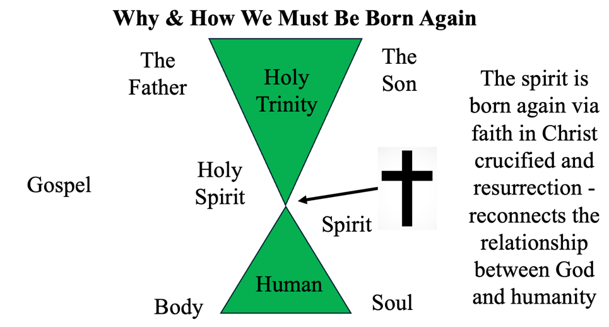
Jesus provided Nicodemus the definition of being born again, “unless one is born of water and the Spirit, he cannot enter the kingdom of God.” He appears to be speaking of two components of being born again – one of water and one of the Spirit. Some people have related the water component of either being the physical birth in the water of a mother’s womb, or a water baptism. I disagree with both. Water is referred, or equated, in John 15:3 and Ephesians 5:26 to the Word of God. In my opinion, Jesus is saying to be born again, you must first hear the truth of God’s word, which is revealed to us by the Holy Spirit. If you don’t know you have a problem, how can you solve what you don’t know? To be born again in Christ – whom we learned in John 1:1 is the Word of God, you need to hear the truth of His Word that:

- You are a sinner and separated from God.
- He loves you despite your sin and wants to reconnect you with God through faith in His saving work at the cross.

To be born of the Spirit is a supernatural birth whose inception is faith. This life-giving act from Christ is affirmed through the giving us of the Holy Spirit to confirm our salvation and lead us down the life-long path of sanctification – making us holy into the image of Jesus and preparing us for eternity fully reconciled to God. Amen?

Nicodemus still wasn’t getting it. Jesus gently rebuked him acknowledging his role as a teacher but not knowing these things. He goes on to tell him that if He won’t understand the earthly things Jesus had been teaching, how would he believe in heavenly things? This is why people who are not believers don’t get the Christian faith – they don’t have their spirits reborn to understand spiritual things. In verse 13, Jesus says something curious to me, “No one has ascended to heaven but He who came down from heaven, that is, the Son of Man who is in heaven.” If He ascended to heaven before He came down from heaven, then He must have been here before. This, in my opinion, speaks to what are known as Theophanies or Christophanies – bodily or physical appearances of Jesus in the Old Testament. Examples may be His interactions with Abraham, Jacob, Moses, and Daniel – the latter in the fiery furnace.

He then began the final approach to the most famous verse in Scripture. He reached Nicodemus at his earthly level – recounting Jewish history he no doubt knew regarding the story of the lifting up the serpent in the wilderness. From Numbers 21, we learned that the people were grumbling about their apparent lack of provision and circumstances. The LORD sent fiery serpents among the people – biting them with many of them dying. Out of His mercy and love for the people, God instructed Moses to make a bronze image of a serpent, put it on a pole, lift it up for everyone in the camp to see it, and those who looked upon the serpent, would live. A notable thing to remember is bronze is a symbol of judgment.

Jesus mentioned this scene as a foreshadowing of what He would personally be doing by going to the cross. We now arrive at John 3:16, and I would like us all to stand and say this together. “For God so loved the world that He gave His only begotten Son, that whoever believes in Him should not perish but have everlasting life.” Please don’t sit back down as I want us also to recite John 3:17, “For God did not send His Son into the world to condemn the world, but that the world through Him might be saved.” You can sit down. I could spend an entire lecture – or several on just these two verses. However, time does not permit this, so I’m going to highlight some key words/points in these two verses:

- The Greek word for love in John 3:16 is agapao, which is where we get agape. It is a different and far greater love than we humans know – it can only come from God. It is sacrificial, it is deeper than we can imagine, and it is unconditional.
- I don’t see any exceptions in God’s expression of His love, do you? He says He loved the world. That’s everyone, brothers and sisters. To exclude anyone from that based on race, gender, or anything else is a lie from the bowels of hell. The enemy has, tragically, successfully pigeon-holed Christianity into a non-inclusive religion. What can be more inclusive than God loving all the world?
- Through faith alone – not of man-made, ever-shifting works of alleged goodness – we are promised eternal life with God.
- Jesus did not come into the world, at this point of time, to condemn it – He came to save it. Again, the Christian faith has been wrongfully accused of a faith of judgment. Yes, there is judgment for sin – that is a clear truth. But that is only half the story. The full truth is the One who judges sin is also the One who makes forgiveness of sin available to, again, everyone who chooses to believe.
- Jesus is the only Savior. It’s not your husband or wife. It’s not a pastor. It’s not Oprah. It’s not Trump or Kamala. True salvation – permanent forgiveness of sin and eternal reconciliation with God is only available through faith in the finished work of Jesus Christ.

Jesus then pronounced the judgment of unbelief to Nicodemus. Condemnation is not an act of God’s will – it is the inevitable fruit of unbelief. Jesus emphasized this clear truth that light came into the world – meaning Himself (we’ll learn in future chapters He is the Light of the World). He went on to say that despite this Light’s arrival, men loved darkness rather than light. Why? Because light exposes the darkness and the evil that goes on in the dark.

In summary, we’ve seen in this lesson Jesus showing grace to:
- His mother and the wedding guests by performing a miracle before His hour had yet come.
- Nicodemus – a religious leader who demonstrated his lack of understanding of both earthly and spiritual things. Yet, He still spoke to and taught him.
- Every person, including you and me, God’s proven love for us and the promise of eternal life at peace with God through faith alone in Him and His finished work at Calvary.

I’m so thankful for God’s grace – it is truly overwhelming when you sit and think about how undeserving we are of it, and, yet He keeps blessing us. Some of you, though, may not be feeling His grace because of your circumstances. Please try to remember that these circumstances, while no doubt painful, are neither the complete picture nor the end of the story. We learned in today’s lesson there is a spiritual realm to which we, as believers, are citizens of the Kingdom of God given to us by Him by His grace. We must hold onto the great promise of Romans 8:18, “For I consider that the sufferings of this present time are not worthy to be compared with the glory which shall be revealed in us.” This glory that will be revealed to us is the Kingdom of God we will enter upon our last breath. Until then, let us be like Jesus’ mother Mary at the wedding. She’s not happy with her Son’s response to her circumstances, but she submits to Him and, effectively, says not my will, but His be done. That’s a place of trust. After what we just read today, I think Jesus has earned our trust. Don’t you? Let’s pray.

