Lesson 29 - Walking in the Way (Obedience)
Psalms 81, 101, 128; Proverbs 13, 31
Dan Leppo

One of the goofy trends in modern society is its lame attempt to clean up its act by allegedly replacing objectionable words, such as curse words or derogatory words, with inserting only the first letter of the bad word and then adding “word” after it. It’s such a farce because even though you say the first letter and then “word” after it, everyone knows what you’re saying. Even kids know this! Here’s a novel thought – how about we just don’t say either the word or the stupid attempt to mask it???
A growing segment of society has included the key word in today’s lesson title to the list of objectionable words that warrant a first-letter-only utterance – the “O” word, or obedience. I thought about why this is the case, and we came up with three reasons. I’m sure there are more, but I like the number three, and I have a hard time counting higher than that. Because of this growing movement to avoid using the word obedience, there must be a covert, or overt, campaign to promote its opposite – disobedience. Whether it’s just my gender or it’s the way God designed me, I like problem solving. I’ve found the most effective way to deal with a problem is get to the root cause of it. If we’re talking Biblical disobedience, then we need to go back to the first display of disobedience, which was in the Garden of Eden. When I read this accounting, guess what I found? The three reasons I came up with regarding why obedience is so unpopular in today’s world, so I figured I must be onto something.
It should come as no surprise as to who the central character is behind introducing the thought of disobedience – our old nemesis, Satan. The word obedience implies there is something to obey. If there is something to obey, then there must have been, at some point, an authority figure or entity that established rules or laws to be followed. With this in mind, we find the first of the three reasons for rejecting obedience in Genesis 3:1. Satan is introducing the concept of distrusting God’s authority in His directive to not eat from the tree of knowledge of good and evil, “Has God indeed said, ‘You shall not eat of every tree of the garden’?”

The second and third reasons for not obeying are:

- By obeying the rules, my rights to do things my own way are being violated
- I can come up with a better way to live than by the way I’m being asked to obey.

Listen to Satan’s words in Genesis 3:4-5: “You will not surely die. For God knows that in the day you eat of it your eyes will be opened, and you will be like God, knowing good and evil.” I hope you can see in Satan’s words his deceiving attempts to say, in effect, “God’s ways are not fair – you have a right to be like him and be your own person. By eating from the tree, there’s a better way to live than God’s ways.”
What was Satan’s biggest issue that got him and 1/3 of the angels kicked out of heaven? – Pride. Let’s again look at the three reasons for disobedience:

- Don’t trust the authority figure’s judgment to deliver reasonable and/or fair rules or laws
- By obeying the rules, my “rights” and freedom are being violated, and I won’t submit myself to anyone.
- By obeying the rules, I’m rejecting my ability/wisdom to come up with a better way

Do you see the common underlying theme behind these three reasons for not obeying God’s Word? It’s the same thing that drives Satan – pride. In one form or the other, pride is almost always the root cause of disobedience. What does Scripture promise to the prideful? Proverbs 16:18 tells us, “Pride goes before destruction, and a haughty spirit before a fall.” If pride brings destruction, and pride drives disobedience, then disobedience and destruction are indivisibly linked. While these two things are indivisibly linked, we’re going to learn there’s another and more powerful inseparable pairing as we get into today’s reading. Speaking of this lesson’s Scriptures, I’m going to attempt to break it out to answer four questions:

- What is obedience?
- What are the fruits of obedience?
- What are the consequences of disobedience?
- What is the value of an obedient woman?

So, what is obedience? Webster’s online dictionary offers this, “submissive to the restraint or command of authority: willing to obey.” This is a great definition because it hits the key words when it comes to being obedient: submissive, command, authority, willing. However, if we change the order to these words, I see a logical and methodical progression to them. An authority issues a command, and those subjected to that authority must choose to willingly submit to the command. In this progression, what is the first step? - The authority. To willingly choose to submit to a command, the first step is to acknowledge the authority that is giving the command. If you don’t know or disrespect the relevant authority, your prideful sin nature, as we noted earlier, will dismiss the command and will likely disobey.
Since God is the ultimate authority, we must consider His character if we are to choose to live a life of obeying His commands. The Bible is a revelation of God’s character. This is why Bible study is so essential in the Christian’s life. We cannot come to know God and His qualifications to be the authority in our lives without learning about Him through His Word. This is why we He gave us the Bible. He designed us, so He knows that what we need first and foremost in our lives is Him. Through His word, as revealed in Scripture, and His Word being His Son, Jesus, we are given a mountain of evidence of the worthiness, faithfulness, and patience of God as our Authority. What more evidence can you want from an Authority than the One who set the example of obedience by going to the cross and then became the ultimate proof of the fruit of being obedient through His resurrection?
Getting back to our progression of obedience, now that we’ve established the trustworthiness of God as our Authority, the next step is to choose whether or not we’re going to consider being obedient. Let’s make something very clear – obedience and disobedience are acts of the will – they are choices. In Psalm 101, David speaks of obedient choices in two forms: 1) to be obedient to do things; and, 2) to be obedient to not do things. When it comes to be obedient to do things, he uses phrases such as:

- I will sing of your love and justice (vs. 1)
- I will be careful to lead a blameless life (vs. 2)
- I will conduct the affairs of my house with a blameless heart. (vs. 2)
- My eyes will be on the faithful in the land (vs. 6)

Regarding obedience to not do things, he says:

- I will not look with approval on anything that is vile. I hate what faithless people do; I will have no part in it. (vs. 3)
- The perverse of heart shall be far from me; I will have nothing to do with what is evil. (vs. 4)
- No one who practices deceit will dwell in my house; no one who speaks falsely will stand in my presence. (vs. 7)

All of these are statements of commitment – of choices.

Once we make the choice to obey God as our Authority, then the next step is to develop a mindset of humility – a true submission to not only the wisdom of what we’re being asked to obey, but also the submission to God through the Holy Spirit to give us the strength to continue to obey. How many of us have made commitments to go on diets, yet only after a few days, a few weeks, or if you’re like me, which I hope you’re not, a few hours, we find ourselves waffling on the choice to stick to the obedience of a diet? One of the countless reasons I love God is how often He lays things out so clearly in terms of cause and effect. Psalm 81:13-14 is a perfect example: “If my people would only listen to me, if Israel would only follow my ways, how quickly I would subdue their enemies and turn my hand against their foes!” The Apostle Paul spoke about the dynamic of owning our weaknesses and the wisdom of submitting to God in those weaknesses in 2 Corinthians 12. He spoke of Jesus telling him, “My grace is sufficient for you, for My strength is made perfect in weakness.” Paul would take from that assurance from Jesus and logically conclude, “For when I am weak, then I am strong.”
Submitting to God is the smartest thing we can do because it is an acknowledgment that God’s ways and powers are far greater than ours. Think about it this way, God is giving us one or more commands, and those commands are rooted in His goodness and kindness towards us. He knows these commands are in our best interest, so how amazing is it that He gives us the Holy Spirit to help us in our obedience? God will respond to obedience – that is something you can absolutely count on. However, how and/or when He responds will quite possibly not be in the way or in the timing we’re expecting. When we don’t see the fruit of our obedience in our timing or the way we’re expecting it to look like, then we get discouraged and start to ask things like, ‘What’s the use of being obedient? I’m getting nowhere, and people who are not being obedient are getting their socks blessed off.’ This is why we need the Holy Spirit to keep us strong in our obedience.
The truth is there is fruit, or results, from God through our obedience. Psalm128:1 lays it out pretty plainly, “Blessed are all who fear the Lord, who walk in obedience to him.” Proverbs 13 provides a laundry list of the promised fruit of being obedient. Let’s take a look at this list:
Wisdom
- Where there is strife, there is pride, but wisdom is found in those who take advice. (v. 10)
- Walk with the wise and become wise, for a companion of fools suffers harm. (v. 20)

Righteousness
- Righteousness guards the person of integrity, but wickedness overthrows the sinner. (v. 5)
- The light of the righteous shines brightly, but the lamp of the wicked is snuffed out. (v. 9)

Satisfaction
- Hope deferred makes the heart sick, but a longing fulfilled is a tree of life. (v. 12)
- The righteous eat to their hearts’ content, but the stomach of the wicked goes hungry. (vs. 25)

Rewards
- Whoever scorns instruction will pay for it, but whoever respects a command is rewarded. (vs. 13)
- Trouble pursues the sinner, but the righteous are rewarded with good things. (vs. 21)

There are many other promises of fruit from obedience including humility (vs. 7), consistency (vs. 11), healing (vs. 17), honor (vs. 18), and generosity (vs. 23).
To this point we’ve covered what is obedience and the promised fruits of obedience. Again, God is so good because not only does He provide us the promised fruits of obedience, but also, He tells us what the consequences are of disobedience. What more can we ask of God? He gives us both sides of the coin of obedience, yet we still in our stubbornness are shocked at the consequences of disobedience when they show up. We already heard some of the consequences of disobedience in the fruit of obedience verses, but there are more in our reading. One of the more chilling ones is from Psalm 81:11-12, “But my people would not listen to me; Israel would not submit to me. So I gave them over to their stubborn hearts to follow their own devices.” This is not the only time God tells us that He has His limits with us. Romans 1:28: “And even as they did not like to retain God in their knowledge, God gave them over to a debased mind, to do those things which are not fitting;”
I know the issue of God having His limits with us is a reason many people reject God. They simply can’t handle that God will one day close the door on salvation – despite the repeated denials and blatant sin. Furthermore, how do we reconcile this truth of God having His limits with 2 Peter 3:9: “The Lord is not slack concerning His promise, as some count slackness, but is longsuffering toward us, not willing that any should perish but that all should come to repentance.”? I believe the answer is the unavoidable dynamic of free will. The Lord’s will is that everyone repents and turns to Him for salvation. There is no doubt about that – this is what 2 Peter 3:9 is proclaiming. Let’s repeat something we said earlier, obedience and disobedience are acts of the will – they are choices. God has made His choice clear about what He wants for each of us.
However, He has given us the gift of free will. In my opinion, He did this to maximize the potential of a loving relationship between Him and each of us. While I understand that arranged marriages are commonplace in some cultures, the true beauty and wonder of love is found when two people choose to love each other. Again, God has made His choice about His intentions towards us – He proved that on the cross. Therefore, it’s 100% on us as to whether we’re going to choose Him. I’m so very thankful God showed me the grace and patience to put up with my denials of Him for the first 35 years of my life. I do believe, though, that had I not chosen Him, I would have reached a point in my life where God would have honored my repeated choices to deny Him and closed the door on the possibility of my redemption. I think I’ve shared with you before that sin is a slap in the face to God. God can take a lot more slaps in the face that any of us can, but even He at some point will say that’s enough. The ultimate consequence of disobedience is permanent separation from God.
Before we go on to the next point, we need to make something clear to those of you caught up in the snare of thorns that is legalism. I come from the school of once saved, always saved. I’ve always loved my wife Vickie’s description of the metamorphosis of a caterpillar becoming a butterfly. Once it becomes a butterfly, it can’t go back to being a caterpillar. Therefore, from this perspective, even when those of us who call on Jesus as our Lord and Savior sin, and we all will, we are not surrendering our salvation. I recently heard a good distinction between spontaneous sin and habitual sin. As a believer, we’re going to stumble in moments of spontaneity and sin. We need to own and confess these spontaneous sins, but we should never be shackled in shame and condemnation because of them. All of that junk that Satan throws at us was dealt with at the Cross of Christ.
The habitual sin – the sin we consciously choose to continue to engage in – is more problematic. It is very easy for us self-righteous and holier-than-thou Christians to slam down the judgment gavel on these people who habitually sin. We come to the conclusion that because of their ongoing sin, they never were really saved. Through constantly reading the Bible and a lot of therapy, I realized I get myself in the biggest trouble when I start playing God and judging people. The truth is we don’t know where that person is in terms of a relationship with God. We may not see the fruit, but we can’t see the entire future. That is why it is not our job to judge – it is our job to be obedient and love these people.
Because we cover so much Scripture in these lessons, we lecturers have to seek the Holy Spirit to guide us to what sections He wants us to teach. We cannot cover every verse in 30 minutes. For me, this is a tough task because there’s always so much rich and meaningful content in God’s Word. For this lesson’s reading, I’m going to be transparent and tell you when I read through the chapters, there was one section I was thinking of skipping. However, there was so much content, I felt the conviction to cover it. That section is found Proverbs 31 – the value of an obedient wife. As I started facing the reality of needing to cover this section, I thought to myself, ‘What more fun could this be than a man standing up in front of a bunch of women telling them how important it is they be obedient to their husbands?’ I could already feel the laser beams coming in twos from the eyes of every woman in the room. This ought to go over like a porcupine in a balloon factory.
I’m going to first provide you the clearly presented fruit of an obedient wife from this lesson’s reading, but then I’m going to give you a couple of real-life examples. From the reading, we learn the obedient wife:

- She is worth far more than rubies. (Prov. 31:10b)
- She brings him [her husband] good, not harm, all the days of her life. (Prov. 31:12)
- She is clothed with strength and dignity (Prov. 31:25a)
- She speaks with wisdom, and faithful instruction is on her tongue. (Prov. 31:26)

The first real-life example of the fruit of an obedient wife is from an experience I had in my days as a banker. My largest customer was acquiring a company, and he wanted me to play golf with the owner of the company they were acquiring. Never missing a chance to play a game of golf for free, I took him up on the offer. When I met this man, he was one of the most vile and disgusting people I ever met. He told the most awful and raunchy “jokes” that were anything but funny. That was a long and painful four hours of golf. About 12-24 months after that encounter, I learned that this man had died. What was significant about this was that his services were going to be held at Calvary Chapel in Costa Mesa, and Chuck Smith would be presiding over the services. I couldn’t think of two more polar opposites than this man and Pastor Chuck, so I went to the services to see how this was possible. I learned that this man’s wife was a Christian, and she had been praying for his salvation for almost 20 years. Six months before he died, he gave his life to the Lord.
The second example of the fruit of an obedient wife is far more personal. I’m talking about my wife, Vickie. I was not a Christian when we got married, but she was. However, she took me to listen to Pastor Chuck, and she showed me what true love and forgiveness looks like. I can tell you without a shadow of doubt that were it not for the obedient love of my wife, I would not be a Christian, and I absolutely would not be teaching God’s Word. The moral of these two stories, ladies, is there is fruit of being obedient – please don’t give up on your prayer lives. God will respond.
Have you ever reached a point in your life, or maybe you’re there now, where you ask yourself questions like, “What am I doing here?” or “What’s the point of life?” These are important questions to ask, and they are even more important for the believer as we are promised persecution as followers of Jesus. Thankfully, we serve a proactive, loving God, and He provides us answers to these questions. One of the clearer answers can be found in 2 Peter 1:5-7: “But also for this very reason, giving all diligence, add to your faith virtue, to virtue knowledge, to knowledge self-control, to self-control perseverance, to perseverance godliness, to godliness brotherly kindness, and to brotherly kindness love.” For those of you who have been sentenced to listen to me over the years, you may recall I’m a pretty methodical person. I love order, and I can’t help to see a progressive order in these verses. I’m also a visual person, so I’ve attempted to provide a picture of these verses that provide us a guide-path in our lives of faith.

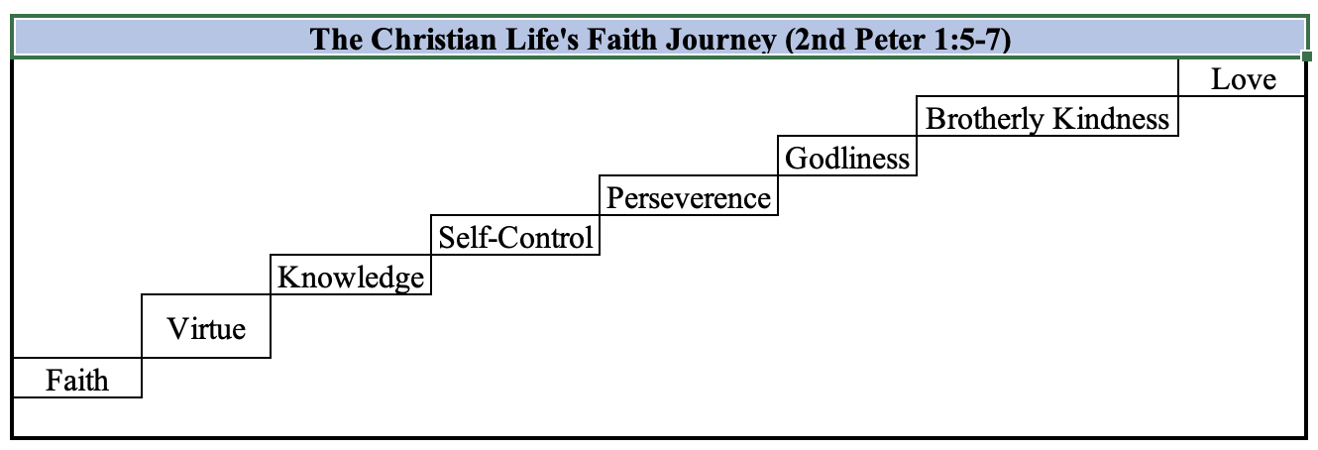

Just as a seed doesn’t suddenly become a giant sequoia, there is a progression of stages in this journey. The Apostle Peter starts us with a declaration of faith, and then provides stepping stones that ultimately conclude with love. This makes sense and is harmonious with Jesus’ two commandments – to love God and to love others. However, as I looked at this diagram, I started to wonder how we get from one step to the next. The answer is obedience. Please see below an update to the above picture.

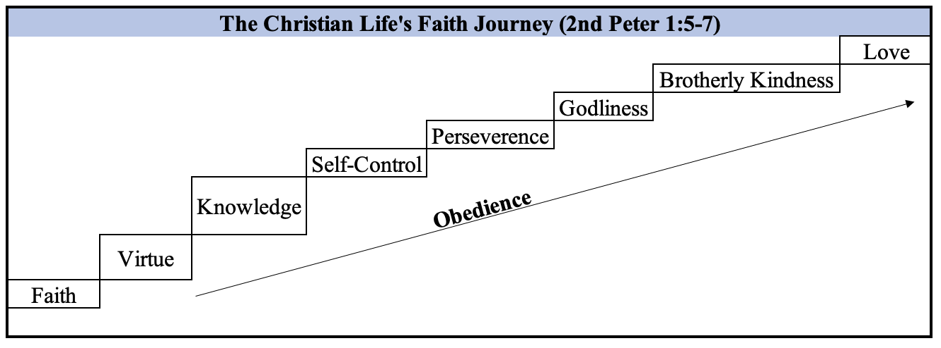

Through our obedience, we learn the importance of being virtuous. As we become more consistent in our virtue, we then start to build up our knowledge of God and His character – and the progression continues. As long as we continue to be obedient, the Holy Spirit will open up the door to each of these stages of faith.
Obedience, though, by itself, comes with a couple of pit-falls, and they are both rooted in judgment. As hard as we try to be obedient, our sin nature is going to rear its ugly head and cause us to stumble in our obedience. When we stumble, and we will, Satan is going to be slinging the fiery darts of condemnation, shame, and lies to keep us stumbling in our commitment to God. The other side of the coin of the pitfalls of obedience is if we get all full of ourselves in our obedience, we can start pointing our crooked, judgmental fingers at others who aren’t being obedient. ‘I can’t believe He did that!’ ‘Oh, how could she not do that!’ Both of sides of the coin of obedience in of itself run the real risk of moving us away from being the very thing our obedience should be producing – being Godly.
This is why obedience should always have a foundation of and healthy seasoning of grace.

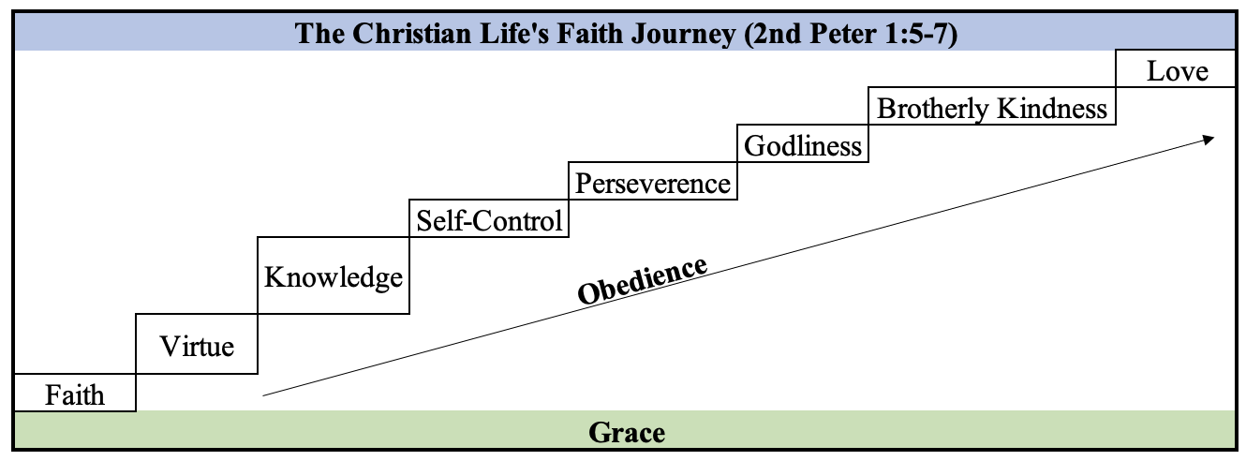

For the times that we stumble in our obedience, we must draw on the grace of God that was, as we said earlier, provided to us at the Cross of Christ. 1 John 1:7 reminds us of the ongoing coverage of God’s forgiveness, “But if we walk in the light as He is in the light, we have fellowship with one another, and the blood of Jesus Christ His Son cleanses us from all sin.” The word “cleanses” implies the blood of Jesus continuously covers and washes us of our sin in the eyes of the Father. When we come to truly believe and understand this amazing grace of God, we can take our shield of faith that will be able to quench all the fiery darts of the wicked one.
For the times we get all full of ourselves in our obedience, we need to remember Jesus threw in that our accountability is not only in our physical acts, but also to our thought life. While our physical acts of obedience may be intact, our minds can go to places that our actions don’t reveal. We need to extend the grace that God gives to us to those we see who are being disobedient. Galatians 6:1-2 tells us to be obedient in this grace, “Brethren, if a man is overtaken in any trespass, you who are spiritual restore such a one in a spirit of gentleness, considering yourself lest you also be tempted. Bear one another’s burdens, and so fulfill the law of Christ.”

In conclusion, we’ve covered the following:

- What is obedience?
- What are the fruits of obedience?
- What are the consequences of disobedience?
- What is the value of an obedient woman?

Additionally, we’ve talked about the fact that while obedience is essential in our faith journey, it must be heavily seasoned with grace to help us to avoid the pitfalls of obedience by itself. The grace of God does not happen first without the love of God. Just as we said earlier, the connection of disobedience and destruction is undeniable, so should be the inseparable connection of obedience and love. 1 John 2:3-6 gives us this connection, “Now by this we know that we know Him, if we keep His commandments. He who says, “I know Him,” and does not keep His commandments, is a liar, and the truth is not in him. But whoever keeps His word, truly the love of God is perfected in him. By this we know that we are in Him. He who says he abides in Him ought himself also to walk just as He walked.” Twice in these verses we see the phrase, “By this we know Him.” The “this” is keeping His commandments and the love of God perfected in us. Our testimony for God’s love for us is proven in our obedience in showing God’s love to others.
Jesus said in John 14:21: “He who has My commandments and keeps them, it is he who loves Me. And he who loves Me will be loved by My Father, and I will love him and manifest Myself to him.” A life of obedience can be tough at times, but we’ll never be alone, and we will find the love of God in our obedience. Nothing compares to the love of God. Let’s stand and sing praise to our amazing God!
May you all have a blessed Summer. I encourage you to stay in the Word, and He will reward your obedience with more of His presence. Thank you for your faithfulness in this study, and we’ll see you in our new home in the fall!

