Lesson 12 Lecture
Psalms 4, 13, 56, 57, 91, 108, 125, 143, 146
Dan Leppo

A belated Happy New Year to you! We kick off this year with a light topic – trust in God. Personally, I can’t think of a better place to begin a new year that will no doubt come with its share of trials and tribulations. There’s an old saying, “Hope for the best, but plan for the worst.” After these last few years of a pandemic, political upheaval, deteriorating morality, and increasing violence, planning for the worst would be good wisdom. This isn’t to say I don’t believe God can and will demonstrate His goodness, mercy, and love towards us, but I believe we are in the end of the end times, and the Bible is pretty clear on the perilous environment of this period in history. This is why the topic of trusting in God is not only relevant, but also vital to explore.
I imagine most, if not all of you who are reading or listening to this lecture believe in God. That’s a great start, but believing in God and trusting in God are not necessarily the same thing. Now, you can’t trust in God without first believing in God. However, can you believe in God, but not trust Him? If we’re brutally honest with ourselves, we will likely arrive at the confession that we don’t fully trust God in every aspect of our lives. How many of you like to be in control of things – translation, are you a control freak? Let me ask you this, if you were to examine all the aspects of your life that you seek to control, how many of those have you sought God’s counsel on whether or not what you’re trying to control is in line with His will? If you’re anything like me, which I hope you’re not, when I look upon those things I seek to control, I have to confess that I have not inquired of the Lord to see if He approves. Anything, and I mean anything, that we seek to control is a potential place in our lives where we are not fully trusting God.
So, let’s ask a question, “Why is it important that you trust in God?” Before you look to answer this question, let’s do a little digging on the definition of trust. Merriam-Webster’s Online Dictionary offers the following: “assured reliance on the character, ability, strength, or truth of someone or something; one in which confidence is placed; dependence on something future or contingent; HOPE.”
There are some great, meaty words and phrases in this definition of trust:

- Assured reliance on the character
- Ability
- Strength
- Truth
- One in which confidence is placed
- Dependence on something future or contingent
- Hope

This is an amazing list! While it sounds wonderful, how many of us really trust anything or anyone to the extent we can say with absolute certainty that what or who we trust meets all of these criteria? The “stock” answer to the question of what or who we trust for a Christian would be we trust in Jesus and His Word. That sounds nice and shiny, but is that really the truth? How often do we say we trust in Jesus/God, but then the moment things get uncomfortable, we look to our own methods of relieving the discomfort? Again, is our “Control Freak” taking over? I’m not trying to condemn you – believe me, I’ve done, and still do, these very things where I look to my own alleged abilities to resolve something that is painful. I’m going to revisit this point at the close of the lecture, but I’m hoping you hold onto your honest answer to how much you truly trust God as we go through these Psalms. I believe you’ll be both convicted and then lifted up by the truth of God’s trustworthiness.
A prerequisite to trusting in God, or in anything else, is you must have a mindset of humility and surrender. To trust to the level of the above definition, there’s an implied understanding of your lesser abilities and wisdom. Additionally, trust is a deferral to Someone’s greater abilities and wisdom. For example, if you have an illness and are not educated in the cause and treatment of the illness, you need to humble yourself and seek someone like a doctor who has the ability and truth of dealing with the illness. Now, not all doctors are reliable, but the point I’m looking to make is there are situations that will come into your life that you simply are not capable of managing, so you must learn humility and defer to someone who is more capable and knowledgeable than you. This is why the first step of trust is an acknowledgement of your limitations, and that cannot happen without a humble mindset. Andrew Murray, in his incredible book “Humility,” said, “Humility, the place of entire dependence on God, is, from the very nature of things, the first duty and the highest virtue of the creature, and the root of every virtue.”
So, let’s get back to the question we posed earlier, “Why is it important that you trust in God?” From a humble mindset, we come to a place that we recognize our weaknesses and our need for help from Someone to be stronger than our weaknesses. We live in both a physical and spiritual realm. When we read about the “world” in Scripture, it is speaking to the physical world. However, there is a greater and far more powerful world, and that is the spiritual realm. John 4:24 tells us God is Spirit, and He reigns in the spirit world. Satan, a created being, is no match against God, but he is indeed powerful – far more powerful than us. What is Satan’s mindset towards us as believers? The Apostle Peter reveals Satan’s intentions towards us in chapter five, verse 8 of his first epistle, “Be sober, be vigilant; because your adversary the devil walks about like a roaring lion, seeking whom he may devour.”
King David, despite all his gifts, acknowledged the presence of the enemy and its intentions towards him in the following two verses in our reading:

- Psalm 57:4: “My soul is among lions; I lie among the sons of men who are set on fire, whose teeth are spears and arrows, and their tongue a sharp sword.”
- Psalm 57:6: “They have prepared a net for my steps; my soul is bowed down; they have dug a pit before me; into the midst of it they themselves have fallen.

Ever felt like what David is describing? Maybe it isn’t individuals who are threatening; maybe it’s a health scare or series of health challenges. Perhaps it’s a relationship crisis, or maybe it’s a financial issue. Whatever it is, Satan is going to relentlessly hassle and persecute the child of God. And here’s the more difficult news – the closer you choose to identify yourself as a follower of Christ through the way you live and minister to people, you are setting yourself up for, potentially, even a greater level of pain and suffering. You’re not going to hear this Biblical truth from any seeker-friendly pulpits, but there is a cost to drawing close to and trusting in God. Your greater commitment to what God stands for makes you a greater enemy to all that Satan stands for. Goodness looks to give life, restore life, and offer it hope. Satan looks to take away/destroy life and eliminate hope. Therefore, you can see a step towards God is a declaration of war against Satan.
So . . . with this in mind, let’s ask another question, “Do you think trusting God will improve the quality of your life?” Our fleshly response – our worldly response – would emphatically say, “No!” Of course it would say that because who wants to continue trusting in Someone if it is going to bring more pain and suffering? Time for another question, “How much of what is going on in your life or in the world do you understand?” Personally, the older I get, despite all the alleged wisdom I’ve obtained in my almost 61 years, I find myself more clueless and lost with what is going on. Perhaps the real wisdom we believers obtain is that sense of humility of how little we comprehend of what is going on around us. Perhaps that wisdom is a confession that our self-titled “Control Freak” is really a “Control Weak,” and a realization that we have no choice but to look to God for help.
In chapter six of John’s gospel, Jesus has miraculously fed the five thousand, but He then begins to raise the stakes on what it means to fully trust Him. He tells them in verse 53, “unless you eat the flesh of the Son of Man and drink His blood, you have no life in you.” He equated Himself as the manna from heaven, and a lot of people stopped following Him. Once they were all gone, Jesus turned to His 12 disciples and asked them, “Do you also want to go away?” Peter, getting it right this time, gave this humble confession in verses 68 and 69, “Lord, to whom shall we go? You have the words of eternal life. Also we have come to believe and know that You are the Christ, the Son of the living God.” What was behind Peter’s confession? He, also, didn’t understand what Jesus was saying. However, from what he had seen and heard from Jesus, he wasn’t willing to let what he didn’t understand of Him get in the way or overwhelm of what he did understand of Him.
Peter’s question is one in which each person should ask him/her self, “To whom shall we go?” I like the Voice’s version of this Scripture, “Lord, if we were to go, whom would we follow?” From this place of humble confession and inquiry, we are acknowledging our need for something that offers:

- Assured reliance on the character
- Ability
- Strength
- Truth
- One in which confidence is placed
- Dependence on something future or contingent
- Hope

In other words, we’re confessing our need to trust in Someone or something. Since today’s lesson is about trust in God, then let’s look at some verses that speak to God’s character that makes Him trustworthy. I know these are a lot of verses, but hang in there with me – I believe you will see why I’m offering all of these as testimonies to God’s trustworthiness:

- Psalm 4:8: “I will both lie down in peace, and sleep; for You alone, O Lord, make me dwell in safety.”
- Psalm 13:5: “But I have trusted in Your mercy; my heart shall rejoice in Your salvation.”
- Psalm 56:9: “When I cry out to You, then my enemies will turn back; this I know, because God is for me.”
- Psalm 57:2-3: “I will cry out to God Most High, to God who performs all things for me. He shall send from heaven and save me; He reproaches the one who would swallow me up. Selah God shall send forth His mercy and His truth.”
- Psalm 57:10: “For Your mercy reaches unto the heavens, and Your truth unto the clouds.”
- Psalm 91:2: “I will say of the Lord, “He is my refuge and my fortress; my God, in Him I will trust.”
- Psalm 91:4: “He shall cover you with His feathers, and under His wings you shall take refuge; His truth shall be your shield and buckler.”
- Psalm 143:1: “Hear my prayer, O Lord, give ear to my supplications! In Your faithfulness answer me, and in Your righteousness.”
- Psalm 143:8: “Cause me to hear Your lovingkindness in the morning, for in You do I trust; cause me to know the way in which I should walk, for I lift up my soul to You.”
- Psalm 143:10: “Teach me to do Your will, for You are my God; Your Spirit is good. Lead me in the land of uprightness.”
- Psalm 146:6-8: “Who made heaven and earth, the sea, and all that is in them; who keeps truth forever, who executes justice for the oppressed, who gives food to the hungry. The LORD gives freedom to the prisoners. The Lord opens the eyes of the blind; the Lord raises those who are bowed down; the Lord loves the righteous.”

Let’s look at the components of trust one more time and then compare them to some of the components of God’s character revealed in these verses:
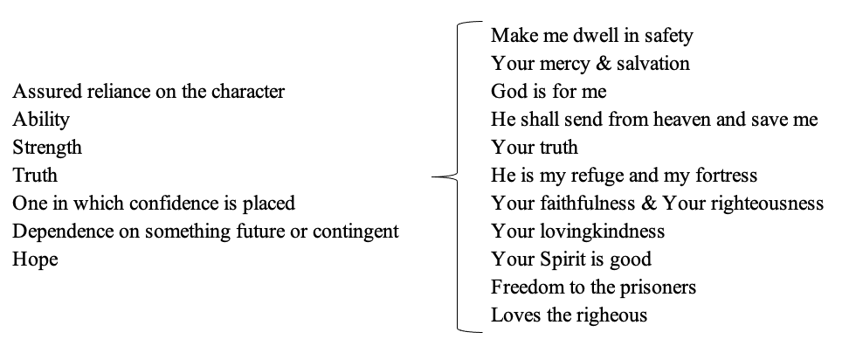
The author, or authors of these verses, declare three times that as a result of these components of God’s character, he can trust God. In the perfect world, we should also conclude that God is trustworthy based on these glorious character traits. There’s a problem, though; we don’t live in a perfect world, do we? Satan, who rules the world, is the source of these imperfections, and they are designed to do one primary thing – cast doubt on God’s character so that we won’t come to fully trust in Him. Here’s the thing –since God cannot lie, these character traits that He presents to us are true regardless of whether or not we believe them; therefore, it comes down to our making the choice and commitment to believe and trust in them.
This imperfect world we live in is full of lies, heartache, disappointments, and a lot of pain. Without God’s Spirit dwelling in us, our flesh is at the mercy of these “imperfections.” We understandably want relief, but we’re not seeing this relief coming from God, so what do we do? We abandon our trust in Him and start looking elsewhere for relief. We take on our Control Freak role. We look to anything that we can find that hopefully will bring relief from our pain. The problem is they’re designed to deal with the symptoms – not the cause.
What I’m about to share is something that I know many Christians refuse to believe – despite the clear Scriptural evidence that what I’m saying is true. The declaration I’m about to make is one of the truest tests of a believer’s trust in God’s Word. Are you ready? God is in complete control. Now, on the surface, that should sound like a good thing, but let’s play this out.
In Job chapter 1, Satan is given an audience to God at His throne. God asks him where he has been. Satan’s response was, “From going to and fro on the earth, and from walking back and forth on it.” From what we learned earlier from 1st Peter, what is Satan looking to do while walking back and forth on the earth – to devour us. Please pay close attention to what God does next, “Have you considered My servant Job, that there is none like him on the earth, a blameless and upright man, one who fears God and shuns evil?” (Job 1:8) God goes on to put limitations on what Satan can do to Job. What do we learn in this remarkable encounter?

- God picked the fight for Job. While Satan no doubt knew God protected Job, it was God who identified Job as a potential target for Satan’s devouring intents.
- Job was righteous in God’s eyes. As opposed to our fleshly-driven judgmental sinful nature, which often looks to place blame on people for their suffering, Job, in God’s eyes, was as strong a believer in God as anyone on the earth.
- God is in complete control of this scenario.

This encounter is repeated a second time in chapter two – with even more leniency from God as to the pain and suffering Satan can inflict on Job – the only restriction is that he must spare Job’s life. So, now, what do you think about God being in complete control? What’s our fleshly response to the truths of this scenario? They probably center around the question “Why?” Why would God choose and allow pain and suffering for the most upright and righteous man on earth? These are all important questions to ask regarding the concept of God being in control. However, are we really willing to hear and believe the answers? We must conclude from these encounters in Job that Satan can do nothing without God’s permission. Therefore, if we are convinced that our pain and suffering is from Satan, then we must come to grips that he can’t do anything to us without God allowing it. Getting uncomfortable? I know I am. I’m going to take this truth of God being in control to one more level, and then I promise relief.
The above deals with the truth of God allowing pain and suffering. What happens to your trust in God when we learn He may initiate pain and suffering? Let’s look at a few verses:

- Isaiah 48:10: “Behold, I have refined you, but not as silver; I have tested you in the furnace of affliction.”
- Psalm 66:10: “For You, O God, have tested us; You have refined us as silver is refined.”
- Deuteronomy 32:39: “Now see that I, even I, am He, and there is no God besides Me; I kill and I make alive; I wound and I heal; nor is there any who can deliver from My hand.”

For many Christians, the concept that God can and will initiate pain and suffering is too much to handle – it’s literally a faith shaking truth. I’ve heard many Christians who reject this core truth of God and seek to rationalize their pain and suffering as “fate” or “the results of the fallen world we live in.” What’s implied behind those statements? God is not in complete control. Let’s play that out, if God is not in control, then who is? The only answer is Satan or the lie he feeds to us that we are. So…we’re faced with Peter’s question, “To whom shall we go?” In other words, in whom do we choose to put our trust?

- Satan – who we know wants to devour us.
- Ourselves – how does that look in the face of Jeremiah 17:9’s assessment of our hearts? “The heart is deceitful above all things, and desperately wicked; who can know it?” I won’t speak for you, but I’ve let myself down enough times to know I’m not the one I should be following.
- God – Who, if He has the ability to allow/cause pain and suffering, He also has the ability to take it away or bring relief.

Let’s take one more step into the truth of God being in control and causing/ allowing pain and suffering. Consider Jesus – God’s only begotten Son in whom He was “well pleased,” was told that He must surrender His glory, humble Himself to be made in the form of a human, live in a world that is anything but heaven, befriend the very people who will betray Him, be wrongfully accused, tortured, and crucified. Moreover, He told Jesus to do this despite the fact He was completely innocent and totally undeserving of such a fate. What was Jesus’ response to the Father’s command? Well, we know the story – His answer was “yes.”
Quoting once again from Andrew Murray’s book, “Humility,” he says, “His [Jesus’] humility was simply the surrender of himself to God, to allow him to do in him what he pleased, whatever men around might say of him, or do to him.” We mentioned earlier that a humble mindset is the prerequisite to trusting God. Taking on a humble mindset leads to the evidence, or fruit, of someone who fully trusts God – obedience. This is what we find with Jesus in His life and, most importantly, at His cross. His trust in and obedience to the Father’s will is our salvation. Every confessed believer and follower of Jesus Christ is the fruit of His trust in the Father.

Our reading reveals other fruit from trusting in God:

- Psalm 56:10: “In God (I will praise His word), in the Lord (I will praise His word),”
- Psalm 57:7, 9: “My heart is steadfast, O God, my heart is steadfast; I will sing and give praise. I will praise You, O Lord, among the peoples; I will sing to You among the nations.”
- Psalm 146:2: “While I live I will praise the Lord; I will sing praises to my God while I have my being.”

When we choose to humble ourselves, trust God, and prove that trust in God through obedience, the natural fruit of that trusting process is praise and worship. God acknowledges our choice to follow Him through our obedience, and He blesses it. How He chooses to bless, though, is totally up to Him because He is our sovereign Lord. We must, again, look to God’s character before we place an assessment on His blessings. If God is love, and He is good, which He is, then He must have some kind of loving and good intentions behind His blessings – even if they include more pain and suffering. Hebrews 5:8 speaks of how Jesus was blessed through His suffering, “though He was a Son, yet He learned obedience by the things which He suffered.” Check out the connection of humility, trust in God, and obedience in Philippians 2:8, “And being found in appearance as a man, He humbled Himself and became obedient to the point of death, even the death of the cross.” If God is not above sending His only begotten Son to die for the greater good, who are we to think He’s not above allowing or initiating pain and suffering to accomplish good in our lives through our trusting Him more and more?
This was not an easy lecture to write because I knew it was going to challenge your understanding of God’s role in your pain and suffering. I won’t speak for my fellow lecturers, but when I write these lectures, the first target for the teaching is me. Please do not think for one second that all these things I teach in this lesson, or any other lesson I have taught on for the last 14 years, that I have it figured out or live it perfectly. Please know that as I wrote the words the Holy Spirit was giving me, I, too, was uncomfortable. I felt the conviction that my pride gets in the way of humility. I felt the sadness that I don’t fully obey God all the time. I felt the sting when I confessed I don’t fully trust God.
I know many of you who are reading or listening to this lecture are currently experiencing a lot of pain and suffering. My heart and prayers go out to you. Please forgive me if this lecture has made things worse. If you’re willing to listen to me a little more, I’m going to offer you what I have come to learn is helpful in the midst of reconciling God’s role in my pain and suffering. The symbol of the foundation of my faith is the cross. In light of what I have just presented to you, I want to share my observations of what I have learned at the cross:

- I find that God’s perspective is greater than mine. At the time of Jesus’ crucifixion, the people were looking for deliverance from their physical circumstances – the Jews were looking for their Messiah to deliver them from the rule of the Romans. God had a bigger issue to deal with – sin. While He knows the pain and suffering we’re experiencing, His mindset is always first and foremost focused on our eternal benefit - where we stand in our belief in, and relationship with Him.
- I find a level of love I’m not familiar with. I can’t imagine being loved more or better than my wife has loved me, but what I see at the cross is a higher level of love. There are two components of this love:
  - Between a Father and a Son – the love Jesus had for the Father was so complete, He was willing to fully submit His will to His Father’s – even if it killed Him. Only love can produce that kind of trust.
  - Between a God and His creation – as I share John 3:16-17, think of your worst moment – your most grievous sin – and then read, “For God so loved the world that He gave His only begotten Son, that whoever believes in Him should not perish but have everlasting life. For God did not send His Son into the world to condemn the world, but that the world through Him might be saved.” Want to make this even more personal? Where it says “the world,” write in your name.
- I find hope. I look at the brutal pain and suffering inflicted on a completely innocent man, but the story isn’t over at His death. His resurrection is His reward for enduring the pain and suffering. His resurrection is His reward for His trust and obedience. For those of us who confess Jesus as our Lord and Savior, we can latch on to the promise and hope in Romans 6:5: “For if we have been united together in the likeness of His death, certainly we also shall be in the likeness of His resurrection.”

In summary, I find at the cross the possibility of purpose in suffering. Again, I won’t pretend to understand your pain and suffering, but I can fully appreciate how senseless and relentless it can be. I would be lying to you that despite my arriving at this place of understanding God’s role in my pain and suffering that I don’t sometimes bow my head in bewilderment and ask God, ‘Why?’ All I can share with you is that when I arrive at this place, my answer to Peter’s question, “To whom shall we go?” is Jesus at the cross. For me, the cross is the place where a finite human being will find an infinite God’s character revealed. Let’s pull up that definition of trust list one more time:
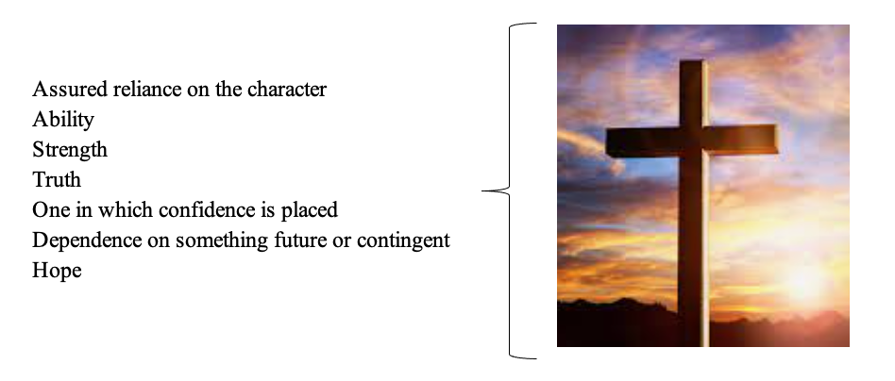

From our reading in Psalm 146:8 we’re told, “the Lord loves the righteous.” As a believer in and follower of Jesus Christ, we are made righteous by the blood He shed on the cross. God’s cross-proven love for us makes Him completely trustworthy. He fully and completely meets the components of the definition of trust. He is the answer to Peter’s question, “To whom shall we go?” What is your answer?

