Lesson 6 Lecture
The Battle of Gog & Magog – Armageddon
By Dan Leppo

Greetings. Because I’m at the point in my life regarding my memory that I hide my own Easter eggs for entertainment, I find it useful to remind myself periodically where we are in the Bible study. So far, we have been assured that Biblical prophecy is not empty optimism, it is true hope – something we can count on because God’s Word is entirely reliable. We then received some prophetic insights from the Psalms. Next, we were given some indications from Scripture what the last days will look like in the world and in the church. Over the last couple of weeks, we have covered the resurrections, the rapture, and the tribulation. Given I’m a guy, and I like things simple – it’s a gender thing - I like pictures. The below provides an admittedly simple, but hopefully helpful, timeline of humanity’s existence according to the Bible.

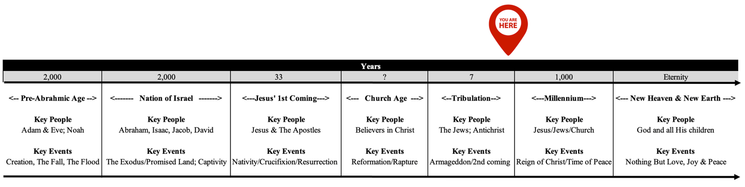

Today’s lesson is titled “The Battle of Gog and Magog – Armageddon.” That little red symbol above the timeline that we see on the mall maps tells us that these events are going to happen at the end of the 7-year Tribulation period. Most of us have heard the term, “The Battle of Armageddon.” It’s often used flippantly as a descriptive of some modern-day clash of prominent individuals, teams, or organizations. Today’s examples might include Truth vs. the Media, Real Life of Winners and Losers vs. Everyone Gets a Participation Award, and the most epic battle of all – Man vs. Woman regarding control of the television remote. Please forgive me if I’m coming across a little silly, but this is heavy stuff. Neither the battle of Gog and Magog nor the Battle of Armageddon are something to trivialize or take lightly. They will be the most awesome and terrifying events in human history. Jesus Himself warned in Matthew 24:21, “For then there will be great distress, unequaled from the beginning of the world until now—and never to be equaled again.” Since Jesus is God, no one would know better than He where these events rank on the scale of destruction.
Again, looking at the timeline, there is an assumption that I’m making to which other prophetic teachers may not agree. I have the rapture of the church happening before the Tribulation. As you may recall from my lecture a couple of weeks ago, this position is known as a Pre-Tribulation Rapture. Why I am reminding you of this is to, hopefully, put those of you who are followers of Christ at rest as we learn about this horrific period. It is my belief that the church will not be around during the Tribulation; therefore, we won’t be around for these unprecedented battles. We will be safely tucked away in heaven preparing to return with Jesus at His second coming in victory over Gog, Magog, the Antichrist, and all Christ rejecting enemies. So, you may ask, if this is the case, then why take the time to learn about something that we aren’t going to be around for? Well, first, I could be wrong about the pre-Tribulation Rapture as its timing is not specifically laid out in Scripture. Much more importantly is we all likely have loved ones and friends who are not yet saved. Knowing this battle is in their future should motivate us to witness to them more than ever in hopes they will come to Christ before this terrible time.
As I prepared for this lecture, I found disagreement among the commentaries over whether or not the Battle of Gog and Magog and the Battle of Armageddon were two separate events. Furthermore, there is some debate on whether or not the Battle of Gog and Magog will either:

- Precede the Rapture and initiate the beginning of the tribulation; or
- It will occur at the end of the Tribulation with Jesus’ 2nd coming.

One thing most scholars do agree upon is that the target to be attacked is Israel.

In 2 Samuel 7:12-16, God spoke to the prophet Nathan who was to convey a message to King David: “When your days are over and you rest with your fathers, I will raise up your offspring to succeed you, who will come from your own body, and I will establish his kingdom. He is the one who will build a house for my Name, and I will establish the throne of his kingdom forever. I will be his father, and he will be my son. When he does wrong, I will punish him with the rod of men, with floggings inflicted by men. But my love will never be taken away from him, as I took it away from Saul, whom I removed from before you. Your house and your kingdom will endure forever before me your throne will be established forever.” This offspring that was mentioned was, of course, Jesus. With the rejection of His Son, God kind of put the Nation of Israel “on the shelf” and authored this period of some 2,000 years to gather up His church. I believe the Rapture will conclude the church age and take Israel off the shelf for God to fulfill His covenant with them.
I believe I mentioned in my last lecture there are no unfulfilled prophecies that would prevent Jesus from rapturing the church. People who challenge this position quote the Lord in Matthew 24:14, which says, “And this gospel of the kingdom will be preached in all the world as a witness to all the nations, and then the end will come.” as proof that the whole world needs to hear the Gospel before He can return. Therefore, the belief is until that happens, the Rapture can’t happen. First, we need to remember the Rapture and His 2nd Coming are two distinctly different events. This global spreading of the Gospel condition noted by Jesus speaks to His 2nd Coming – not the Rapture. Secondly, I present to you Revelation 14:6, “Then I saw another angel flying in the midst of heaven, having the everlasting gospel to preach to those who dwell on the earth—to every nation, tribe, tongue, and people.” The angels are going to handle the complete and world-wide communication of the Gospel during the tribulation, so for those of you claiming that box needs to be checked before we can feel like we are that close to His return, you can consider it checked!
Our homework opens up in Ezekiel 38 & 39, but it’s worth mentioning that there is a prophecy in Ezekiel 37 that is significant and relevant for the next two chapters. You may recall the story where the Spirit of the Lord takes Ezekiel to a valley of dry bones. This is a symbol of the nation of Israel residing in its land – they had been dispersed throughout the world and lost their homeland. God tells Ezekiel to prophesy to these dry bones, and they come to life. Then, in verses 12-14, God told Ezekiel why he asked him to do this, “Behold, O My people, I will open your graves and cause you to come up from your graves, and bring you into the land of Israel. Then you shall know that I am the Lord, when I have opened your graves, O My people, and brought you up from your graves. I will put My Spirit in you, and you shall live, and I will place you in your own land. Then you shall know that I, the Lord, have spoken it and performed it,” says the Lord.” This is a message that the nation of Israel would be reborn and brought back into its land – something that had never happened in history. Praise the Lord, that took place in 1948. David Ben-Gurion, the first prime minister of Israel said in 1948, “Ezekiel 37 has been fulfilled.”
Ezekiel 38 – describes an attack from Gog & Magog. In the first two verses of chapter 38 we read, “The word of the LORD came to me: Now the word of the Lord came to me, saying, “Son of man, set your face against Gog, of the land of Magog, the prince of Rosh, Meshech, and Tubal, and prophesy against him.” Probably the best way to unpack this verse is to define some terms:

- Gog - is a word for “ruler” meaning roof, which actually means the “man on top” – a type of dictator.
- Magog speaks to a people as if they were in a geographic area.

In Genesis 10:2, Magog, Meshech, Tubal, and Gomer are named sons of Japheth and founders of the northern group of nations. Directions in the Bible are in relation to the land of Israel. So, who are these people and what is north of Israel?

- Prince of Rosh – Rosh is an ancient name of the area north of the Caucuses – Russia.
- Meshech - Moscow
- Tubal – Tubolsk (Western Siberia)

It appears that the likely leader of this invasion will be Russia, which is directly north of Israel. However, it won’t just be Russia – they’re going to have some help. Verse 5 of chapter 38 of Ezekiel adds their names, “Persia, Ethiopia, and Libya are with them, all of them with shield and helmet; Gomer and all its troops; the house of Togarmah from the far north and all its troops—many people are with you.” A couple of these names are easy to know because they are still the names of these countries to this very day. Specifically, the countries joining Gog and Magog will be:
- Persia – Iran/Iraq
- Ethiopia
- Libya
- Gomer – Germany (mainly eastern part) and possibly Poland
- Togarmah – Turkey/Armenia/Yugoslavia/Romania – the Balkans

An argument against the Battle of Gog and Magog being the same as the Battle of Armageddon is according to Revelation 16, which is clearly a description of the Battle of Armageddon, there are some key players missing in the Gog/Magog list. These missing players are noted as the “kings from the east” (Rev. 16:12) – I’ll get to who those likely are in a few minutes.
So, we have this massive federation lead by Russia on one side. The other side is going to consist of Israel and God. Spoiler alert – I like any team’s odds when God is on their side. Verse 3, speaking to Gog, offers a warning none of us want to hear, “Thus says the Lord God: “Behold, I am against you, O Gog, the prince of Rosh, Meshech, and Tubal.” The fact that God says to Gog in Ezekiel “I’m against you” is different from other countries He has voiced His opposition to in Scripture - those countries were in existence at the time of His comments. At the time of the writing of Ezekiel, though, the country of Russia was not yet in existence. What also makes Russia an interesting choice as a key player is that it is a nation that has been founded on the concept that there is no God – it is largely atheistic. Praise the Lord, however, as the church has made progress in Russia in the last 30-40 years spreading the Gospel.
Animosity against Israel is both Biblical and historic. But, from verse 4, we see this federation is being influenced by an unexpected instigator, “I will turn you around, put hooks into your jaws, and lead you out, with all your army, horses, and horsemen, all splendidly clothed, a great company with bucklers and shields, all of them handling swords.” What this verse is alluding to is that God is going to set a trap for Gog and its cohorts to invade Israel. What’s the bait? Money and resources. To fund the military build-up of Russia and its partners, Israel offers deep agricultural and natural gas resources that will be too enticing to avoid. The deeper reason, though, is a spiritual one. Satan hates God, Israel is God’s chosen people and land, so Satan wants to destroy anything that is God’s.
This attack is not going to go unchecked. Further in Ezekiel 38 there are some objectors noted to this plan of attack – they include:

- Sheba & Dedan – Saudi Arabia
- The Merchants of Tarshish – England
- Young Lions – U.S.A.? Canada? Australia? We don’t know. With the Rapture, a significant portion of the United States will disappear. Those left behind will likely preside over and expedite this once great country founded on God’s principles into insignificance.

The balance of Chapter 38 and Chapter 39 speak of the judgment, destruction and burial of Gog. Gog and his forces may think they are driving this plan, but as I just mentioned and as chapter 38:16 further details who is really driving the story, “It will be in the latter days that I will bring you against My land, so that the nations may know Me, when I am hallowed in you, O Gog, before their eyes.” Brothers and sisters, please don’t ever think you or anyone else you know is in control. God’s will is unstoppable, and He is far mightier than anything man or Satan can come up with. The last verses in chapter 38 provide some detail of God’s methods for providing judgment on Gog. They include:

- There will be a massive earthquake that will at least shake the Middle East if not further as all of the people on the face of the earth will feel its effects.
- Mountains are overturned, cliffs crumble, and walls fall to the ground.
- All of this is going to cause confusion and turn the attacking armies against each other.
- God will pour down torrents of rain, hailstones, and burning sulfur on Gog and his forces. This sounds very similar to the way He judged Sodom and Gomorrah.

Please forgive the spoiler alert, but God will soundly defeat Gog – wiping out 5/6th of its forces. The death toll will be so heavy that it will take the Nation of Israel seven months to bury all the bodies. The artillery and equipment will be used as fuel for seven years. I believe this component of the story is one of the reasons some people believe this battle will inaugurate the tribulation as it is seven years in duration. I disagree.
So, we saw that God set the trap for this invasion. God always has purpose to everything He does, and according to Warren Wiersbe, He had four primary purposes for this Battle:

- To reveal the greatness of the Lord as He displays His power before the nations.
- To reveal His holiness as He judges the sins of the leader from Magog and deals with enmity against the Jews.
- To reveal Himself to the Gentile nations, and the world will recognize the holiness of God and be convicted of their sins.
- To wake up the Nation of Israel to the truth of God and Jesus as the Messiah.

If that wasn’t enough excitement, we now move into the Battle of Armageddon. It takes place in the Valley of Jezreel, just below Mount Megiddo, 60 miles north of Jerusalem. The word, “Armageddon”, associated with this site, derives from the Hebrew words “har” = “mount” or “hill” and Megiddo.
As opposed to the Battle of Gog and Magog, there is little questioning the Battle of Armageddon’s timing – per Revelation 16, it will happen in the 6th and 7th bowl judgments, which are at the end of the tribulation. So, what is going to happen in the Battle of Armageddon? While the Bible offers passages of Scripture that provide some detail to the devastation, many of them are symbolic. I’ll go over just a few of these and offer my personal speculation as to what or how this might materialize based on what we know of today’s situation and technology. Regardless of my speculation, if God says it’s going to happen, He can do it on His own or use the tools of the time to affect His purposes.
Revelation 16:12-16 speaks of the sixth bowl of wrath being poured out with the Euphrates River being dried up. The drying up of the Euphrates is no small task – it’s the longest river in western Asia – about 1,800 miles, an average of thirty feet deep, and three to twelve hundred feet wide. So, what could happen to dry up a river this size? The suddenness of the event rules out the construction of a dam or a prolonged drought – something that would take years to accomplish. It’s possible a nuclear event scorched this area, which would have the power to dry up a river of this magnitude in such a short time-frame.
As noted earlier, there are players in the Battle of Armageddon that are not part of Gog and Magog. The purpose of the drying up of the Euphrates River is to allow passage of the “kings of the east” to enter the battle. In verses 13-14, we read of three evil spirits coming out to demonstrate miracles to lure the kings of the east to join the battle. Notably, the “kings of the east” is literally “kings of the rising sun” in the original text. The “rising sun” should ring a bell and is why the assumption these kings will consist of at least China and Japan. The final missing player in the Battle of Armageddon is the Antichrist. This will be his final attempt to defeat God.
Verse 15 says, “Behold, I am coming as a thief. Blessed is he who watches, and keeps his garments, lest he walk naked and they see his shame.” Jesus will rapture the church with no warning. With the church removed, there will be fewer people to communicate His Second Coming. Moreover, there will be even fewer who will believe it even if they hear it. At this point, the vast majority of humanity will have sealed their fate in terms of their standing before God. It’s interesting that God describes Himself as a thief in this verse. The Hebrew word for this is “kleptes.” This literally means “steals.” You may recognize that it sounds similar to klepto, which is what we sometimes call people who steal things. An unbelieving world won’t want Jesus to return, so those living on the “river de-Nile” will be many. Despite the clearly identified period of time within the Tribulation, Jesus’ 2nd Coming will catch many by surprise – and not a good one.
As for the battle itself, Daniel 11:40-47 provided a vision of the attack. We learn of a “king of the South” will rise up against the Antichrist, who at this time is residing in Babylon. The “king of the South” is likely a federation of north African countries possibly lead by Egypt. They will not hold up against the king of the North, which will overwhelm much of Israel as well as the king of the South. Then we learn that the Antichrist will be troubled by the news from the east, which are the kings we described earlier. The Battle of Armageddon will involve a major portion of the nations on this planet.
In chapters two and three of his book, the prophet Joel speaks of a time when the sun and the moon will be darkened, and the stars no longer shine. This implies there is a covering around the earth – or at least this part of the earth - that is blotting out the view of the heavens. Either the impact of an asteroid or comet or the aftermaths of nuclear exchange creating a “nuclear winter” could cause the scene described by Joel.
Zechariah 14 suggests that there will be some limited success of the attacking armies when it says Jerusalem will be captured, the houses ransacked, and the women raped. However, a plague comes where “their flesh will rot while they are still standing on their feet, their eyes will rot in their sockets, and their tongues will rot in their mouths.” (Zech. 14:12) This description sounds similar to the effects of a neutron bomb detonation.
As noted in our homework, there is another mentioning of Gog and Magog in Revelation 20. If you don’t get the depth of the depravity of man, this portion of Scripture should shake you. More than 50% of the earth’s population is going to be extinguished during the tribulation. With almost 8 billion people on the planet today, we’re talking about at least 4 billion people losing their lives during these 7 years. With Jesus’ return, the next 1,000 years, known as the Millennium, will be a very different world than what we are living in today. Jesus will be residing on earth – ruling and reigning with the church saints serving Him to enforce His rule. Satan will be put in a spiritual prison during this period, so it would seem to me this should be a very peaceful period of time. For reasons only God knows, at the end of the Millennium, God is going to allow Satan out of this prison, and he will gather Gog and Magog for one more final battle. Stunningly, despite this apparent peaceful period of time, countless people (whose number is as the sand of the sea) will join Gog and Magog and surround Jerusalem. God will send fire down from heaven and put an end to this attack. Satan will be thrown into the lake of fire – never to be heard from again. That will be a day I am greatly anticipating. I have had enough of his lies and misery.
There are more details and Scriptural references to speak to these two battles, but I recently woke up early with a strong compelling to deliver a message of assurance to this study. The last couple of weeks have been pretty heavy and scary stuff – the seven-year tribulation and the battles of Gog/Magog and Armageddon. Perhaps even the rapture leaves some of you feeling uneasy. I can imagine more than a few of you might be wondering how can a loving God exact all this carnage on His creation? I think this is a critical question every person should ask because it forces the conversation about God’s character. God is infinite, and we, as His creation, are finite. The finite cannot fully comprehend the infinite. However, we were created to be in a close and personal relationship with God. To make this possible, out of His love, mercy, and grace, He gave us His Word – the Bible.
God’s Word has many purposes, but, for me, its greatest purpose is to reveal His character. If we choose to spend time in His Word, God will reveal His character more and more. Yes, I’m a finite being, but, for me, there’s more than enough in the Scriptures to come to know God and His character that allows me to believe in, trust in, confess, follow, and serve Him. For those of you who have been sentenced to listening to my teaching over the years, [I hope] you have noticed a common component in most, if not all of the lectures. In my opinion, there is no other place in Scripture that better presents the totality of God’s character other than the cross. In the below picture, I have surrounded the cross with words and phrases that I believe are discovered in Christ’s crucifixion resurrection. I would suspect each of you could come up with your own list and would encourage you to do so. Everything changed at the cross and Jesus’ resurrection. That not only happened to the world, but it should happen to each person who finds Jesus at the Cross. Things should change as you get overwhelmed by God’s character and love for you.

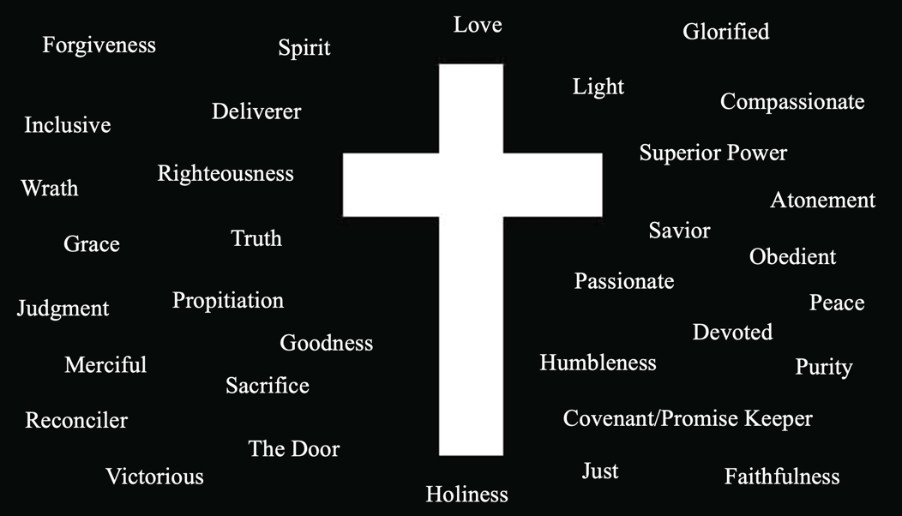

The events outlined in these last couple of lessons will be discussed in even more detail when we get into the Book of Revelation, and they are, indeed, horrifying and tragic. The original plan for creation did not comprehend the events we have covered in the last couple of weeks and will continue to cover in the coming months. What God originally created was good, but His greatest creation - humanity - turned on Him via sin. Sin is an attack on God’s character of holiness and righteousness, so He must exact judgment on sin to defend His character. What we’re covering in this year’s study isn’t what God wanted – we forced it on Him by our sin.
As I mentioned in my last lecture, one of the primary purposes of the Tribulation is for God to judge a Christ rejecting world. For those of us who have not rejected Christ, but rather have chosen to confess His name as Lord and Savior, I don’t believe we will be subjected to the Tribulation. I shared with you two weeks ago some strong Biblical arguments for the Pre-Tribulation scenario, but possibly my greatest conviction of this position is it rings true with my understanding and appreciation of His character. He punished His only begotten Son, so for those who choose to believe in Jesus, God wouldn’t have to punish us. Try taking that statement in and wrapping your head around it. I just can’t see God putting us through this period of horror because of the cross.
I’ll conclude this lecture with a challenge. Despite my belief of the timing of the Rapture and given that the Scriptures do not clearly lay out the timing, I acknowledge I could be wrong. Therefore, the only thing that is truly going to bring peace regarding these future events is my faith. However, faith is much less meaningful when things are comfortable and easy. Faith doesn’t become truly real until God initiates and/or allows trials to test it. Let’s take a trip to chapter 3 of Daniel. King Nebuchadnezzar has warned Shadrach, Meshach, and Abednego that unless they worship his image, they would be thrown into the fiery furnace. These young men responded with two of the greatest statements of faith I could only hope to utter with such conviction. In verse 17, they proclaim, “If that is the case, our God whom we serve is able to deliver us from the burning fiery furnace, and He will deliver us from your hand, O king.” What courage! But they offered a new level of faith to which we should all aspire in the very next verse, “But if not, let it be known to you, O king, that we do not serve your gods, nor will we worship the gold image which you have set up.” That, my brothers and sisters, is conviction.
My hope is in my interpretation of the timing of the Rapture in order to avoid this terrible time. However, my confidence is in my God who, regardless of when He raptures me - during, in the middle, or at the end of the tribulation -, will be no less who I believe He is than when I see Him at the cross. My prayer is that each of us will arrive in such trust in Jesus Christ. He will reward that trust with a peace that passes all understanding, and don’t we need that? Let’s pray.

