Lesson 24 Lecture
Judges 1-5
A belated Happy Easter to each of you! I pray you are still basking in the wonder, the power, and the love of God who effected the greatest transaction of grace and mercy in human history. After all these years of being a follower of Jesus Christ, I am still in awe of what transpired over those three days some 2,000 years ago. He lived a perfect life that so clearly showed the character of God in human form. Yet, He was falsely accused, mocked, scourged, and sentenced to death by the very people He came to save as their Messiah. Yet, our precious Lord’s first words once raised up on the cross were, “Father forgive them for they know not what they do.” I’m going to get back to these words at the end of this lesson.
Today’s reading begins our journey through the Book of Judges. Before we get into this lesson’s reading, we want to give you a little context to this section of Scripture. There were 13 judges who lived between the time of Joshua and Samuel. Samuel was the last of the judges and the first of the prophets. The Book bridges the gap between Joshua and the rise of the monarchy. While many Bible scholars suggest this Book covered a span of 400 years, the exact duration is not certain. The entire period from Exodus to King Solomon, which includes also the 40-year period of travel through the wilderness as well as the eras of Eli, Samuel, Saul, and David is given as 480 years in 1 Kings 6:1. The author of the Book of Judges is believed to be Samuel, but, again, this is not certain.
There is a recurring pattern throughout this period of history with the Nation of Israel. The graph below describes the pattern:

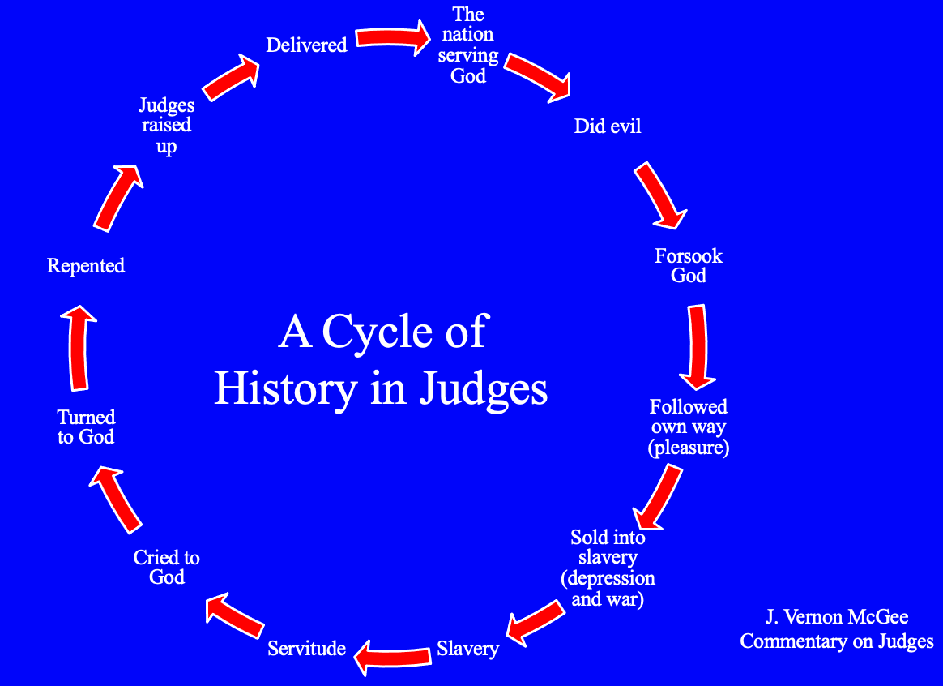

At the top, or beginning, of the cycle, the people would always start with good words claiming their desire to serve and obey God, but their deeds quickly proved them otherwise. As you follow this cycle, you can see the evidence of their empty promises found in the words from Judges 21:25b, “every man did that which was right in his own eyes.” The inevitable consequences of sin and rebellion to God’s commandments leads to apostasy – an abandonment or renunciation of God and His ways. Each of these cycles include apostasies, and there are seven them in this book. They are found in:

- Judges 3:1-11
- Judges 3:12-31
- Judges 4:1-5:31
- Judges 6:1-8:32
- Judges 8:33-10:5
- Judges 10:6-12:15
- Judges 13-16

With Joshua’s passing, the Hebrew nation had become a confederacy of 12 independent tribes with no unifying element except their God. This was a theocracy – God Himself was supposed to be the direct ruler of the nation. As written in Exodus 19:1-8, God established the nation with a desire to be ruled by Him – where they were to be a kingdom of priests and a holy nation – one not ruled by man or some human government. Moses and Joshua had done great work serving in this structure, but with Joshua’s passing, the nation was void of a leader. It is interesting that God appointed Joshua to succeed Moses, but He did not appoint anyone to succeed Joshua.
As the people reached their limits of suffering because of their sins, they would call out to God, and He, because He is merciful, would raise up a judge to deliver them from the consequences of their sin. The Hebrew word for Judges is “shopehtaim”, which means deliverer. While not seeking to discount the brave things these people did, all the judges were limited in their capabilities.
The table below offers a picture of all the judges along with various information relating to each of their reigns.

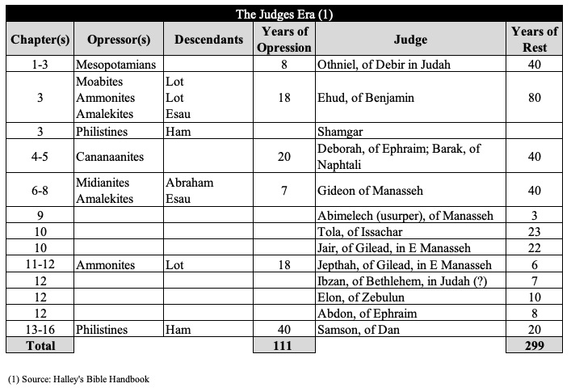

You can see the grace of God in this table. Just look at the total years of oppression vs. the years of rest – it’s almost 3 times the years of rest vs. oppression.
Ok, that’s enough context. As you can see by this table, we’re going to cover 4 of these judges’ reigns in today’s reading. Warren Wiersbe wisely points out that the first two chapters of Judges document the four stages of the decline of the nation of Israel:

- Fighting the enemy (1:1-21)
- Sparing the enemy (1:21, 27-36)
- Imitating the enemy (2:1-13)
- Obeying the enemy (2:6-23)

As we get into Chapter 1, Joshua has died, and the people began to start taking the Land God promised them by fighting the enemy. They start out on the right foot by inquiring of the Lord who is to go fight against the Canaanites? The Lord responded with the tribe of Judah. Judah means “praise.” Praise always has priority in warfare. Praise paves the way to victory. Judah enlisted the tribe of Simeon to help them fight, and the two tribes would prevail. The Lord gave the Canaanites and Perizzites into their hands, and they struck down ten thousand men at Bezek. In verses 6 & 7, they caught the king of Bezek, and cut off his thumbs and big toes. Interestingly, the king acknowledged that what was done to him, he had done the same to 70 kings. He even said, “Now God has paid me back for what I did to them.” The king was the embodiment of Galatians 6:7, “Do not be deceived, God is not mocked; for whatever a man sows, that he will also reap.”
The men of Judah attacked Jerusalem also and took it. However, they did not possess it. This wouldn’t happen until Kind David in 2 Samuel 5. After that, Judah went down to fight against the Canaanites living in the hill country, the Negev and the western foothills. They advanced against the Canaanites living in Hebron (formerly called Kiriath Arba) and defeated Sheshai, Ahiman and Talmai. Sheshai, Ahiman and Talmai were descendants of the giant Anak whose people had frightened ten of the twelve Jewish spies who first explored the land. The Israelites would go on to attack Debir, Hormah, Gaza, Ashkelon, and Ekron (but only claimed the hill country), and Bethel. Bethel was special because of its connection with the patriarchs.
It is at Debir we learn of our first judge, Othniel. From verse 13, we find he is Caleb’s nephew, so faith was deeply rooted in Caleb’s blood line. Caleb pledges his daughter to the one who will lead the battle who attacks and captures Kiriath Sepher.” Othniel is successful and is awarded Caleb’s daughter. At verse 19, we find a turning point for the Nation of Israel. We learn that the Lord was with the men of Judah, and they took possession of the hill country. That’s the good news, but something went wrong after this - they were unable to drive the people from the plains. How could something go wrong if the Lord was with them?
Remember the story of Peter walking on the water? The Lord was with Him, and as long as his focus was on Jesus, he could walk on water. What happened? The winds and the waves picked up causing fear, and he began to sink. What did we learn in today’s story that prevented them from driving the people from the plains? – Their enemies had chariots fitted with iron. Despite the presence of the Lord, they let their circumstances dictate their faith as opposed to letting their faith carry the day upon their circumstances. I like what Jon Courson says, “While the reasons for our failure may vary, the root cause is the same. The failure to obey what God commands is always the result of failure to believe what He has promised.”
When we lose faith in God and His promises, we open a door for Satan to storm the gates of our peace and fill that gap of faith with fear, doubt, and deception. Many of you more seasoned believers have been challenged by the story of David and Goliath. The only difference between the men of Judah and Simeon in today’s story and King David in his battle with the “stronger” enemy was David’s faith. He fully believed there was no man or man-made thing that was a match against the power of God. We must remember that at this time – in this pandemic. We must hold on to the promise of Psalm 27:1b, “The Lord is the strength of my life; of whom shall I be afraid?”
From verse 21 to the end of the chapter, we learned that the Benjamites, Manasseh, Ephraim, Zebulun, Asher, Naphtali, and Dan all were unable to drive out the Canaanites and Amorites. This meant that they had reached the second stage of their downfall – sparing the enemy. When we, as followers of Christ, fail to take the “territory” – the promises that God offers every believer, we are, by definition, sparing Satan from the victory Jesus won at the cross. From Ephesians 1:3, we are blessed with every spiritual blessing in the heavenly places in Christ. Yet, because we don’t fully trust what God’s word says, we allow Satan a place in our life to continue inflicting his misery. One of the real takeaways we should get from the Book of Judges is the serious cost – the pain and suffering that happens when we don’t fully possess and live wholly trusting day-to-day the promises of God.
Moving into Chapter 2, we find, by most Bible commentators’ opinions, a theophany or Christophany. This is the belief that the Angel of the Lord is the pre-incarnate Jesus. He is personally visiting the people and reminding them of His faithfulness to His covenant. He then calls them out for breaking their end of the bargain. He is pointing out the 3rd stage of their decline – imitating the enemy. The fact that Jesus Himself came to deliver this message should be a clear sign of the seriousness of their sinful behavior. He then confirmed His earlier warnings of the consequences of, instead of completely driving out the enemy, sparing them, “I will not drive them out before you; they will become traps for you, and their gods will become snares to you.” We’re going to see the truth of that statement going forward.
The people sorrowed over this rebuke, but their sorrow was only at the surface. There was no repentance as we will see throughout this Book. Repentance literally means to turn around and go the other way. There should be visible fruit of such a commitment. What we are seeing in this story is their sorrow isn’t over the conviction of their sin, but rather the correction of their sin – the fact that they were caught and called out for it.
We then learn of the terrible news of the post-Joshua generation in verse 10 in chapter two, “After that whole generation had been gathered to their ancestors, another generation grew up who knew neither the Lord nor what he had done for Israel.” Warren Wiersbe offers his thoughts on this development, “One of two things was true:

- The older generation had failed to instruct their children and grandchildren in the ways of the Lord.
- If they had faithfully taught them, then the new generation had refused to submit to God’s law and follow God’s ways.

He goes on to say, “The first step the new generation took toward defeat and slavery was neglecting the Word of God.” 2 Timothy 4:3-4 confirms this, “For the time will come when they will not endure sound doctrine, but according to their own desires, because they have itching ears, they will heap up for themselves teachers; and they will turn their ears away from the truth, and be turned aside to fables.”
With this downward progression, we arrive at the 4th and final stage of decline of the people – they went from imitating the enemy to obeying the enemy. Verse 11 proves this backsliding development, “Then the Israelites did evil in the eyes of the Lord and served the Baals.” Baal was the main deity in Canaan – he was the god of rainfall and fertility, and Ashtoreth was his spouse.
A generation is typically 40 years, so with Joshua’s passing, it took less than 40 years for the people to commence the seven cycles of apostasy. Wiersbe, again, offers the steps down the path away from the Lord:

- Friendship with the world (James 4:4)
- Spotted by the world (James 1:27)
- Loving the world (1 John 2:15)
- Conformed to the world (Romans 12:2)
- Condemned with the world (1 Corinthians 11:32)

George Orwell said, “Who controls the past controls the future: who controls the present controls the past.” With the absence of God’s Word, which is an accurate documentation of history, that opens the door to evil, non-believing people to revise history. Their primary objective is to remove the truth of God’s providence and provision. If you remove God from the past, then there is no need to have Him in the present. Yet, when we look at the above steps away from the Lord, where do they leave us? – Condemned. Do you see the evil in this? One other thing over these steps – they almost always happen over a long period of time. We let the enemy take toe holds in the gaps of our faith and understanding of God’s Word, and the soul erosion commences. This is why we must be relentless in our study of God’s Word, so we can fully trust Him in the midst of painful circumstances and ward off the lies from the enemy.
I know there are many of you who struggle with the fact that God intentionally allows or initiates suffering. Yet, there are multiple references of the Lord giving the people into the hands of their enemies. Verse 22 of chapter 2 tells us one of the reasons God did this, “I will use them [the Canaanites] to test Israel and see whether they will keep the way of the Lord and walk in it as their ancestors did.” God takes no joy in allowing or inflicting pain and suffering, but His Son on the cross demonstrated there is always purpose, or intent. In some cases, we may never know why God allowed or initiated our painful circumstances until we see Him face to face. However, when I look in the “rearview mirror” of my life, I can mostly see what God was doing in the tougher times.
Moving into chapter 3, we begin with our first cycle of apostasy and our first judge – Othniel. Due to their sin, the Lord had sold them into the hands of Cushan-Rishathaim king of Aram Naharaim to whom the Israelites were subject for eight years. They cried out to the Lord, and Caleb’s nephew, Othniel, delivered them. He prevailed because verse ten tells us the Spirit of the Lord came on him. As a believer in and follower of Jesus Christ, you have the indwelling Holy Spirit. By faith, when you’re in a battle, the best thing you can do is call upon the Holy Spirit. He will give you the victory. Candidly, though, the victory He gives you may not be the victory you were looking for. Because He is part of the triune Godhead – the victories He seeks for you are firstly for the benefit of your soul. This isn’t to say He won’t provide victory for your fleshly needs, but God is far more interested in the healing, restoration, and development of your soul than He is anything else.
As a result of Othniel’s deliverance, the land had peace for 40 years. Othniel dies, and the people backslide again into their evil ways – this is the second cycle of apostasy. The Lord gives them into the hands of Eglon - king of Moab, and he took possession of the City of Palms, or Jericho. The people would suffer under his reign for 18 years. God raised up the second judge, Ehud, a Benjamite. The people sent him to Eglon with a tribute, but he came with an 18” knife strapped to his leg. After getting alone with Eglon, who was very fat, Ehud sunk the entirety of his knife into Eglon and then escaped. Ehud then led an attack on the Moabites, struck down about 10,000 of them, and then the land had peace for 80 years.
We’re then given only one verse about the third judge, Shamgar. We learn, he was the son of Anath, who struck down six hundred Philistines with an oxgoad. An oxgoad was a long stick with a pointy end. Shamgar must have been a pretty tough cookie to strike down 600 Philistines with such a humble weapon. We may think we don’t have much to offer in a battle for the Lord. We’re not so strong, we’re not so tough, we’re not so smart, etc. But if we have the Lord with us in our battles, he can use the simplest of things to give us a victory. As the saying goes, ‘You and God are a majority.’ You don’t need anyone else to do what God has called you to do. If God calls you, He will also empower you.
We are now in Chapter 4, and with Shamgar’s passing, we find the people entering their 3rd apostasy cycle. As a result of their sin, God gives them into the hands of Jabin, the king of Canaan. We learn he had nine hundred chariots fitted with iron and had cruelly oppressed the Israelites for twenty years. The Israelites once again cried to the Lord for help. This time, the judge God raises is a woman, Deborah. She enlists Barak to take with him ten thousand men of Naphtali and Zebulun and lead them up to Mount Tabor. Barak showed his faith was shallow and said he will only go if Deborah goes as well. Deborah’s response was telling, “But because of the course you are taking, the honor will not be yours, for the Lord will deliver Sisera into the hands of a woman.” In these times, the idea of a woman getting the credit for a battle was about as shameful as you could get.
Despite the fact the enemy had 900 chariots fitted with iron, Deborah gave the command to Barak to attack. You can hear her confidence in her faith in her command, “This is the day the Lord has given Sisera into your hands. Has not the Lord gone ahead of you?” (Judges 4:14) The Lord wiped out all of Sisera’s men, but he got away. He goes to hide in the tent of another tough lady, Jael. She gives him some warm milk, which makes him sleepy. The women in those days were responsible for erecting the tents, so Jael knew her way around a hammer. In Sisera’s sleep, she drives a nail into Sisera’s temple. God would ultimately give them the victory over Jabin the king of Canaan.
Chapter 5 is a song sung by Deborah and Barak. It was a song of praise and Wiersbe offers this summary:

- Praise the Lord all you people (1-12)
- Praise the Lord for the volunteers (13-18)
- Praise the Lord for His victory (19-23)
- Praise the Lord for a courageous woman (24-31)

I must confess that this was a hard lesson for me to prepare. My reason for this assessment isn’t due to the difficulty of the content, but rather the realization that I believe we are today in a cycle of apostasy. When I look at the below regressive progression, I can’t help but to wonder how far down we are on this path.

- Friendship with the world (James 4:4)
- Spotted by the world (James 1:27)
- Loving the world (1 John 2:15)
- Conformed to the world (Romans 12:2)
- Condemned with the world (1 Corinthians 11:32)

Getting back to the opening of this lecture, I am recalling what Jesus first said on the cross, “Father, forgive them, for they know not what they are doing.” We find it so easy to call out the nation of Israel for their repeated sinful cycles of apostasy, but are we any different? I argue our situation is worse because we do know what we are doing. We have the benefit of the life, death, and resurrection of the Lord Jesus Christ and the Holy Spirit living in each of us. Yet, we quietly stand down while the enemy takes more and more of the moral territory the Lord purchased for us on the cross. For me, it is not difficult to see the hand of the Lord on this pandemic. We have kicked Him out of our schools, we have sanctioned the assassination of millions of babies via abortion, and we have let immoral philosophies overwhelm Biblical principles to the point they are the social norm. The question shouldn’t be “Why God?” in this painful time, but the realization should be “Why not, God.”
Are we ready to cry out to the Lord – unified under the conviction of our sins of commission and omission? Thanks be to God He has already provided us our Deliverer. 2 Samuel 22:2 proclaims, “The Lord is my rock, my fortress, and my deliverer.” The risen and victorious Jesus Christ purchased our salvation and empowers us to take the territory that He won on the cross – the promises He has given us. The question for each of us is will we trust His Word, step into the battle with whatever He has given us, and fight? Our reading today proves His willingness to be there for us when we move in faith. If we do this in spirit and truth, He will honor that and give us victory. He is risen! We have hope! We have His promises! We have Him! I don’t know about you, but I have had enough of the enemy’s evil. Let’s join arms, step out in faith, and show the power of God’s love is greater than anything Satan can throw at us. Amen?
Father, we give you thanks and praise for the resurrection of your only begotten Son, Jesus. We thank you for the promises of salvation and victory that are available to us to take the territory stolen by Satan. We ask that you have mercy on the gaps in our faith and fill those gaps with the truth of Your Holy Word. We ask that by Your Spirit, we redirect our focus from on our circumstances to being solely on You. We thank you for the lessons that we learn in the Scriptures, and we pray we can take these lessons into each of our lives and bring you glory in the victory you secured for us with Jesus’ death and resurrection. Amen.

