Lesson 12 Lecture
Numbers 1:1-2:34; 3:39-51; 9:15-10:36

Happy New Year! I would imagine most of us are glad to see 2020 behind us. However, we should not place our hope in the mere fact it is a new year. No doubt, 2021 will have its fill of troubles, so if you’re looking for hope for the better, there’s no other place to go to than Jesus Christ – He is where you will find the truth and true hope. Romans 5:5 confirms this about hope in Christ, “Now hope does not disappoint, because the love of God has been poured out in our hearts by the Holy Spirit who was given to us.” Hope may be hard to see in the midst of today, but God cannot lie. He has promised to never leave us nor forsake us. Hang in there, brothers and sisters – God’s goodness and love will prevail.

We begin this year with the opening of the book of Numbers. Several commentators offered a similar progression of the books of the Bible:

- Genesis is a book of beginnings
- Exodus is a book of redemption
- Leviticus is a book of the Law
- Numbers is a book of warfare

I’m going to divide this teaching into 3 sections:

- The Value of Preparation & Organization
- The Importance of Identity & Inheritance
- The Reality of Warfare

Our reading kicks off with the Lord speaking to Moses. Scripture records the Lord speaking directly to Moses at least 150 times. Imagine the wonder and privilege of having direct dialogue with the Lord Jesus Christ! I don’t know about you, but there are times I wonder if I’m hearing the Lord correctly. How amazing that must have been to have clear and direct communication with the Lord. In verse 2, the Lord tells Moses to, “Take a census of the whole Israelite community by their clans and families, listing every man by name, one by one.”

This command should be thrilling to us. He is interested in every person - by name. Do you know that the Lord is that interested in you? The God of creation – the Great Almighty – the Lord who’s span of His hand holds the universe knows you by name. How amazing is that! Not only does He know your name, but everything He thinks about you is good. Jeremiah 29:11 tells us, “For I know the plans I have for you,” declares the Lord, “plans to prosper you and not to harm you, plans to give you hope and a future.”

Israel is divided by the 12 tribes of Jacob, so the Lord identifies leaders for each of the tribes to assist Moses with the census. I did a study of the meaning of each of the names of these leaders, and it’s pretty cool. I don’t have time to cover these in the video of the lecture, but for those of you who are going to read the text, they are provided as an addendum at the end of this document. Verse 45 of chapter one tells us the purpose of the census – to determine how many men are available for the army. As mentioned earlier, the book of Numbers is largely about war. We’ll get more into that topic in a little bit, but to be successful for any challenge, it is wise to be organized and prepared. Reasons for this wisdom include:

- Letting those who are with you in the battle know they are important to you
- People appreciate the thoughtfulness of an established plan
- Organization, if done properly, holds everyone accountable to each other – starting with leadership.
- Organization and planning are consistent with God’s character. Evidence of the brilliance of God’s design are everywhere if you look closely enough. Look at the human body – it takes more faith to not believe in the design of it as it does to believe it all came together over millions of years through a series of random combinations. No – God is a God of order – 1 Corinthians 14:40 tells us, “Let all things be done decently and in order.”
You may have heard the saying, “The Devil is in the details.” Well, today’s reading challenges the exclusivity of this claim because it is very clear God is very much in the details. We saw that in the construction of the Tabernacle and the preparation of the priests. In today’s reading, we see more evidence of God’s attention to detail in how the nation of Israel is to encamp in all of its stops along its journey through the wilderness.

Below is a diagram that provides the specifics of where each tribe was to be situated around the focal point of each encampment – the Tabernacle. Putting the Tabernacle in the center of the camp was a testimony - not just for the people back then, but even with us today - to the wisdom that God should be at the center of our lives. Is He in yours?

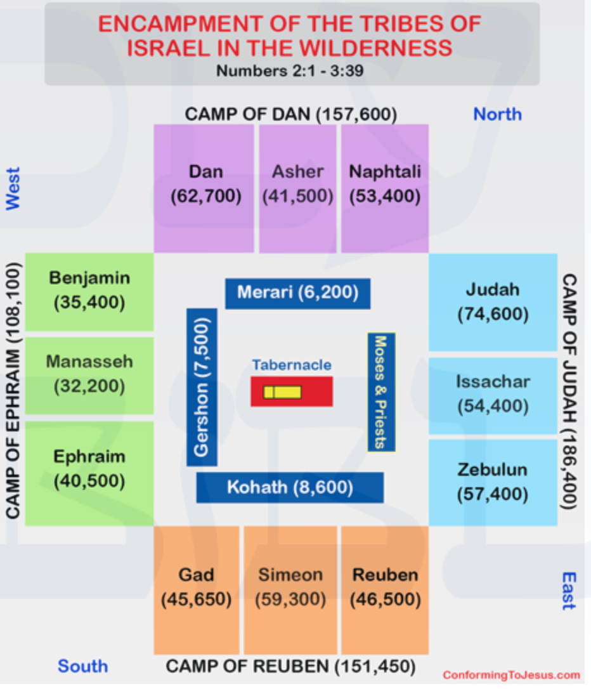

Question # 4 of our homework asked us to record the results of the census, and there were 603,550 men of military age among the 12 tribes (Joseph was split up Ephraim and Manasseh). The tribes were sectioned off in 4 groups – each group assigned to one side around the Tabernacle – forming an outer perimeter. Notably, God had the three tribes related to Rachel - Benjamin, Manasseh, and Ephraim together. Inside the outer perimeter, an inner perimeter was formed with the descendants of the three sons of Levi – the Kohathites, the Gershonites, Merarites, and the families of Moses and Aaron (both descendants of Kohath). The Levites were designated as priests, and they were excluded from fighting. Their responsibilities were to construct, tend, serve, deconstruct, and transport the Tabernacle. In looking at this diagram, you can see the plan of having the largest of the four groups situated on the side of the entrance to the Tabernacle – providing the most protection to the most important place.

From Chapter 2, verse 2, each of the camps were to be identified by a standard, or banner, that was supposed to be emblematic of his father’s house. According to rabbinical tradition, the colors of the banners were those of the 12 gems in the high priest’s breast plate. Furthermore, the emblems of the standards of the leading tribe of each of the 4 groups that formed the outer perimeter around the Tabernacle were believed to be for Judah – a Lion; for Reuben – a Man; for Ephraim – an Ox; and, for Dan – an Eagle.

From Ezekiel’s vision of God in 1:10 of his book and John’s interpretation of what he saw in Revelation 4:7, we’re told of four living creatures. One was like a lion, the second living creature like a calf, the third living creature had a face like a man, and the fourth living creature was like a flying eagle. Nowhere in Scripture supports this tradition, but it’s pretty cool if it was true.

The organization and planning didn’t just stop when the people camped. There was a God-defined order for them to move from one place to another. From chapter 10, the below provides a diagram of the order of the tribes, the number of each of them, and, for the Levitical tribes, what components of the Tabernacle they were responsible for:

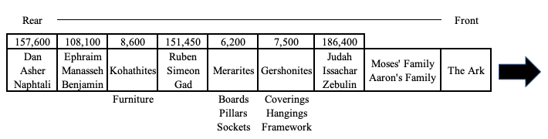

You can see the wisdom in this order. First, The Ark of the Covenant – symbolic of God’s presence, is leading the way. That should always be the case – even for us today. We also see the largest two groups of three tribes at the front and at the rear of the parade – providing strength in numbers on both ends. Jon Courson makes a couple of interesting observations regarding the fact that Judah’s tribe led the parade. First, Jesus, our Leader, would come from the tribe of Judah. Therefore, Judah would always be in a place of priority. Secondly, the name Judah literally means “praise.” Praise is always to lead the way, for it is through praise that we can enter into Jesus’ courts – from Psalm 100:4.

One of the more extraordinary components of this story is the unmistakable presence of God. There was a cloud that would hover over the Tabernacle and the people by day – keeping them cool in the hot sun. There was a pillar of fire that made light available to them at night. As long as the cloud or fire remained over the Tabernacle, the people were to stay where they were. When it lifted up off the Tabernacle, that was the sign it was time to move. This miraculous pillar first appeared at the exodus (Ex. 3:21-22), and it stayed with Israel throughout their journey as noted in Nehemiah 9:19.

Warren Wiersbe notes that this miraculous pillar brought light to the people of Israel but darkness to their enemies - from Exodus 14:19-20. In this respect, it symbolizes the Word of God because those who don’t know Christ by faith simply can’t understand what the Word is saying – from 1 Cor. 2:14. Isaiah 63 indicates this cloud and pillar was the Holy Spirit. What is the Holy Spirit’s role? To testify to the truth of who Jesus is. What is a description of Jesus? – The Word of God (John 1:1). The harmony of Scripture is one of the most powerful testimonies to its authenticity. As a teacher, this makes my life so much easier – let Scripture be the best proof of its truth.

We saw the organization and planning in the taking of the census. That leads us to the second point of this lecture – the importance of knowing your heritage, identity, and inheritance. As we saw in Chapter 1 of Numbers, the centerpiece of the census was to perform the count by each of the tribes. This would only be possible as long as each person was fully aware of his identity – his heritage and inheritance. J. Vernon McGee offers four purposes for the Nation of Israel to know their pedigree:

- They were interesting and beneficial to those who were concerned – what kind of stock you came from.
- To preserve the genealogy of Jesus Christ.
- God forbade intermarriage – a true Israelite had to be able to declare his pedigree – they were beneficiaries of the Abrahamic covenant.
- To determine who was eligible for the priesthood.

Understanding your identity as a follower of Jesus Christ should be a foundational exercise. From the firm belief and trust in your identity in Christ, you can move forward in life with more boldness as you follow Him. Knowing your identity will help you defeat the attacks of the enemy who will constantly challenge the truth of your inheritance. The following are good Scriptures to memorize and take hold.

Galatians 3:26: “For you are all sons of God through faith in Christ Jesus.”

John 1:12: “But as many as received Him, to them He gave the right to become children of God, to those who believe in His name.”

1 John 3:2: Beloved, now we are children of God; and it has not yet been revealed what we shall be, but we know that when He is revealed, we shall be like Him, for we shall see Him as He is.

Romans 8:14-17: “For as many as are led by the Spirit of God, these are sons of God. For you did not receive the spirit of bondage again to fear, but you received the Spirit of adoption by whom we cry out, “Abba, Father.” The Spirit Himself bears witness with our spirit that we are children of God, and if children, then heirs—heirs of God and joint heirs with Christ, if indeed we suffer with Him, that we may also be glorified together.”

J. Vernon McGee is correct when he says, “The authority to become the sons [and daughters] of God is given to those who do no more nor less than simply believe in His name.” Your faith is what gives you your identity. While your faith may be weak at times, God’s faithfulness to you as His child is unwavering. Whenever you are feeling attacked for your faith, remember that the same power that resurrected the Lord Jesus Christ from the dead rests upon you as a child of God. Anyone or anything that challenges this truth is a liar. There is great power and authority in your identity. Don’t let the enemy try to rob you of this.

The Nation of Israel had camped at Mt. Sinai about eleven months. They arrived there in the third month after their deliverance from Egypt, and it was now the second month of the second year. During that time:

- God’s law had been presented
- The tabernacle had been designed, constructed and dedicated
- Moses had consecrated the Levites and the priests
- Moses counted the soldiers
- Moses organized the tribes

Up until this point, God had been doing all the fighting. In today’s reading, via His organization and order through the identity of the people, He was preparing Israel to put some “skin in the game” – to start fighting themselves. There was territory that the Lord had promised the people – the Promised Land. In the NKJV, the phrase “were able to go to war” is used fourteen times in the 1st chapter. The subject of warfare is uncomfortable for many people – especially when it comes to their thoughts about who God is. We think of Jesus as this Man of peace and love. We must remember, though, that Jesus is God, and God is the Lord. The Lord God does not change. Exodus 15:3 tells us the Lord is a man of war. God’s objective in war is righteous and straightforward – to punish sin and remove evil. When thinking of the harshness of warfare, Wiersbe asks the right question, “Would anybody today criticize a surgeon for removing a cancerous, life-threatening tumor from a patient’s body?”

In observing what went on in just 2020 alone, you would have to be purposely not seeing the growing evil in our culture. The tidal wave of immorality flooding our television programs; the obliteration of truth in the media for the purpose of forwarding liberal agendas; the shameful continuance of racism; and, the corruption of our political system are the more obvious examples of the “ground” the enemy has taken in our society. All of this evil is rooted in the spiritual realm. Wiersbe rightly says in his commentary, “The Christian life is a battleground, not a playground, and there’s an enemy to fight and territory to gain for the Lord. God declared war on Satan in Genesis 3, and there can be no neutrality in this spiritual conflict, for Jesus said, “He that is not with me is against Me.” (Matthew 12:30)

Wiersbe continues and asks a convicting question, “If God were to number the believers in the church today according to their ability to wage spiritual warfare, we wonder how big the army would be?” Brothers and sisters, we clearly see in today’s reading that God’s plan was to prepare and engage His chosen people to fight to take the territory that God had promised them. You may ask, “Why doesn’t God just do it for us?” I’ll answer that question with another question, “How much more valuable is something to you if you go out and earn it as opposed to having it just given to you?” Just like when we were in school and were given tests, those tests were meant to show us how much of the subject we really understood. Fighting the fight of faith reveals to us the depth of what we believe.

For those of you who believe you are too old to get into the fight, you are believing a lie. Fighting for the faith takes many forms. You can teach your grandchildren the Word of God. You can challenge non-believers when they preach their deceived beliefs. For those of you who are going to church, you can simply be role models to the younger generations that you have remained true to your faith. I understand that in the midst of this pandemic, your ability to reach others is limited, but there are still ways to strengthen each other through technology. Jesus went to the cross to win the ultimate fight – life over death. We are to follow Him wherever He leads us, and that is what we must remember when getting into a fight. Just as the Ark of the Covenant was at the head of the Nation of Israel, so is He ahead of the fights He wants you to fight. 1 Samuel 17:47 tells us the battle is the Lord’s, but He wants us to be with Him in the fight.
I know I have been quoting Warren Wiersbe a lot in this lecture, but his commentary on this section is exceptional. Regarding the fear we may have when thinking about getting into the game of spiritual warfare and confronting our “comfort zone”, Wiersbe makes an astute observation. “The more comfortable we become, the less we welcome change, and yet there’s no growth without challenge and there’s no challenge without change. Comfort usually leads to complacency, and complacency is the enemy of character and spiritual growth. In each new experience of life, one of two things happens: 1) either we trust God and He brings out the best in us; or, 2) we disobey God and Satan brings out the worst in us.”

In summary, we covered three primary topics from today’s reading:

- The Value of Preparation & Organization
- The Importance of Identity & Inheritance
- The Reality of Warfare

All of these topics are relevant to us today. In anything we do, there is good wisdom in preparing and organizing. Most of you do not understand what goes into the preparation and organization of just this Bible study. Carol and Maggie have put, and continue to put, countless hours into making this study the best it can be – especially in light of the challenges of the pandemic. We are beneficiaries of this organization and planning, so People of the Word is a good example to what Wiersbe says, “When God’s work is done in God’s way, in obedience to God’s truth, it will never lack God’s blessing.”

In the face of the growing animosity towards the Christian faith, you need to immerse yourself in the Scriptures – especially those that assure you of your identity in Christ. Personally, I believe things are only going to become more difficult for us as believers, so we need to put on the full armor of our faith to remind us of the truth of our inheritance as we faithfully follow the Lord Jesus – wherever He leads us.

Finally, we must concede that as followers of Christ, we’re going to be put into battle. To help us with this truth we need to remember two important things. First, Jesus will never leave you nor forsake you – even if it may feel like you can’t feel Him close to you in your battle. Secondly, taking from the name of this book we are reading now, there is strength in numbers. We need to stick together. Iron sharpens iron – we need to hold each other accountable for our roles in the Kingdom. We started this lesson with the truth that God knows each of you by name. He deeply cares about each of you as individuals, but He also cares about His church. Let us join together – arm in arm – as God’s children and get in the game for the sake of our unsaved loved ones. They are the territory we need to take back from the enemy. Will you join in? Let’s pray.

Father, we thank You for Your holy Word. We thank You that as believers in and followers of Your Son, Jesus, we are Your adopted children. I pray for each person watching/reading this lecture You will deepen their faith and trust in their identity in You. I pray from that truth they will become mighty warriors for their faith and Your Kingdom. May they grab the territory You have designated for each of them. May You help them to remember that He who is in each of them is greater than he who is in the world. In Jesus name, AMEN!

