Lesson 7 Lecture
The Tabernacle

Hello, my name is Dan Leppo, and with the help of the Word of God and the Holy Spirit, I would like to welcome you to our tour of the Tabernacle of the Old Testament. We thank you for your interest in this journey. We trust God is going to reveal Himself in both your mind and your heart as He unveils His wisdom and His foreshadowing in the construction of this mobile place of worship. You will discover that this foreshadowing was meant to point to what all of God’s Word is intended to do – to point to our great and conquering King – our Lord, and Savior, Jesus Christ. As our dear sister in Christ, Carol Martin, said so eloquently in 1993, “The Tabernacle was the gospel in pictures. God didn’t have two gospels; rather, when Christ came, He revealed the gospel shadow that was concealed in the Tabernacle.”
Before we begin our tour, we should pause for a moment as to the wonder that there ever was a Tabernacle. God had created the heavens and earth. He created the sky, the land, and the seas. He created all of this for not only His good pleasure, but also for the pleasure of His greatest creation, human beings. How did they reward this gift of life and grace? They disobeyed His lone commandment – they sinned, which ushered all its death and destruction into what was originally created as perfect and good. God could have turned away from His creation and let the consequences of their choices rage unchecked, but out of His love for what He created, He chose to show mercy and love with a redemptive heart. For each one of us, we should marvel and forever praise God that while we were still sinners, Christ died for us. This mindset of God didn’t just happen with Jesus some 2,000 years ago. His merciful and redemptive mindset and heart has been on display since Adam and Eve. We have the distinct privilege of being able to look in the rear-view mirror of history and, upon closer inspection, see God unveil the wonder and the consistency of His will in this Tabernacle. So, please open your hearts and listen carefully. God has some exciting revelations of Himself to show you.
As our homework pointed out in question 5.b., Hebrews 8:5 tells us the Tabernacle is a copy and shadow of what was in heaven, so pay attention to what you read . . . as you may very well be seeing it when you breathe your last breath and go to heaven. One last thing before we get into the details of the Tabernacle. Moses received this instruction during one of his visits with the Lord on Mt. Sinai. I liked what my friend said about Moses on Mt. Sinai. The people didn’t want to go up to the mountain because they were afraid; but because Moses was willing to go, he got a relationship with God. What did the people get out of their fear and unwillingness to come to God? They got the Law. For so many people, and sadly, many Christians, their idea of believing in God is an endless list of “dos and don’ts.” That’s the Law. True Christianity is not a religion – it is a relationship. God wants to have the people make a sanctuary for Him, so He can dwell among them. That is the heart of God – He doesn’t want to be some far-off unknowable and disconnected Being. He wants to dwell with us. He wants to dwell with you.
Prior to entering the Tabernacle, we should get some perspective on its dimensions and outward appearance. The below diagram indicates that the Tabernacle footprint was about 25% of the size of a football field. Surrounding the temple grounds was a fence that was constructed with 60, 7.5’ pillars of acacia wood – 20 pillars on each of the north and south sides, and 10 on each of the east and west sides. A curtain of white fine linen was strung across these pillars – white being symbolic of holiness, righteousness, and purity. Sadly, much of today’s teaching shies away from God’s holiness. I don’t think that it is an accident because in this “seeker friendly” age of modern Christianity, God’s holiness forces us to deal with our sinful condition. This is an uncomfortable place for most of us, so instead of going deeper with God to seek His help in cleansing, forgiving, and healing us from our sin, we just stop talking about His holiness. As we go through the Tabernacle in this lesson, dealing with God’s holiness is, thankfully, unavoidable.
There were 3 components, or sections, of the Tabernacle grounds: 1) The outer courtyard; 2) the Holy Place; 3) the Holy of Holies.

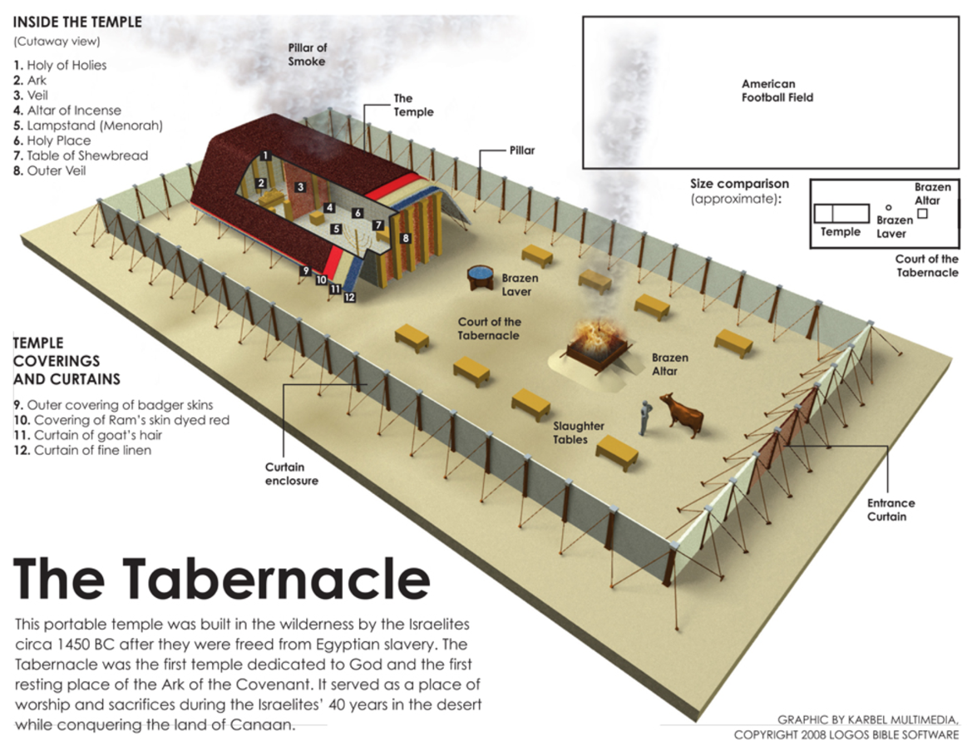
3
2
1

As we enter the courtyard, we find the first of two important pieces of furniture that are symbols of the work of Christ. The first item is the Alter of Burnt Offering, and it is the largest object in the courtyard. The altar is made of brass. Brass, in Scripture, is symbolic of judgment of sin. This is where sacrifices were made – this is symbolic of the cross. Below is a depiction of the Altar of Burnt Offering:

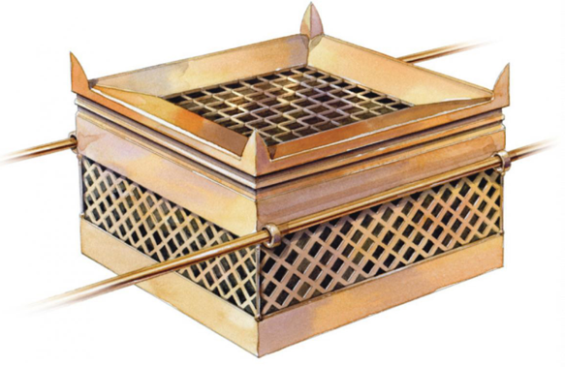

You will see horns on each of the corners. These were used to tie the sacrifice to the altar. I like Jon Courson’s comments on this altar, “Jesus Christ was tied to the altar of the Cross – not by the spikes pierced in His hands and feet, but by the bands of His love for you and me.” The cross becomes far more personal when we remember that Jesus chose to go to the cross – for the joy set before Him. What was that joy before Him? The idea of you understanding the depth of God’s love for you, and His desire for you to be redeemed and reconciled to the Father; to be in constant fellowship with Him for eternity. His joy and love for you is what drove Him to the cross.
As we consider approaching a perfect and holy God, we must recognize our sinful condition. We cannot get to God before we first are forgiven of our sin by God. Hebrews 9:22 tells us, “In fact, the law requires that nearly everything be cleansed with blood, and without the shedding of blood there is no forgiveness.” The wages of sin is death, so to atone for sin’s deadly effects, it must be covered by the life that is in the blood (Leviticus 17:11). Therefore, for a sinful being to approach God, something has to die as a substitute to offer life-giving blood as a symbolic gesture of pardon. In the Old Testament, this blood came from pure and spotless animals, but their blood merely covered sins.
When seeing Jesus, John the Baptist said in John 1:29, “Behold! The Lamb of God who takes away the sin of the world!” According to Revelation 1:5b speaking of Jesus’ sacrifice on the cross, “To Him who loved us and washed us from our sins in His own blood.” Jesus’ precious blood went beyond the Old Testament sacrifices – through faith in the finished work of Christ crucified, our sins are not covered – they’re washed and taken away. Jesus paid the judgment for our sins and allows us to continue to approach the Holy of Holies cleansed and pure. Otherwise, we would have no hope of having access to God the Father. Ephesians 5:2 assures us, “And walk in love, as Christ also has loved us and given Himself for us, an offering and a sacrifice to God for a sweet-smelling aroma.”
From Numbers 4:13, we see that the altar was the only piece of tabernacle furniture that was covered in purple. Purple is symbolic of royalty, and Jesus is our King. He is a worthy King, isn’t He? He’s not some far-off king sitting on an unapproachable throne. He not only saves us from hell, but also, He walks with us through our lives – never leaving nor forsaking us. He answers our prayers and is our rock and fortress. Over the purple on the altar was a second covering made of badger skin. These two coverings are symbolic as to how people see Jesus. Without faith, there is nothing attractive about Him. Isaiah, in speaking about the Messiah, tells us, “He has no form or comeliness; and when we see Him, there is no beauty that we should desire Him. (Is. 53:2) However, for those who believe, we see the extraordinary beauty of the inside the Lord Jesus - His royalty, His Deity, and His glory blesses and overwhelms us. He is the embodiment of what 1 Samuel 16:7 tells us, “The Lord does not look at the things people look at. People look at the outward appearance, but the Lord looks at the heart.”
From the altar and before we get to the tent that houses the Holy Place and the Holy of Holies, we proceed to the second brass laden piece of furniture – the bronze laver. Below is a depiction of what the laver may have looked like.

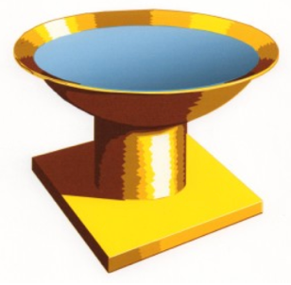

The laver was the place that the priests would wash themselves before entering the tent. The laver was full of clean water, and when water is used in Scripture for washing, it is symbolic of the Word of God. Ephesians 5:26 invokes husbands to love their wives by cleansing them with the washing of the water through the Word. The laver was made of bronze, and the material was from the mirrors of the Jewish women. This is another proof of the laver being symbolic of God’s Word as it is likened to a mirror in the first chapter of James.
Let’s think about the two steps we have taken so far inside God’s house. We have come to the altar to deal with sin. While we are forgiven by the grace of God, we still get dirty, don’t we? Our eyes, either intentionally or unintentionally, see things we shouldn’t be looking at. Our thoughts are not always pure and holy, are they? Our words sometimes bring shame, condemnation, and destruction as opposed to being life-giving and offering hope and encouragement. If we’re about to get closer to a perfect and holy God, we need to clean up, and there is no better place to do that than in God’s Word. What was Jesus’ reply to Peter when he refused to have Jesus wash his feet, “Unless I wash you, you have no part with me.” (John 13:8) Jesus is the Word of God (John 1:1), and 1 Corinthians 6:11 reminds us, “But you were washed, you were sanctified, you were justified in the name of the Lord Jesus Christ and by the Spirit of our God.” Stay in the Word, brothers and sisters – it will make you clean.
As for the construction of the tent that contains the Holy Place and the Holy of Holies, the west, north, and south walls were constructed of 15’ high, 27” wide acacia wood boards overlaid with gold. Each of these boards stood on silver bases made from the shekels collected from Jewish men of military age. Silver shekels are equated in Scripture to redemption money, so in Warren Wiersbe’s words, “God’ sanctuary isn’t built on the shifting sands of this world, but on the solid foundation of redemption.” The gate of the Tabernacle was always from the east, and it was the only way to enter. Jesus told us in John 14:6, “I am the way, the truth, and the life, and no one comes to the Father but by Me.” From chapter 43, we read in the third temple in the Millennium, the glory of the Lord will enter through the east gate.
The tent was covered with ten curtains for walls made of fine white linen, blue, purple, and scarlet. The number four leads us to the four gospels. The four colors line up with each of the gospels. Luke talks of the righteous humanity of Jesus, and white is symbolic of righteousness. John speaks to Jesus’ Deity, which is emblematic of blue – the color of the sky and heaven. Matthew writes about the Kingship of Jesus, and the color for royalty is purple. Mark tells us of Jesus as the Suffering Servant, and this is typified by the color of scarlet – red for His shed blood.
Once past the curtain, we are now in the Holy Place. We’re going to find three pieces in this section of the Tabernacle, and they all relate to God’s provision. This is the character of God – He asks us to come to Him seeking forgiveness and cleansing, and for those who do so, the very first thing He rewards us with is His demonstration of is His complete provision. The first thing we see? The table of showbread. The below is an image of what it may have looked like:

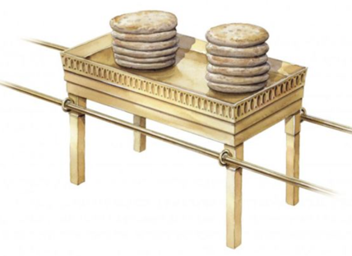
This table would be made of acacia, or shittim, wood and pure gold. “Showbread” refers to the twelve loaves of bread – two rows of six each – which were set before the Lord each Sabbath (Leviticus 24:5-8). The length of the table is to be two cubits. The number two is the number of union, communion, and agreement (Amos 3:3). When we come to the table of communion with God, one of the first things we should do is come into agreement with our sins – to confess our sins before Him. Even though He already knows them, the verbalization of our confession activates the blood of Christ for the forgiveness of those sins and is another step towards being emancipated from the slavery of those sins.
Jesus said in John 6:32-33, “It is my Father who gives you the true bread from heaven. For the bread of God is the bread that comes down from heaven and gives life to the world.” He would go on to say in verse 35 that He was the bread of life and whoever comes to Him will never go hungry. What are you hungry for? More importantly, is what you are feeding on satisfying you? Oh, it may satisfy your flesh for a moment or two, but no doubt you will once again be hungry. The spiritual food of the Word of God totally satisfies. If you don’t think the Word of God is that important, what did Jesus implore Peter to do three times as He was restoring the shamed Apostle? – To feed His lambs. Brothers and sisters, what you are doing in this Bible study is taking bites from the Bread of life. There is no time I feel closer to God and safe than when I am in His Word. Spend some time at this table, and He will give you life-satisfying bread!
After the table of Showbread, we arrive at the lampstand – or the Menorah – which held oil lamps instead of wax candles. Below is a depiction of the lampstand.

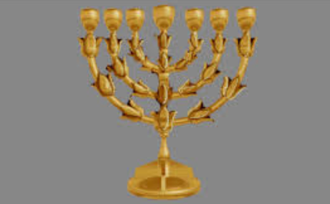

According to the KJV of Exodus 25:31, the people were to make a “candlestick of pure gold: of beaten work shall the candlestick be made”. Jesus is the light of the world (John 8:12), so the candlestick is symbolic of the Lord. Isaiah 53:5 tells us Jesus was “crushed for our iniquities.” When is a Christian’s greatest witness? – When he or she is being beaten – when we are in a trial and still praising the Lord for His goodness and love. That is when our light is brightest.
There were to be six branches – three on each side of the main stem. Jesus said in John 15:5, “I am the vine, and you are the branches.” The number seven is that of completion, so the number of lamps on the candlestick represents God’s provision of the complete light of Christ that we need in our lives to drive out the darkness that is in us and the darkness that surrounds us. This light isn’t just for us – it’s for us to share. Chris Rice has a beautiful song called, “Go Light Your World.” The chorus goes like this:

Carry your candle
Run to the darkness
Seek out the helpless – confused and torn.
And hold out your candle
For all to see it
Take your candle and go light your world.

The third and final item we see in the Holy Place is the altar of incense – this is the second altar with the first being the bronze altar for the sacrifice representing Jesus’ first coming. This altar is made of gold and speaks to Jesus’ Deity and His second coming. Below is an image of what he altar of incense may have looked like:
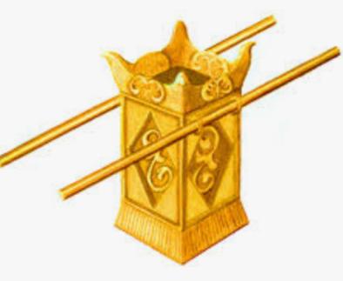

The altar of incense was to be tended day and night by the priests. Incense is symbolic of prayer in Scripture. There’s another golden altar of incense in Scripture, and we find it in chapter 8 of Revelation. It is full of the prayers of the saints. Did you know your sincere prayers are not only heard by God, but they are also kept as a testimony to your faith and heart for God? Our prayers are not the only prayers in this altar – there are the intercessory prayers of your Lord and Savior – protecting you from the accusations of Satan. He is praying for you at this very moment (Hebrews 7:25), and He intercedes for you with exceeding joy (Jude 24).
Do you see prayer as an instruction list for God to follow, or do you see it as His provision to you to fellowship with Him? For those of you who struggle with prayer, there’s nothing to be ashamed of. Prayer is probably the hardest thing to do for a Christian because it is the line of communication between us and God. The bonds of a relationship are never stronger than when there is clear and constant communication. This is why Satan absolutely hates when we pray – his influence diminishes and we become a far greater adversary to him when we are close to and communing intimately with God. Therefore, he will throw relentless distractions, doubts, and insecurities our way when we want to pray. One final thing on prayer – it is not the length of prayer that moves God – it is the heart behind it. Solomon encouraged us to let our words be few with God in Ecclesiastes 5:2.
In the Holy Place – the place before we enter the Holy of Holies - God provides bread, light, and communion with Him via prayer. This is why our mindset towards God should always be of gratitude. He provides everything we need. The Apostle Paul exhorted in Philippians 4:6, “Be anxious for nothing, but in everything by prayer and supplication, with thanks-giving, let your requests be made known to God.” He also told us to be vigilant in thanksgiving in our prayers in Colossians 4:2.
We now get to the veil – this is the curtain to which we must pass through as we approach the Holy of Holies – as we come into God’s presence. Its colors are blue, purple, and scarlet. We’ve already spoken to the significance of those colors. The veil is symbolic of the humanity of Jesus (Hebrews 10:20), and it hung on four pillars. Again, we can easily equate the four pillars to the Gospels. Until Jesus’ death, this place was only reserved for the High Priest, who would enter the temple one time per year and pray for himself and for the people. As our High Priest and upon Jesus’ death, the veil was torn from top to bottom, signifying the Lord’s finished work on the cross now making unfettered access to God available to all who believe. Please take a moment and praise the Lord for this glorious provision.
We have reached the ultimate destination of our tour – the glorious place we all should be panting for – the Holy of Holies – the place of God’s presence. In there we find the ark of the covenant. Below is a depiction of the ark:

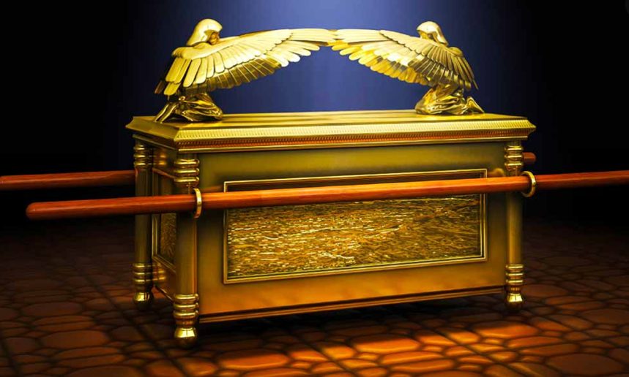

The ark was to be constructed of acacia wood and pure gold. Acacia trees grow in desert regions in dry ground. Isaiah 53:2 told us Jesus would be “a root out of dry ground.” As we have noted before, gold is a symbol of Deity, so the ark would be overlaid with pure gold. Acacia trees are the only thorn-bearing trees in the desert. Jesus would wear a crown of thorns, but He will also wear a crown of Gold (Revelation 14:14).
Question 8 of our homework asked us to provide the list of the ark’s contents taken from Hebrews 9:4. There were three items: a gold jar of manna, Aaron’s rod that had budded, and the stone tablets of the covenant. Jesus is the bread of life (John 6:35). He is the one that gives life to the dead (John 11:25). Jesus kept the commandments from John 8:29, “I always do the things that please the Father.”
Beginning in Exodus 25:17, God provides the details for the mercy seat – a symbol of God’s character that sits upon the ark. As Jon Courson wisely states, “God doesn’t meet us at the ark, which contains the law, which brings judgment. God wants to meet us at that which covers it – the mercy seat.” What does this tell us? How many of us walk around day-in, day-out thinking that in order to be right with God, we must do this and not do that? We’re saved by grace, but we think we’re sanctified by works. The mercy seat tells us the only way we can have fellowship with God is through His mercy and grace.
As we conclude our tour, we have taken you from the gate of the Tabernacle into God’s presence. He wanted the Tabernacle constructed, so He may dwell among His people. Just as this was the heart of God for His children in the Old Testament, so it is still His heart for you today. Brothers and sisters – He wants to dwell with you – He wants to be a part of every aspect of your life providing for you, healing you, restoring you, and growing you into the image of His beloved only begotten Son. Speaking about the Holy Spirit, Jesus said in John 14:16-17, “And I will pray to the Father, and He will give you another Helper, that He may abide with you forever - the Spirit of truth, whom the world cannot receive, because it neither sees Him nor knows Him; but you know Him, for He dwells with you and will be in you.”
Brothers and sisters – each of you is a walking Holy of Holies. Your Creator; your Savior; and, your Lord has provided you the grace of His constant presence to make your life free of fear, full of love, and loaded with purpose. The fact that the very first piece of furniture God provided the detail to when speaking of the construction and contents of the Tabernacle was the ark of the covenant – symbolic of God’s presence – is no accident. God’s desire is to bless you with His presence, His power, and His love. Do you believe that? Let’s pray. Father, we thank you so much for demonstrating so clearly over history Your desire to dwell with us. I pray for each person reading this they will more deeply understand and believe what You have done to make this possible. May they find the joy of Your presence that You made possible through the blood of Your Son, and the power of Your Spirit. In Jesus name -AMEN!

